TakingITGlobal Impact Research 2008

Final Report

Prepared by: | Muqing Zhou
Key Advisors: | Jennifer Corriero, Co-founder and Executive Director, TakingITGlobal  Luke Walker, Director of Education Programs, TakingITGlobal  Nick Yeo, Development and Communications Manager, TakingITGlobal  John Horrigan, Associate Director, Pew Internet Project; Advisor, TakingITGlobal  Ellen Ratchye-Foster, Principal, Burning Glass Consulting; Board Member, TakingITGlobal  Stephanie Wilson, Writer and Strategist, Write Brain
Table of Contents

Acknowledgements 5

Executive Summary 6

- Introduction 8

Member Impact SURVEY
- Methodology 9
  - Analysis 10
- Demographics of Survey Participants 12
  - Sex 12
  - Region 12
Sex and Region 13
  - Age 14
Sex and Age 14
- Results and Discussion by Section 15
  - Expanding Networks and Connections 15
    - Quantitative Results 15
    - Qualitative Results 17
    - Discussion 18
General 18
Correlation 19
Comparison to 2004 Member Survey 19
Variance by Demographic Groups 19
Region 19
Age 20
Sex 21
Discussion on Comments and Suggestions 21
  - Inspiration and Empowerment 23
    - Quantitative Results 23
    - Qualitative Results 25
    - Discussion 26
General 26
Correlation 27
Variance by Demographic Groups 27
Region 27
Age 28
Sex 29
Discussion on Comments and Suggestions 29
  - Information and Expression 31
    - Quantitative Results 31
    - Qualitative Results 32
    - Discussion 34
General 34
Correlation 35
Variance by Demographic Groups 36
Region 36
Age 37
Sex 37
Discussion on Comments and Suggestions 37
  - Action 39
    - Quantitative Results 39
    - Qualitative Results 40
    - Discussion 42
General 42
Correlation 43
Comparison to 2004 Member Survey 44
Variance by Demographic Groups 44
Region 44
Age 45
Sex 45
Discussion on Comments and Suggestions 46
  - TIG’s Greatest Impact 48
    - Results 48
    - Discussion 51
- General Discussion 52
  - Demographic Limits 52
  - General Insights from Data 52
  - Recurring and/or Interesting Comments and Suggestions 53
  - Variance by Demographic Group 54
Region 54
Age 55
Sex 55
  - Correlation 55
- Recommendations 56
  - Survey Tool 56
  - Survey Questions 56

Impact INTERVIEWS
- Methodology 58
- Active Youth 59
  - Results 59
  - Discussion 61
    - TIG’s Impact 61
    - Other Reoccurring Themes 66
    - Interesting Insights and Learnings/Tips 67
    - Suggestions 69
- Educators 70
  - Results 70
  - Discussion 71
    - Impact of TIG/TIGed 71
    - Other Reoccurring Themes 74
    - Suggestions 75
- Organizations 76
  - Results 76
  - Discussion 78
    - Impact of TIG on Organizations 78
    - Suggestions and Areas for Future Collaboration 80

General SYNTHESIS
- Overall Discussion 82
- Conclusion 83

APPENDICES
Appendix 1: Survey Questions 84
Appendix 2.1: Survey Responses by Frequency 88
Appendix 2.2: Survey Responses by Percentage 91
Appendix 3: Correlation Coefficients for Survey Responses by Question 93
Appendix 4: Survey Results by Region 94
Appendix 5: Survey Results by Age 96
Appendix 6: Survey Results by Sex 98
Appendix 7: P-Values by Demographic Groups 99
Appendix 8: Guiding Questions for Interviews 100
Youth 100
Educators 101
Organizations 102
Appendix 9: Interviewees 103
Youth 103
Educators 104
Organizations 104
Appendix 10: Interview Stories and Summaries 105
Youth 105
Educators 137
Organizations 147

Acknowledgements

Special thanks to Jennifer Corriero, Luke Walker, Nick Yeo, John Horrigan, and Ellen Ratchye-Foster for their invaluable direction, guidance, and support throughout this research project; to Laura Kenyon, Kirsten Jordan, Kimia Ghomeshi, and Emily Kornblut for their advice and input; to Michael Furdyk for technical support with the survey and statistical data; to Stephanie Wilson for editing the interview stories; and to Chiara Camponeschi, Tala Nabulsi, Maged Hassan, Elaine Castro, and Damian Profeta for helping to make the research more linguistically inclusive.
EXECUTIVE SUMMARY

This report outlines the findings from the TakingITGlobal (TIG) impact research, which ran from January to April 2008. Since the TakingITGlobal online community (www.takingitglobal.org) launched in 2000 with the goal of inspiring and informing youth to become more engaged and involved in their communities, there have been few concerted efforts to assess the impact of TakingITGlobal. Thus, the purpose of this research initiative was three-fold: first, to evaluate if, how, and how much TakingITGlobal was having an impact on its key stakeholders; second, to generate benchmark data and results with which to compare future impact research to trace the evolution of TIG’s impact; and third, to identify the strengths and weaknesses of TakingITGlobal and its programs.

The research took form through two streams: a member impact survey and in-depth one-on-one interviews with active young TIG members, educators, and organizations. The survey, which included both quantitative and qualitative questions regarding TakingITGlobal.org’s impact on its members, was released to all TakingITGlobal.org members electronically in English, French, Arabic, and Portuguese. The 384 fully completed responses were then aggregated and analyzed for correlations and for variance between demographic groups (quantitative questions), as well as for common themes (qualitative questions). The second phase of the research involved interviewing 23 youth, 7 educators, and 7 organizational representatives from around the world, all of whom had been pre-selected based on their high level of involvement with TakingITGlobal or its programs. Summaries of the interviews were drafted, and the transcripts were then analyzed for common themes.

Overall, the research demonstrated that TakingITGlobal’s greatest asset for all stakeholders seemed to be its vast network of globally aware individuals. For members and youth, the TIG network was key in enabling them to make friends (82.0%) and to find collaborators (71.9%); for educators, the community enabled them to facilitate global education for their students by connecting their classes with other classes from around the world; and for organizations, TIG’s extensive and active membership presented a valuable network that they could tap into for outreach purposes.

TakingITGlobal also seemed to have a strong impact in terms inspiring and empowering members, such as greatly improving their view of young people as change agents (69.0%) or greatly increasing their sense of belonging to a community (57.8%). It was interesting to note, however, that only a portion of the TakingITGlobal membership felt TIG’s impact in terms of receiving support and recognition, as was demonstrated by the high enthusiasm that the active youth interviewed expressed at receiving appreciation, encouragement, and support from both TIG staff and other TIG members, which motivated them to become more engaged, and the contrasting lukewarm response from general TIG members (36.5%), who expressed wanting to receive more communication and encouragement from TIG.

In terms of providing information, TIG seemed to be doing quite well at increasing members’ awareness of local and global issues (57.3%). However, TIG was generally not seen as an effective platform for exchanging of best practices (29.7%), although many of the active youth interviewed disagreed, suggesting that the sharing of best practices was linked to taking action (this was also corroborated through correlation data from the survey).

When it came to taking action, TIG was quite successful at getting members to join (63.8%) or start (49.7%) their own projects and/or organizations, and relatively so at prompting members to attend (39.8%) or organize (33.3%) an event. Members can essentially be divided into three groups in terms of action: those who were engaged in their communities prior to TIG and who were using TIG to access additional opportunities, those who may or may not have been active before TIG but whose involvement had generally not changed since joining TIG, and those who were not previously engaged and became more engaged through TIG. The research suggested that while the first two groups were common, the third category of members was much more rare.

In terms of significant variance between demographic groups, survey results revealed that African, Asian, Middle Eastern, South American, and Caribbean members were more strongly impacted across the board by TIG than members from Europe, Oceania, or North America. For different age groups, interestingly, variance was generally only significant for questions related to creating connections (with those aged between 21 and 35 leading). Between the sexes, male respondents were significantly more impacted by TIG in terms of making friends and being connected to leaders and organizations, becoming more self-confident and gaining a greater sense of belonging, as well as most questions related to taking action.

The research also suggested that the main impacts of TIG and TIGed on educators were in creating and facilitating connections (as mentioned above), providing resources for a global education and facilitating global learning, fostering personal and academic growth amongst students, and through enhancing the learning and teaching experience through new and innovative media. For organizations, the interviews pointed to TIG’s impact being significant in terms of providing technological and/or graphic design support, event support, and content development, as well as supplying more exposure and visibility for organizations through TIG’s network (as mentioned above), and providing various benefits derived from the use of specific TIG tools.

In general, the research suggested that TakingITGlobal’s goal of inspiring, informing, and involving youth from all over the world is being fulfilled, but to varying degrees for different members, educators, and organizations. The research also drew out common member suggestions, such as promoting the exchange of best practices or increasing communication between TIG and stakeholders in the form of updates, suggestions, support, and encouragement, to help strengthen TakingITGlobal’s impact in the future. Through identifying the key strengths and weaknesses of TakingITGlobal and its programs, this report hopes to contribute to the TIG knowledge base, prompt further discussion, and help inform future strategies on the road to fulfilling TIG’s vision of a world where young people are more engaged in their communities on local, national, and international levels.
INTRODUCTION

TakingITGlobal is an international youth organization that inspires, informs and involves more than 190 000 young people from over 260 countries around the world through its online community. Launched in 2000, TakingITGlobal.org uses technology as a vehicle for youth empowerment, as the Internet has begun to have a ubiquitous presence in today’s youth society. The highly interactive online community offers opportunities for youth to shape their world and express themselves through blogs, pod casts, videos, artwork, and other media.

From January to April 2008, TakingITGlobal undertook a research initiative to evaluate its impact for key stakeholders, including members of its online community, educators, and partner organizations. The project encompassed a member impact survey, which was released to all TakingITGlobal.org members, as well as numerous in-depth interviews with active youth within the TIG community, teachers who utilize the TakingITGlobal educational program tools (TIGed), and organizations.

The TakingITGlobal member impact survey was developed to assess the impact of the TIG online community on its members. The purpose of the survey was to collect both quantitative and qualitative data that would help us to better understand where, how, and how much TIG is making a difference in the lives of its members, if it is at all. A second purpose was to generate benchmark numbers against which future impact research can be compared and analyzed. It was acknowledged that survey data and results could also be used to illustrate TIG’s impact in any publication or PR materials. Results of the survey will be discussed in sections 2 through 6.

Since impact cannot be solely measured by numbers and statistics, the second component of the impact research entailed conducting in-depth interviews with active youth within the TIG community (as identified by TIG), educators, and organizations. The purpose of these interviews was primarily to collect qualitative data of how key stakeholders of TIG have been using TIG tools and resources and how these have had an impact on them. As a result, due to the focus and the interviewees targeted, these interviews were conducted in part to collect success stories and best practices for TIG, and in part to determine which parts of TIG are driving these “successes”, hence TIG’s strengths and weaknesses. The results of the interviews will be discussed in sections 7 through 11.

TakingITGlobal Member Impact Survey, 2008

- METHODOLOGY

The survey questions were drafted between mid- to late January of 2008. After several consultations with advisors (Jennifer Corriero, Nick Yeo, Luke Walker, John Horrigan, and Ellen Ratchye-Foster) and subsequent revisions, the survey questions were finalized at the end of January 2008. These included 22 quantitative multiple-choice questions and 6 optional qualitative questions, focusing on 4 different areas of TIG’s perceived impact: expanding networks and connections, providing inspiration and empowerment, sharing information and encouraging self-expression, and inciting positive action.

English and French versions of the survey were uploaded electronically to the TIG website. An explanation of the survey, along with a link, was sent to all TIG members by email in tandem with the Dispatch newsletter on February 10th, 2008. The Portuguese version of the survey became available online on February 20th, 2008, and the Arabic version was made available on February 21st, 2008.

A follow up TIG message reminder, including links to all versions of the survey, was sent to all members who had logged in from September 2007 to February 2008 (27,000) on February 24th, 2008. After ensuring that all versions of the survey had been online for at least 2 weeks, the survey was closed on March 9th, 2008.

750 responses were logged in total (624 from the English survey, 56 from the French survey, 25 from the Portuguese survey, and 45 from the Arabic survey). Since the survey targeted a random sample, only the 384 fully completed surveys were analyzed.

  - Analysis

Responses for each question were aggregated by frequency and by percentage. To facilitate easier comparison of data, questions with the agree-disagree scale were grouped by Agree (clustering strongly agree and agree responses) and Disagree (clustering strongly disagree and disagree responses). Questions with the 5-point “to what extent” scale were clustered in 2 ways: a more reader-friendly format, and a more comparison-friendly format. The reader-friendly format consisted of clustering the top two points on the scale (“to a large extent” and “to a very large extent”) to constitute the “positive” response to each question, and similarly clustering the two lowest points on the scale (“not at all” and “to a small extent”) to constitute the “negative” response to each question. The comparison-friendly format consisted of taking the average of the responses after taking each selection on the scale and transforming it into a number (to no extent = 1, to a small extent = 2, to a moderate extent = 3, to a large extent = 4, to a very large extent = 5, don’t know responses were not counted).

The CORREL function in Microsoft Excel was applied to return the correlation coefficient of responses to all possible unique pairs of questions. Since the correlation coefficient measures the strength of a linear relationship between two data sets, any “don’t know” responses would skewer any calculation if a value were assigned to such responses. As a result, “don’t know” responses were counted as missing values (i.e. were excluded) when calculating correlation. However, the function still remained limited, given that the scales were based on personal ratings and differences between points on the scale are not fixed (e.g. the difference between “to a moderate extent” and “to a large extent” might not necessarily equal the difference between “to a large extent” and “to a very large extent”). In addition, different scales were used throughout the survey, meaning that a medium correlation coefficient for questions of the same skill might indicate a medium correlation, but for questions of different scales might indicate a strong(er) correlation. In addition, it is important to highlight, however, that correlation does not represent causation. Nevertheless, despite all of its limits, this function was useful in identifying general links between the responses to different questions.

Responses were also separated and aggregated by frequency according to each demographic group varying by age, region, and sex. To test for significant variances, the CHITEST function in Microsoft Excel was applied to actual results and expected results (percentage of group population to survey population multiplied by overall survey results) for each demographic group for every question. P-values less than the level of significance (0.05), suggested that the distribution was not random, and therefore statistically significant. While interesting insights could be inferred from this sectoral analysis, it is important to note that a few of the demographic groups within each category (notably respondents from Oceania, and those aged 15 and under) had extremely small samples (around 2% of responses analyzed) and so it would be difficult to make any strong conclusions based on those limited sample sizes.

For qualitative questions, responses were analyzed for common themes and clustered accordingly. Portuguese and Arabic qualitative responses were translated into English by the TIG multilingual team.

In terms of comparing the data, since this survey will primarily be generating benchmark data, few comparisons will be possible. While a member survey was done in 2004, the 2004 member survey had a different focus and used different scales, questions, and analysis methods. For example, while the 2004 member survey analyzed all surveys responses that were at least 50% completed, the 2008 survey only analyzed responses that were fully completed. In addition, all of the quantitative questions in the 2004 surveys were presented as statements to which respondents indicated their level of agreement or disagreement on a 5-point scale, in this survey, in order to avoid bias as much as possible and to make the questions more balanced, most of the questions asked respondents to evaluate the extent to which TakingITGlobal had an impact on them in various areas (also on a 5-point scale). There were, however, in the 2008 survey, 4 questions presented in statement format in the section regarding networks and connections, but using a 4-point agree/disagree scale instead of a 5 point scale. As a result, rough comparisons between 2004 survey and 2008 survey results can be inferred for this section, if we compare only the percentage of respondents who chose “strongly agree” out of the scales (since anyone likely to select the median (neutral) in the 2008 survey (if the option were offered) would not be likely to choose “strongly agree” as their next-best option).

3.0 DEMOGRAPHICS OF SURVEY PARTICIPANTS

The demographic makeup of survey participants was more or less representative of the overall TakingITGlobal membership in terms of age, less so in terms of sex, and not very representative in terms of region of origin.

  - Sex

Of the total number of surveys analyzed (384), 65.9% (253) were male while 34.1% (131) were female. In April 2008, the TIG membership was 56.3% male and 41.6% male. As a result, the gender makeup of the survey was not extremely representative of that of the TIG community as a whole.

  - Region

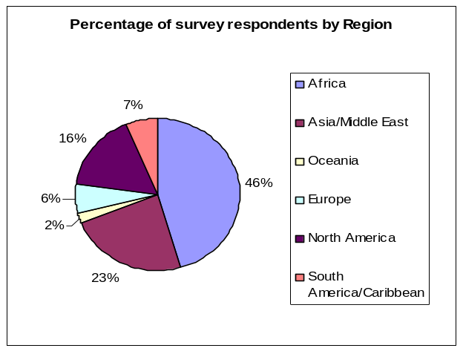
The regional breakdown of survey participants is as follows:
Region | Frequency | Percent
Africa | 175 | 45.6%
Asia/Middle East | 90 | 23.4%
Oceania | 8 | 2.1%
Europe | 24 | 6.3%
North America | 62 | 16.1%
South America/ Caribbean | 25 | 6.5%
Total | 384 | 100.0%

The most frequent region of origin cited was Africa (45.6%), followed by Asia and the Middle East (23.4%), then by North America (16.1%). Fewer respondents indicated South America and the Caribbean (6.5%), Europe (6.3%), or Oceania (2.1%) as their region of origin.

The regional makeup of the TIG membership as a whole is as follows: Africa (23.7%), Asia (21.2%), Middle East and North Africa (7.2%), Oceania (4.4%), Europe (12.3%), North America (34%), South America, Central America, and the Caribbean (5.5%), and the Polar Regions (0.1%). Survey respondents were therefore not representative of the overall regional makeup of the TIG online memberships, since there were proportionately twice as many respondents from Africa and about half as many respondents from North America and Europe compared to the general TakingITGlobal membership.

Survey Participants by Sex and Region

Region | Male |  | Female
Region | Frequency | Percent | Frequency | Percent
Africa | 143 | 81.7% | 32 | 18.3%
Asia/Middle East | 64 | 71.1% | 26 | 28.9%
Oceania | 2 | 25.0% | 6 | 75.0%
Europe | 8 | 33.3% | 16 | 66.7%
North America | 25 | 40.3% | 37 | 59.7%
South America/Caribbean | 11 | 44.0% | 14 | 56.0%

When further breaking down the demographic data by both region and sex, we noticed that a large majority of survey respondents from Africa and Asia and the Middle East were male, as opposed Oceania, Europe, North America, and South America and the Caribbean, where the majority of participants were female. | 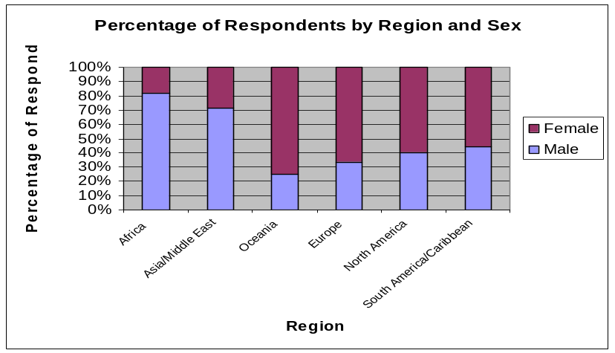

In comparison to the TIG membership as a whole (see table below), some of the regions are more or less representative of the overall membership (Africa, Asia and the Middle East, and North America) while others are not (Oceania, Europe, and South America/Caribbean).

 | Males | Females
Africa | 75.3% | 24.7%
North Africa/Middle East | 70.6% | 29.3%
Asia | 66.9% | 33.1%
Oceania | 43.8% | 56.3%
Europe | 52.0% | 48.0%
North America | 41.3% | 58.7%
South America/Caribbean | 56.0% | 44.0%
  - Age
The age breakdown of survey respondents is as follows:  The most frequently cited age group was 21-25 (31.8%) followed closely by those between the ages of 26 and 30 (27.9%).  Survey Participants by Sex and Age  It is interesting to note that the majority of respondents for each age group above 20 were male, whereas the majority of both groups ages 20 and under were female. | 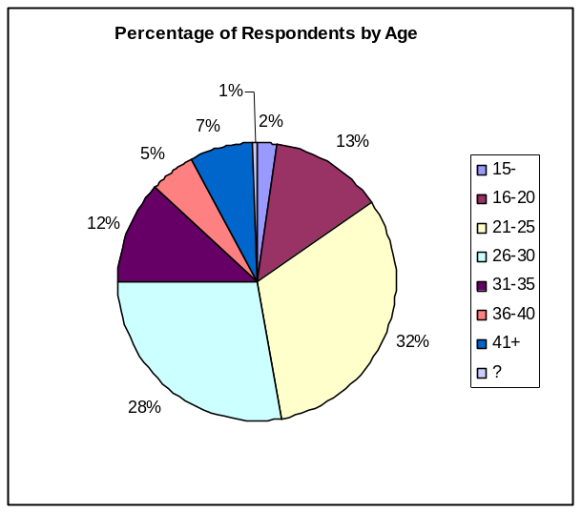  This is largely on par with the age makeup of the TIG membership, which is detailed as follows:  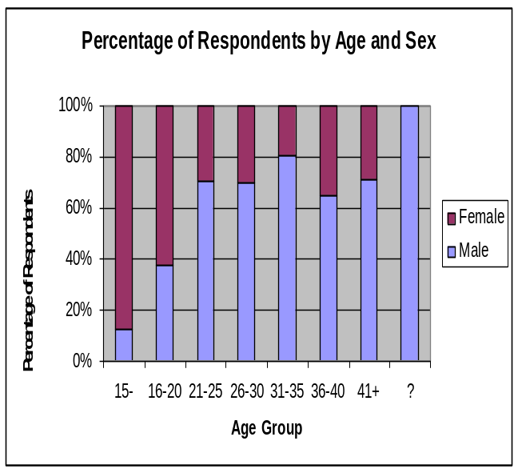
  Age | Frequency | Percent | Valid Percent
  15- | 8 | 2.1% | 2.1%
  16-20 | 51 | 13.3% | 13.4%
  21-25 | 122 | 31.8% | 31.9%
  26-30 | 107 | 27.9% | 28.0%
  31-35 | 46 | 12.0% | 12.0%
  36-40 | 20 | 5.2% | 5.2%
  41+ | 28 | 7.3% | 7.3%
  Missing | 2 | 0.5%
  Total | 384 | 100.0% | 100.0%
   | Male |  | Female
  Age | Freq. | Percent | Freq. | Percent
  15- | 1 | 12.5% | 7 | 87.5%
  16-20 | 19 | 37.3% | 32 | 62.7%
  21-25 | 86 | 70.5% | 36 | 29.5%
  26-30 | 75 | 70.1% | 32 | 29.9%
  31-35 | 37 | 80.4% | 9 | 19.6%
  36-40 | 13 | 65.0% | 7 | 35.0%
  41+ | 20 | 71.4% | 8 | 28.6%
  ? | 2 | 100.0% | 0 | 0.0%
  Age | Percent
  15- | 5%
  16-20 | 13.9%
  21-25 | 24.6%
  26-30 | 26.4%
  31-35 | 13.9%
  36-40 | 7.6%
  41-60 | 10.2%

- RESULTS AND DISCUSSION BY SECTION

The survey results will be presented in 4 sub-sections, as they were broken down in the survey. There will also be discussion of the results in each sub-section, and more general discussions will be presented in the next section of this report.

  - Expanding Networks and Connections

This section of the survey asked members to rate their experience in making connections and expanding their networks through the TIG online community.

    - Quantitative Results

Survey participants were given 4 statements about their experience with networking within TakingITGlobal.org. They were asked to indicate for each statement whether they strongly agreed, agreed, disagreed, strongly disagreed, or didn’t know. The results are indicated below in graph format.
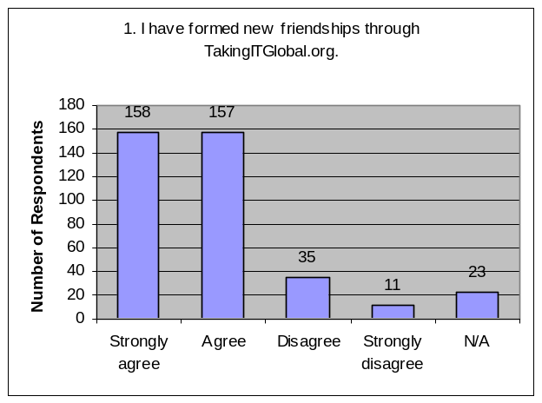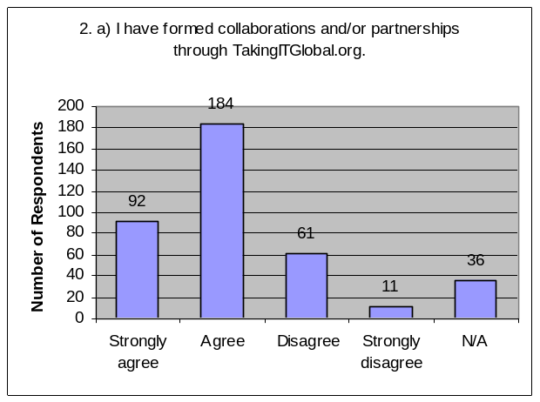
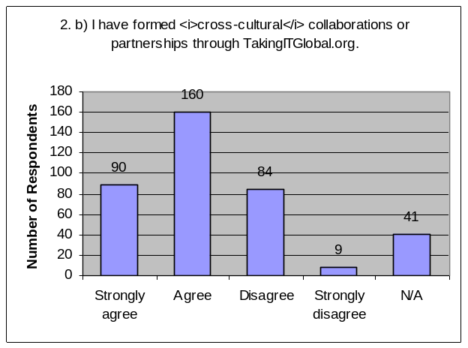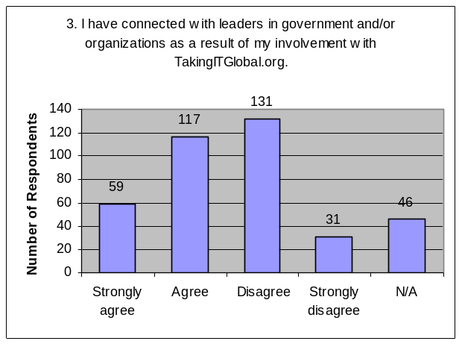

The following table illustrates the percentage of respondents who agreed (those who responded “strongly agree” or “agree”) and disagreed (those who responded “strongly disagree” or “disagree) with each question:

Statement | Agree | Disagree
1. I have formed new friendships through TakingITGlobal.org. | 82.0% | 12.0%
2. a) I have formed collaborations and/or partnerships through TakingITGlobal.org. | 71.9% | 18.8%
2. b) I have formed cross-cultural collaborations or partnerships through TakingITGlobal.org. | 65.1% | 24.2%
3. I have connected with leaders in government and/or organizations as a result of my involvement with TakingITGlobal.org. | 45.9% | 42.2%

In addition, participants were asked whether they had contacted an organization listed in the TakingITGlobal.org organizations database. Out of 384 respondents, 221 (57.6%) responded that they had, while 163 (42.4%) stated that they had not.

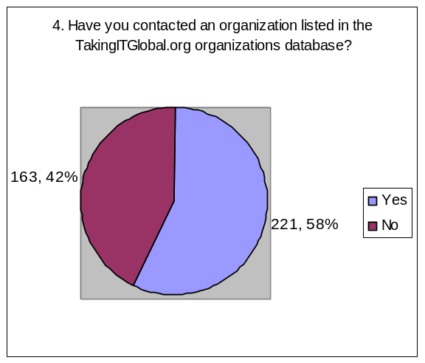

Rough comparisons to 2004 Member survey
Statement (in 2004 survey) | 2004 (% of strongly agree) | 2008 (% of strongly agree)
I have made new friends as a result of TakingITGlobal (compared with Q. 1 in 2008 survey) | 25.5% | 41.1%
I have created a partnership or collaboration with others in the TakingITGlobal network (compared with Q. 2-a in 2008 survey) | 15.3% | 24.0%
I have connected with leaders in my local community, region or country as a result of TakingITGlobal (compared with Q. 3 in 2008 survey) | 13.8% | 15.4%

    - Qualitative Results

Survey respondents were also provided with the chance to voice any comments or suggestions that they had about TIG’s impact in the area of expanding networks and connections.

Reoccurring Themes
Positive | Negative | Suggestions
- Global connections (22)  - Sharing experience and knowledge and exchanging ideas and services (21)  - Connecting to organizations (12)  - Developing personal relationships (making friends) (13)  - Improving professional performance or networks (9)  - Local connections (4)  - Increase visibility or membership of own initiative (4)  - Offline meetings (3)  - Fostering unity (3)  - Telling friends about TIG and having friends join network (3) | - Discrepancies between online information and offline real status/activity (organizations and members) (8)  - Time constraints or limited effort (6)  - No encouragement from TIG to be more active on site (4)  - Older members less at ease (4)  - Looked but hasn’t found partners (3)  - Language barrier to interacting with other members (3) | - More promotion of TIG in local regions (10)  - More updates, communication, and encouragements from TIG staff or TIG as an organization (8)  - More user-friendly interface (7)  - Have TIG recommend partnerships or collaborations between members or organizations or groups (6)  - Between developed and developing (2)  - Country/region-based volunteers, coordinators, or chapters (6)  - Way to verify member or organization (4)  - More information from TIG regarding grant or funding opportunities or organizations (3)  - Expand CLC to other regions (3)  - Develop an IM tool (3)  - Involve more government institutions (2)

The following includes a sample list of quotations from survey participants responding to “Comments or suggestions regarding TakingITGlobal.org’s impact in the area of expanding networks and connections”, selected based on their relevance to reoccurring themes.

I work with Pacific Youth Health in West Auckland and it very important to network to share positive idea to support and help our young people. So it very important to me any my role to have a wide network of people, organisation that work with young people in difference part of the world.

TIG has enabled me to connect with very many like-minded youths involved in similar initiatives like me. TIG has also enabled me to learn and share experiences I have based on my work and community development. I have hosted friends who came visiting after having interacted for the first time through TIG. TIG is the best thing that ever happened to my development work as a youth in the 21st century.

Taking It Global is my home away from home where I interact and make new friends. It has immensely increased the visibility of NAYA Kenya chapter. All organisations should start a massive campaign to inform other young people about TIG

TIG has given remarkable opportunity for organizations and individuals around the world to form one community.

So many organisations have identified with mine as a result of our membership with TIG and [the] network is so strong and educative. The administration is so unique and organized without prejudice.

The site is great and also the work done, but it need[s] [a] more friendly interface and more encourage[ment] for participants to share in discussion board[s].

It is an excellent forum for expanding one's network and offers plenty of opportunities for the same. Personally speaking, time constraints is a delimiting factor

I believe TIGlobal has to do more effort in [establishing] personal relationship[s] with members.

It is not easy to be considered when contacting people or organization through the internet due to the fear of scam. So if TIG could verify the identities of some members. It should be very well if TIG could have local chapter in each country made of volunteers.

Have country based volunteers/coordinators for TakingITGlobal.org

I think to expand networks the overall look of our site needs to appeal to a wider audience. The content itself is great! But how do we package it in a more user friendly way?

Perhaps a way of generating suggested networks. For instance if I have a group about sustainability then TIG could suggest that my group network with another group about sustainability. Kind of like an online
match-making service for groups instead of individuals.

I think TIG has been doing a lot in that regards and more needs to be done at least to carry along her member[s] and by keeping them updated on relevant issues of interest that will educate and encourage her members in their various drive towards making the world a better place to be

Now that I'm not exactly a youth anymore (i.e. I'm above the age of 30) yet I still am interested in socio-economic initiatives, I look forward to TIG also making causes/advocacies across any age group more searchable, so people understand caring about the world is not just a youth thing but a lifelong thing that can have great foundations in youth & IT such as through TIG

TakingITGlobal is excellent to interact with new friends spread books, music, humanity help, travel. For example, I receive a lot of comments about my texts, mainly poetry. But I don't speak or write in other languages, so I find some translation site to help me. (Translated from Portuguese)

    - Discussion

General
In terms of connecting youth to each other and to organizations from around the world, TIG’s impact seems to be quite strong. The online community seems to be particularly conducive to fostering personal relationships among TIG members, with 82.0% of survey respondents agreeing to having made friends through TIG. TIG’s impact in terms of fostering professional relationships and partnerships between TIG members also appears to be strong (71.9% of survey respondents formed partnerships or collaborations through TIG, with 65.1% forming cross-cultural partnerships), although somewhat less so compared to personal relationships. It is also interesting to notice that with Q. 1 (making friends on TIG), there were roughly the same number of respondents who chose “strongly agree” (158) and “agree” (157), while for questions 2-a and 2-b, the number of respondents who strongly agreed (92 and 90, respectively) was significantly lower than the number of respondents who simply agreed (184 and 160, respectively), suggesting again that TIG’s impact at fostering personal relationships is stronger than its impact at encouraging professional partnerships.

TIG’s impact in terms of connecting members to organizations or world leaders was less evident. Only a small majority of survey respondents (57.6%) had contacted an organization listed in the TIG database, while only 45.9% of survey respondents agreed with the statement that they had connected to leaders in government and/or organizations (42.2% disagreed). This could be due to the fact that organizations and world leaders are less well integrated into the online community (or in some cases, not at all integrated).

Correlation
The correlation data showed a strong correlation between all possible pairs of questions 1, 2-a, 2-b, and 3. The correlation was strongest between questions 1 (making friends) and 2-a (forming collaborations), and between questions 2-a and 2-b (forming cross-cultural collaborations), the latter of which was expected from just looking at the aggregate data itself. This suggests that members who make friends through TIG also tend to seek out and find partners for through TIG.

Comparison to 2004 Member Survey
Roughly comparing the results to those of the 2004 member survey, the percentage of respondents who strongly agree that they have made friends through TIG has increased by about 15%, and the percentage of respondents who have formed collaborations through TIG has increased by about 9%. However, there is no significant difference with the statement regarding connecting to leaders, although it must be noted that these two questions were worded differently between the 2004 and the 2008 survey.

Variance by Demographic Groups

Variance by Region
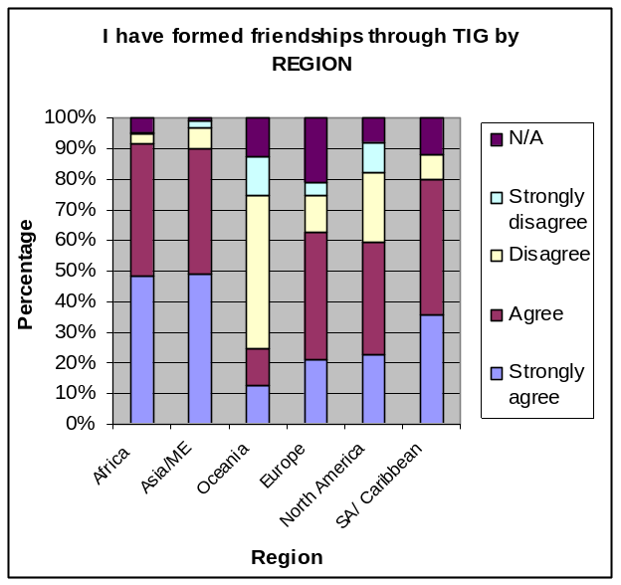
Variance between regions was significant for questions 1 (making friends), 2-a (forming collaborations), and 4 (contacting an organization), and particularly so for question 1. Respondents from Africa, then Asia and the Middle East, then South America and the Caribbean tended to agree more often that they had made friends through TIG, found partners on TIG, or contacted an organization in the TIG databases, while respondents from Europe, North America, and Oceania seemed to feel much less of an impact in these areas. There was no significant variance for questions 2-b (cross cultural collaborations) and 3 (connections to leaders in government and/or organizations).
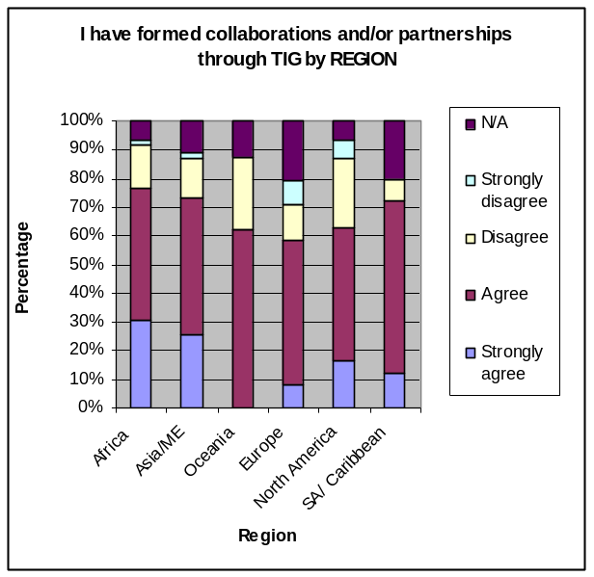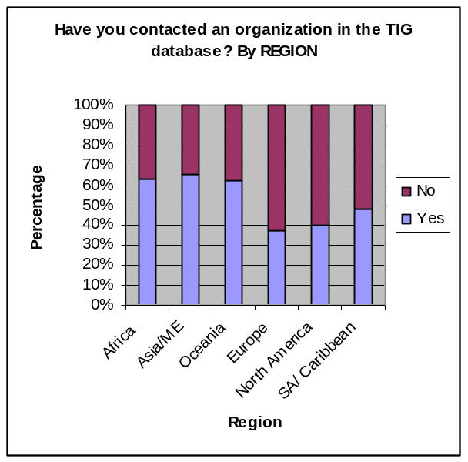

Variance by Age
When it came to variance by age, TIG’s impact was significantly stronger across the board in this section for age groups between 21 and 35 for questions 1 (forming friendships), 2-a (forming collaborations), and 4 (contacting organization in the TIG database). The variance was not statistically significant for question 2-b (forming cross-cultural collaborations).
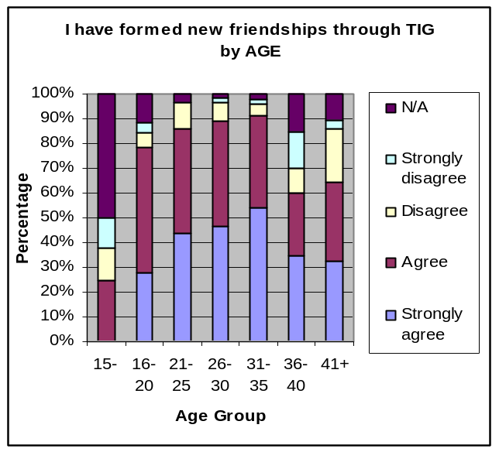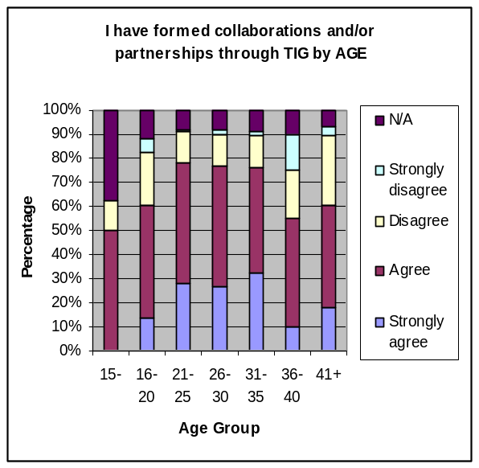
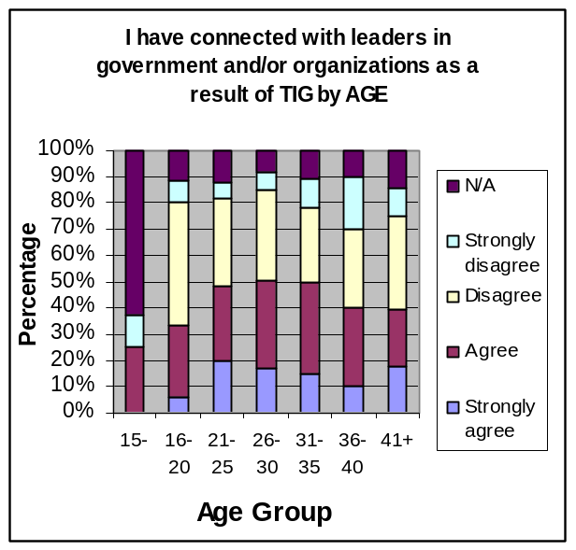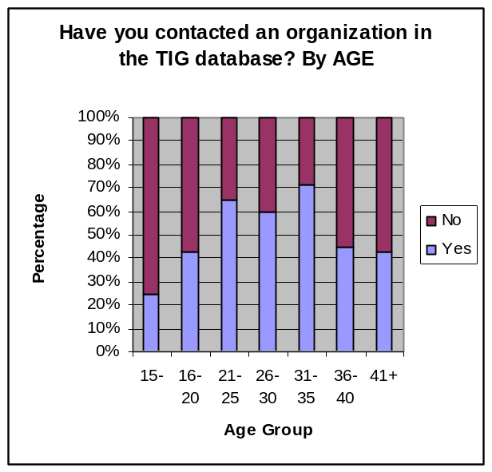

Variance by Sex
TIG also seemed to have a greater impact for male respondents as opposed to female respondents in some areas. Variance was significant for questions 1 (making friends), 3 (connections to leaders), and 4 (contacting an organization), and not significant for both questions on forming collaborations.
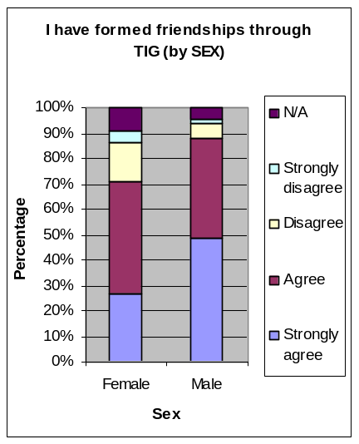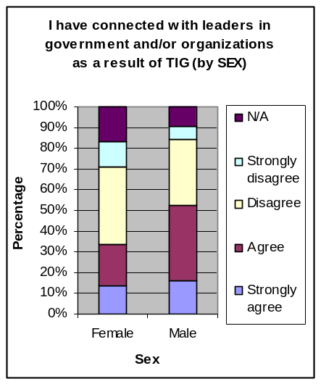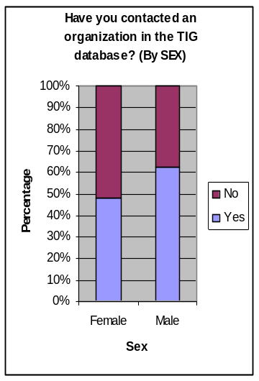

Discussion on Comments and Suggestions
When it came to the comments and suggestions, many respondents noted that networking on TIG was useful for sharing experiences and knowledge and exchanging ideas and services with other members. Respondents also mention connecting to organizations as important. Respondents also commented on developing personal relationships and making friends through TIG, as well as establishing professional relationships and using TIG to improve work-related performance. The concept of establishing “global connections” was mentioned much more often than connecting with others in the same community, city, or even country (this corroborates with the data – 71.9% claimed to have formed collaborations through TIG, while 65.1% claimed to have made cross-cultural collaborations). It could be that survey respondents are more enthusiastic about using TIG to connect internationally as opposed to locally, or regionally, or it could be that there are not many active youth connected on TIG in their own communities. In addition, a few participants commented on the TIG network giving their work and/or initiatives international visibility, which seemed to be a very motivating factor.

Several respondents expressed a concern for discrepancies between online information on TIG and the offline reality, both with respect to other members and organizations, which they felt impeded on network development. While some respondents pointed to members and organizations making their own work and initiatives look more impressive than they actually are, other respondents expressed frustration at organizations who are doing great work on the ground but who are not sharing their progress on TIG. Several respondents also acknowledged TIG’s potential as a connecting tool, but admit to not having the time or not wanting to put in the effort. Interestingly, respondents also commented on a lack of encouragement from TIG’s part, and older (over 30 years of age) members also commented on being less at ease on the site.

Respondents suggested increasing the promotion of TIG in their region or country to entice so that they can further expand their local networks, as well as making the site more user-friendly (although the “what” and the “how” of user-friendly was never specified). Quite a few respondents also suggested that TIG send out more updates and provide more communication and encouragements to TIG members, or give members, groups, and organizations recommendations on possible partners. Respondents also asked for country or region-based volunteers, coordinators, or TIG chapters (or to expand CLC to other parts of the world), a way to verify members or organizations to avoid scamming (or embellishments), more information on funding opportunities, involving government institutions on TIG more, and an instant messaging or live chat tool on TIG to more easily communicate with members online. In addition, a few members who participated in the Arabic and Portuguese surveys commented on the language barrier impeding direct member interaction.

Overall, the majority of comments in this section were overwhelmingly positive and encouraging of TakingITGlobal. It seems that TIG’s impact in connecting members to each other, both personally and professionally, has been quite strongly felt. The online community’s impact in terms of connecting members with organizations and world leaders, while somewhat less significant, still represented a majority. In terms of connecting members to leaders in government and organizations, TIG’s impact is more questionable. How important is it to be connected to local, national, or international leaders in terms of effecting change?

  - Inspiration and Empowerment

    - Quantitative Results

This section asked survey participants 6 questions regarding the extent of TIG’s impact in their lives in terms of providing inspiration, support, and encouragement, as well as fostering positive behavioural or attitudinal change. Respondents were asked to choose from the following scale: “not at all”, “to a small extent”, “to a moderate extent”, “to a large extent”, “to a very large extent”, and “don’t know”. The results are shown below in chart format.

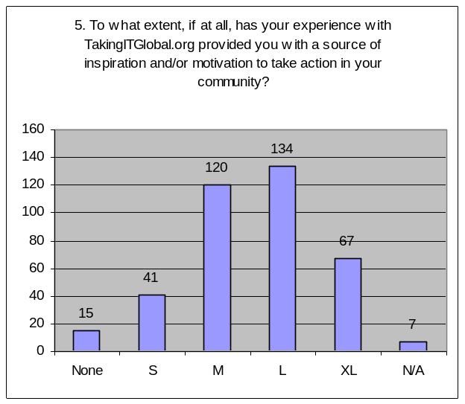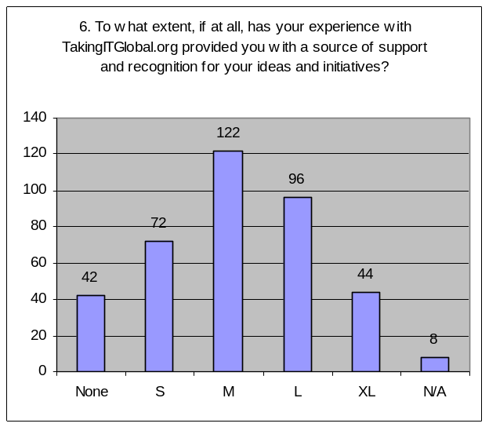

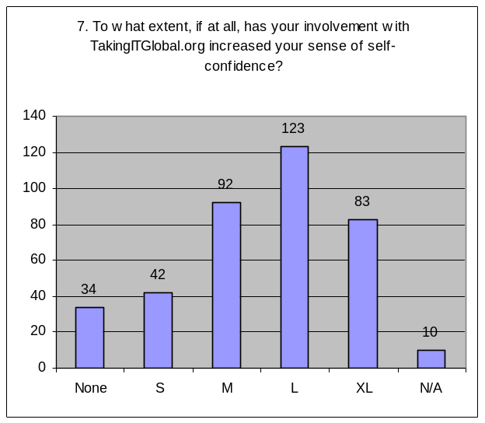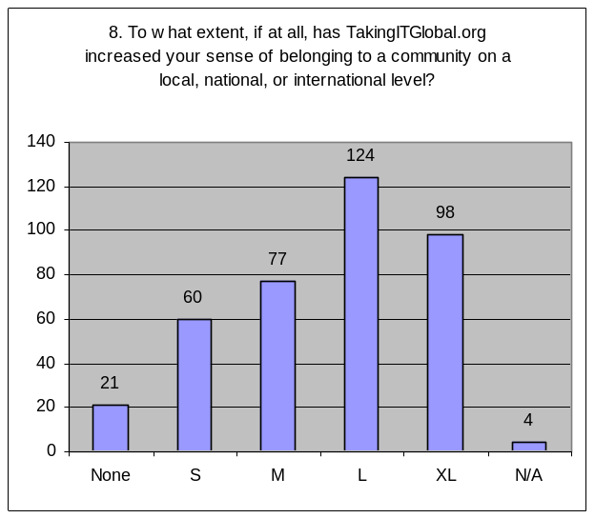

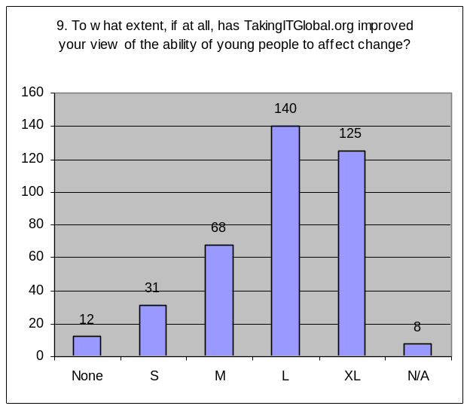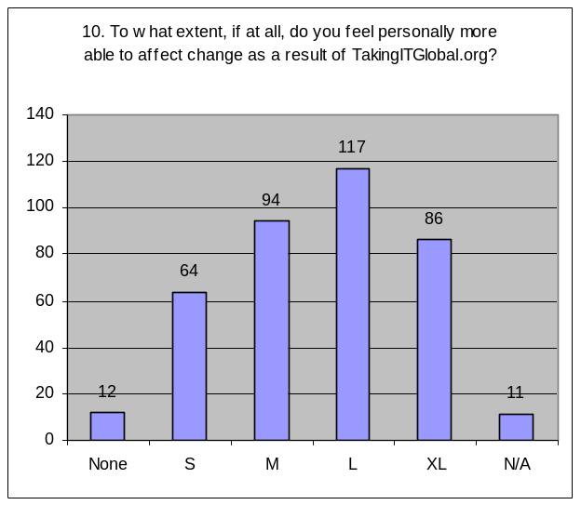

The following table illustrates the percentage of respondents who felt that TIG had a little or no impact (those who responded “not at all” or “to a small extent”) and those who felt that TIG had a strong impact (those who responded “to a large extent” or “to a very large extent”):

 | To little or no extent | To a large or very large extent
5. To what extent, if at all, has your experience with TakingITGlobal.org provided you with a source of inspiration and/or motivation to take action in your community? | 14.6% | 52.3%
6. To what extent, if at all, has your experience with TakingITGlobal.org provided you with a source of support and recognition for your ideas and initiatives? | 29.7% | 36.5%
7. To what extent, if at all, has your involvement with TakingITGlobal.org increased your sense of self-confidence? | 19.8% | 53.6%
8. To what extent, if at all, has TakingITGlobal.org increased your sense of belonging to a community on a local, national, or international level? | 21.1% | 57.8%
9. To what extent, if at all, has TakingITGlobal.org improved your view of the ability of young people to effect change? | 11.2% | 69.0%
10. To what extent, if at all, do you feel personally more able to effect change as a result of TakingITGlobal.org? | 19.8% | 52.9%

    - Qualitative Results

Survey respondents were also provided with the chance to voice any comments or suggestions that they had about TIG’s impact in the area of providing inspiration and empowerment.

Reoccurring Themes
Comments | Suggestions
What inspires and motivates members to take action?  - Specific members’ or groups’ experiences, success stories, achievements, struggles, realities, personal viewpoints (15)  - Network itself with youth from around the world who care and who are working to make change happen (11)  - Information, resources, and opportunities available (8)  - Recognition, plus work and opinions being showcased to international audience (Panorama) (6)  - Feeling “not alone”, solidarity (5)  - Member stories (3)  - Members directly providing inspiration and motivation (2)  Inspires to do what  - Continue with goals and initiatives (never quit) (12)  - Make own change, start own initiative (6)  - Dream (anything is possible) (2) | - More capacity building opportunities (workshops, seminars, trainings) to empower and increase confidence (7)  - Physical TIG encounters/meetings (5)  - More accounts of what members are doing (showcasing of youth role models), more exchange and sharing of ideas (3)  - Grants, funding to support youth projects (3)  - More communication with members (e.g. quote of the week, etc) to empower and encourage (2)
 | Other
- Developing world more greatly impacted (info, ICT access) (8)
- Isolation between super-activists and non-activists (disconnect between “idealists” and “realists”) (3)
- Introduce in schools and universities (2)

The following includes a sample list of quotations from survey participants responding to “Comments or suggestions regarding TakingITGlobal.org’s impact in the area of providing inspiration and empowerment”, selected based on their relevance to reoccurring themes.

TIG inspires young people do make a difference. It really does! It helps you by showing you that all over the world there are a lot of people working on projects, developing them or expressing their opinion about global issues. You feel like you are not alone.

Taking it global is just a resource of its own kind. I applied for the vacancy of GYCA East Africa Region because of Taking It Global. On world AIDS day, we organised a blood drive along with a friend in Kenya whom we only met at TIG. The event was very successful. My articles at Panorama have given me an edge with numerous people requesting for more of these. This has greatly inspired and currently I am in a collection and research spree for more articles

Most of the materials obtained from the site and network we have been able to motivate and encourage our youth group. They all have access to the site and are very happy on the materials they receive from the other members.

KNOWING HOW OTHERS AFFECT OTHER PEOPLES LIVES THROUGH VOLUNTARISM, HELPED ME START UP ONE WITH SUPPORT, HELP AND MOTIVATION FROM TAKING IT GLOBAL MEMBERS

For inspiration and empowerment the many stories of TakingITGlobal members that are published on their site, have given like minded people more motivation to wake up be positive in there undertaking.

I’ve read a lot of success stories, struggles and personal viewpoints of the members... this empowered me as a youth knowing that I am not alone in conquering fears, dreaming and dreaming BIG and with this I am inspired and motivated go beyond the what I can see... to extend my horizons and to never quit...life may be about disappointments… but surely, SURPRISES is also at stake...

Happy with discussions and comments that are happening in our website they encourage us people living in developing countries

It would be beneficial, to the youths, if TakingITGlobal would perform role as a platform to enhance capacity and other skill oriented programmes specially in underdeveloped countries

More avenues and fora should be organized and youths from virtually all countries invited to participate and contribute their own quota of educational merit. Also in instances where funds are needed, those without funds who have the capacity and are willing to contribute meaningfully should be granted free participation

Showcasing youth role models and their projects

TIG is a great networking tool but I feel that the members that lack the necessary experience (i.e. international experience) in certain fields may feel somewhat isolated from the members who have engaged in many of these experiences.

    - Discussion

General
When it came to inspiring and empowering TIG members, TIG’s impact was noticeably strong for Q. 9 (improving the view of young people as change agents), which averaged at around 3.9, relatively strong in terms of providing inspiration and motivation, increasing members’ self-confidence and sense of belonging, and improving members’ views of themselves as change agents (averaging at around 3.5 to 3.6 for each question). In terms of providing support and recognition, TIG’s impact was noticeably lower, averaging at 3.07.

A strong majority of survey respondents (69%) felt that TIG improved their view of the ability of young people to effect change to a large or very large extent. (This was also corroborated in the comments and suggestions section with the verbatim comments, where many respondents expressed being inspired by fact that that there were so many youth in the TIG community from all over the world who are passionate and who are making change happen.) A majority, albeit somewhat less significant, of respondents (52.9%) also felt, to a large or very large extent, personally more able to effect change as a result of TIG.

The TakingITGlobal online community also seemed to be effective at increasing members’ sense of belonging (57.8% of survey respondents felt that TIG increased their sense of belonging to a community to a large or very large extent), building self-confidence (53.6% of respondents felt that their involvement with TIG increased their self-confidence to a large or very large extent), and inspiring and motivating members to take action in their own community (52.3%). However, only 36.5% of survey respondents felt that their experience with TakingITGlobal.org provided them, to a large or very large extent, with a source of support and recognition for their ideas and initiatives, while 29.7% felt that this had not occurred at all, or only to a small extent. This less enthusiastic response could be partially due to the relative ambiguity of the question (different types and levels of support and recognition, which was not specified), however, it should be something to keep an eye out for, given the perceived importance of receiving recognition, a reoccurring theme in the comments sections (see Discussion on Comments and Suggestions).

Correlation
There was a particularly strong correlation (x = 0.65) between Q. 7 (self-confidence) and Q. 8 (sense of belonging), suggesting that members feel a stronger sense of connection to their offline or online communities are also likely to have become more self-confident through TIG. There was also a strong correlation (x = 0.58) between Q. 9 (view of young people as change agents) and Q. 10 (view of self as change agent), as expected. It would be interesting, now, to see if and how this correlation coefficient changes in future surveys.

There were also strong correlations between Q. 5 (inspiration and motivation) and Q. 6 (support and recognition), Q. 5 and Q. 7 (self-confidence), and Q. 5 and Q. 10 (view of self as agent of change), suggesting that inspiration and motivation may encourage other positive behavioral or attitudinal changes as well. There was also a strong correlation between Q. 8 (sense of belonging) and Q. 9 (view of young people as agents of change).

Variance by Demographic Groups

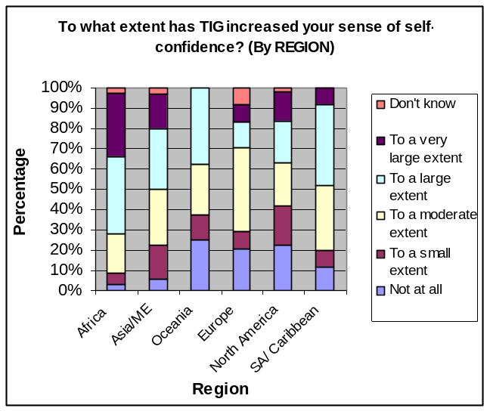
Variance by Region
Respondents from Africa generally felt most positively impacted by TIG in this section, followed by respondents from Asia and the Middle East, and South America and the Caribbean, while survey participants from Europe, North America, and Oceania felt usually that TIG made less of an impact on them in terms of inspiring and empowering them, or encouraging positive attitudinal or behavioural change in them. The variance was most significant for questions 7 (self confidence) and 10 (view of self as change agent). This discrepancy may be due to cultural differences in standard attitudes before TIG (e.g. youth in Europe may have higher levels of self-confidence in general compared to youth in Africa, so interaction with TIG would be more likely to have a bigger impact on the self-confidence of African youth than that of European youth). Interestingly, the only variance that was not statistically significant in this section was for question 6 (support and recognition).
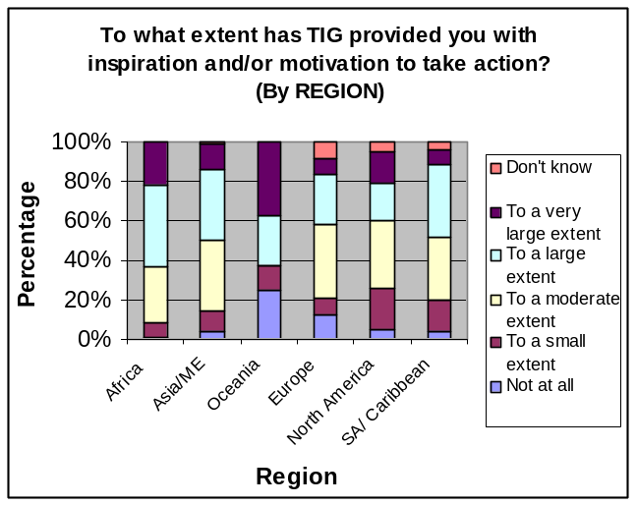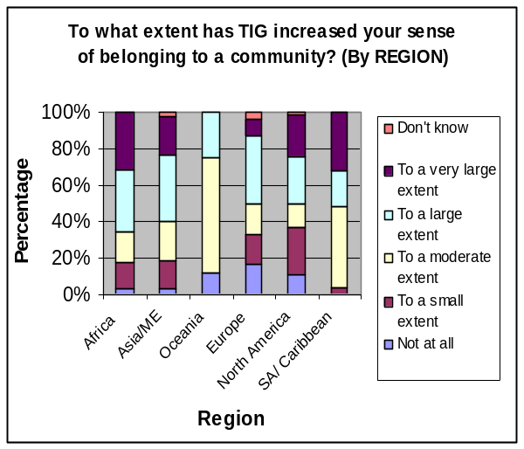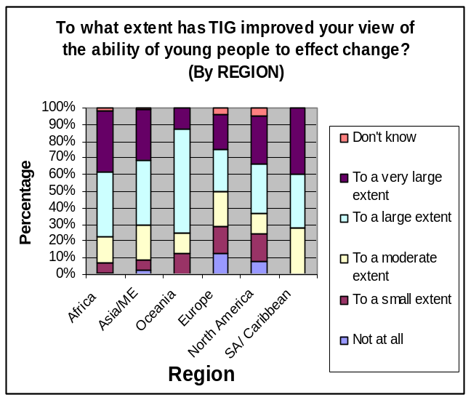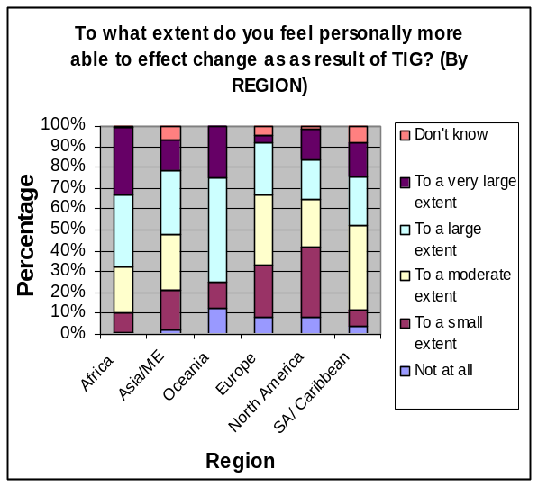

Variance by Age
Variance in this section was only significant for questions 5 (finding inspiration and motivation) and 9 (improved view of the young people as change agents), where TIG’s impact was noticeably stronger with respondents aged between 16 and 35. This is not surprising, as those aged between 16 and 35 make up the majority of TIG’s membership, and thus this age group may be able to better identify with the online community and, as a result, be more deeply impacted.
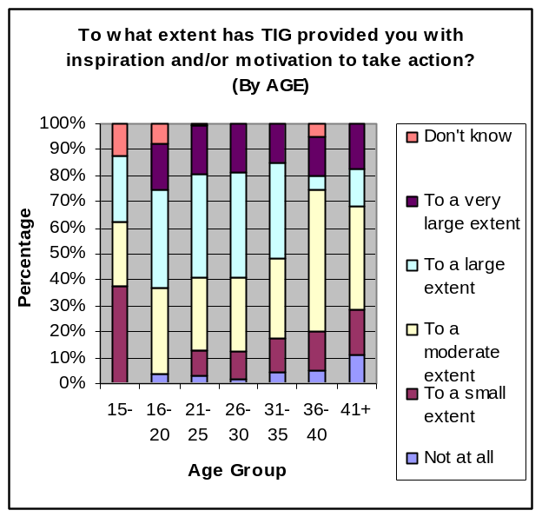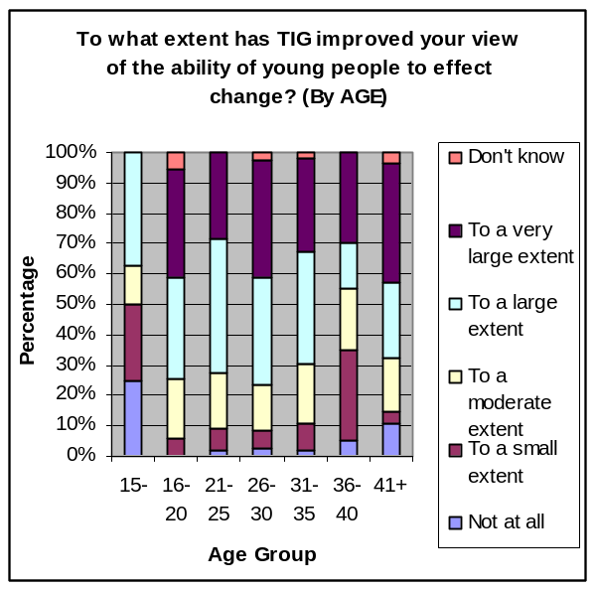

Variance by Sex
While male respondents in general responded more positively in this section, variance between female and male respondents was only statistically significant for question 7 (increased self-confidence) and question 8 (sense of belonging).
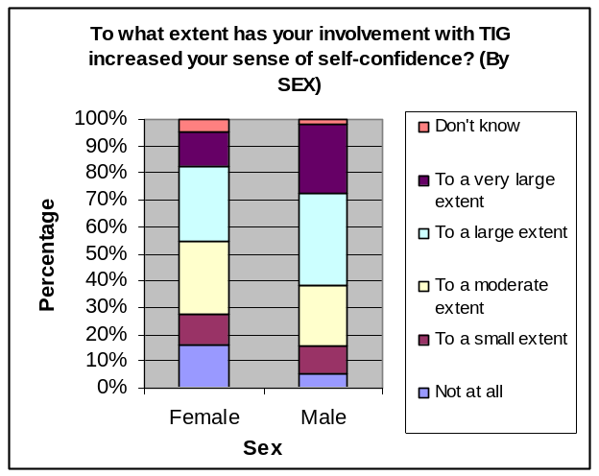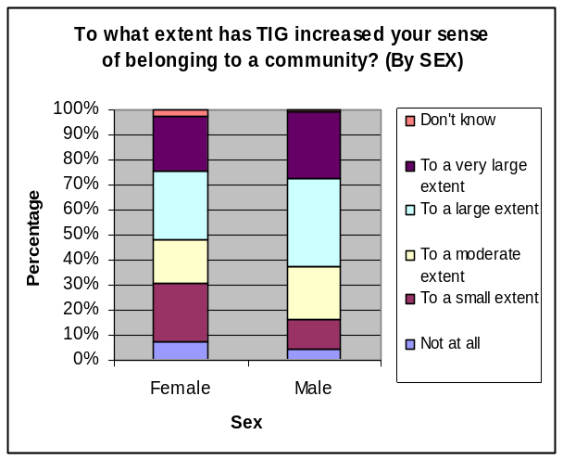

Discussion on Comments and Suggestions
In the comments and suggestions box, survey respondents primarily pointed to other TIG members’ experiences, success stories and achievements, struggles and challenges, and personal viewpoints and opinions as sources of inspiration and motivation for them (there were also a few direct references to Member Stories). They also noted that the idea of the TIG online community itself, where so many international youth who care about the world and who are working to address local and global challenges come together, also inspired and empowered them. In addition, survey respondents found that the plethora of information, resources, and opportunities available on the site were also conducive to producing positive changes in attitude.

Recognition was also cited several times as a motivating factor for survey respondents: the fact that their works and opinions were being showcased to a global audience of active youth seemed to be an empowering factor for them. By being a part of the network, several participants felt an increased sense of solidarity. It is, however, interesting to note that only 2 survey respondents commented on having received direct motivation or recognition from other TIG members, while a significant number of the “active” members with whom we spoke in one-on-one in-depth interviews mentioned direct messages of appreciation or recognition by fellow TIG members as an important factor in motivating them to continue their work. (This could potentially illustrate why TIG’s impact was comparatively less significant for Q. 6 regarding support and recognition: while the potential of recognition is there with international exposure to TIG’s network, direct expressions of support and appreciation may be less common.)

In terms of how survey respondents acted after being inspired and empowered through TIG, many commented on being motivated to continue, sustain, or work harder on their own initiatives on the ground (to “never quit”), while others were inspired to make their own change by creating their own initiative or launching themselves into existing initiatives.

There were several reoccurring suggestions in this section: survey participants wanted to see more capacity building workshops, trainings, opportunities, etc. to further empower youth and youth-led initiatives, more physical TIG encounters or meetings, more grants or funds for youth-led initiatives, more exchange of ideas and best practices (showcasing youth role models and their projects), and more motivational communication from TIG.

Two interesting themes also popped up from the comments and suggestions. First, a fair number of survey respondents commented on TIG’s impact being more significant in developing countries (the global “South”) and some wished to see more region-focused strategies. Another interesting theme that emerged (although to a lesser scale) was that there seemed to be some disconnect between two groups of TIG members: the activists and the non-activists (those who were logging onto the site just to enlarge their social networks, express themselves, etc.). It would be interesting in the future to find out how significant this disconnect or isolation is, and how it could be bridged (or even if it needs to be bridged).

Lastly, there were a few unique points of interest. One respondent suggested that TIG needed to find new and innovative ways to attract youth and sponsors and felt that TIG members themselves should have more say in TIG’s evolution and development (brainstorming session with TIG members, for example). Another member mentioned that TIG needed to be “decentralized”, although he did not elaborate any further on what this entailed. Interestingly, another participant felt that TIG needed to make a concerted effort to supervise, review, and rate projects and organizations in order to motivate them to keep their pages updated and accurate.

  - Information and Expression

    - Quantitative Results

This section asked survey participants 6 questions regarding the extent of TIG’s impact in their lives in terms of providing information to further awareness, learning, and skill development, as well as providing a platform for self-expression and the exchange of ideas and best practices. Respondents were asked to choose from the following scale: “not at all”, “to a small extent”, “to a moderate extent”, “to a large extent”, “to a very large extent”, and “don’t know”. The results are shown below in chart format.

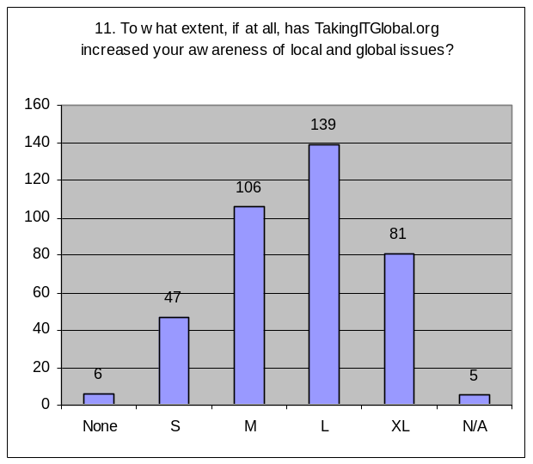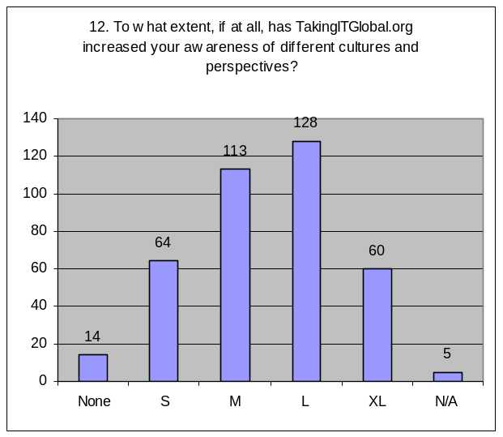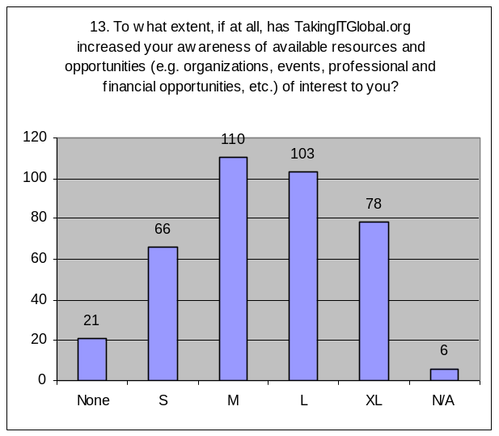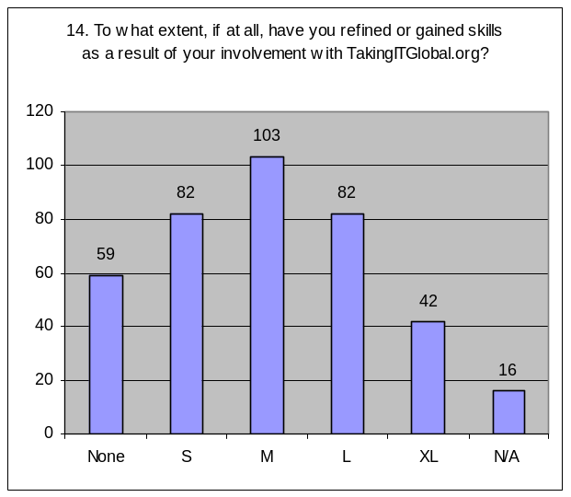
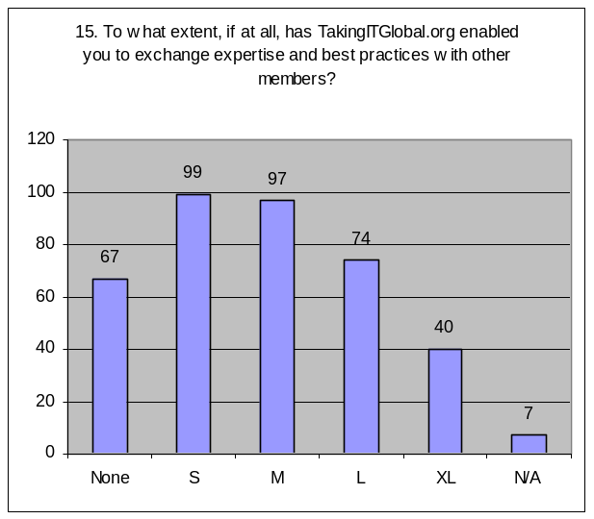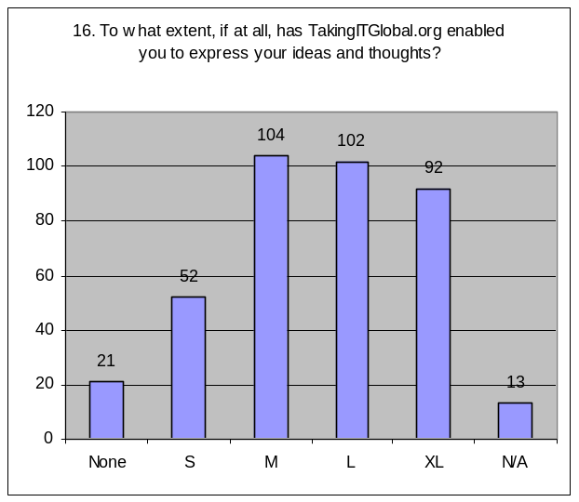

The following table illustrates the percentage of respondents who felt that TIG had a little or no impact (those who responded “not at all” or “to a small extent”) and those who felt that TIG had a strong impact (those who responded “to a large extent” or “to a very large extent”):

 | To little or no extent | To a large or very large extent
11. To what extent, if at all, has TakingITGlobal.org increased your awareness of local and global issues? | 13.8% | 57.3%
12. To what extent, if at all, has TakingITGlobal.org increased your awareness of different cultures and perspectives? | 20.3% | 49.0%
13. To what extent, if at all, has TakingITGlobal.org increased your awareness of available resources and opportunities (e.g. organizations, events, professional and financial opportunities, etc.) of interest to you? | 22.7% | 47.1%
14. To what extent, if at all, have you refined or gained skills as a result of your involvement with TakingITGlobal.org? | 36.7% | 32.3%
15. To what extent, if at all, has TakingITGlobal.org enabled you to exchange expertise and best practices with other members? | 43.2% | 29.7%
16. To what extent, if at all, has TakingITGlobal.org enabled you to express your ideas and thoughts? | 19.0% | 50.5%

    - Qualitative Results

There were 2 qualitative questions in this section. Question 14-b asked members to specify what skills they had gained or refined as a result of their involvement with TIG, if applicable. The following table and graph illustrate the most commonly cited skills.

Skill | Frequency
Communication skills | 58
ICT-related skills | 24
Writing and editing skills | 24
Networking skills | 23
Job or interest-specific skills and knowledge | 19
Project or organization coordination and management skills | 17
Leadership and/or entrepreneurial skills | 16
Advocacy and/or engagement techniques | 16
Global awareness and cultural sensitivity | 14
Organization and planning skills | 13
Language skills and translation skills | 11
Research skills | 7
Public speaking skills | 6
Critical thinking | 5
Teamwork skills | 4

Survey respondents were also provided with the chance to voice any comments or suggestions that they had about TIG’s impact in the area of providing resources for information and self-expression.

Reoccurring themes
Comments | Suggestions
Importance of TIG resources for information and self-expression:  - Offering freedom of expression and fostering creativity (13)  - International visibility and exposure (making local/personal experience global) (6)  - Learning  - From TIG content (7)  - From other members and member content (ideas, opinions, global awareness and sensitivity) (19)  - Prompting or supporting action on the ground (5) | - More content and opportunities (especially educational and financial) (8)  - Communicate opportunities via list-serve/email (have TIG be more proactive) (5)  - Difficulty identifying relevant resources – have easier way of sorting through information (5)  - Be more aware of lack of ICT access in the Global South and react accordingly (resources for orgs on the ground, more physical events, more best practices featuring youth from South working with ICTs, etc.) (5)  - More multilingual functions (not just TIG content, but member content too) (2)

The following includes a sample list of quotations from survey participants responding to “Comments or suggestions regarding TakingITGlobal.org’s impact in the area of providing resources for information and self-expression”, selected based on their relevance to reoccurring themes.

This is the central part of what I use TIG for. It's useful for providing information on my interests, skills, abilities to others. I enjoy the blogs, galleries, and forums as a source for self-expression and information. The Issues pages are useful sources of information--I was just on one last night looking up resources for climate change.

In Taking It Global you learn a lot by saying and writing what you wanna say but also by reading what all the people from the world want to communicate. It helps you getting information from places that are far away by land but very close by the web.
The fact is that the variety of outlets available offer many opportunities, in different ways, to offer information and personal ideas and concerns. Our project includes the word “Mentor." Mentors teach one another, and that is basically what TIG permits, encourages, fosters, etc."

The projects, events, and groups pages are things I bring up at every meeting I go to now. They are innovative and ground-breaking materials that allow you to create your own design for your initiative.

I have seen how sheltered we are in America by personally talking to others from around the world. (A great experience)

The Team managing the site have inspired me into fine-tuning my writing skill (courtesy of Panaroma ). This online community provides for every young people a golden opportunity to be heard and makes one visible to others. My life has literally changed from good to better and keep gravitating for the best daily. I have set up a site to network young people in community, check: www.youthstrategists.ning.com, and every member of this unique community from my locality will be introduced to the 'TIG' site.

TakingITGlobal has help me a lot in broadening my horizon and also help to gain resource for my organization which has help me able to express my self more to other members and friends

TIG would better meet the needs of its members if events and financial opportunities were sent our through a mailing list. Youths from the Global South with limited internet access usually get some of these opportunities very late to effectively react. The problem of resource mobilisation not with standing. Alerts are not sent out, when posted they are late.

Please provide more information and create connections with educational institutes. Young people are willing to learn, so, if you can help them with promoting their chances of education such as workshops, meetings, conferences and scholarship opportunities.

We have problems due to remoteness of some of our members who cannot get access to computers and network. Site to increase the events which are very helpful for contact discussions and experience sharing.

It is all very good on how much information you have but you should have a place where you can go (on the website) that would give you give you a list on what type of information you could get! Please explore on that thought!

Providing information no doubt is very essential but Helping youths manage and properly utilize the information provided is another greater challenge. TIG can seek for ways to integrate other sources of information into the site while moderating content on the site and an easy way to navigate / browse through information

There are plenty of information and resources, the only problem is to know how those materials can reach many people, especially no ICT youth. For example young people who can have access to ICT are less than 5% in my country.

    - Discussion

General
In terms of providing information and an area for self-expression, TIG’s impact is strongest at increasing respondents’ awareness of local and global issues (57.3% choosing top 2 selections, and only 13.8% choosing bottom 2 selections). A small majority of respondents (50.5%) also felt that TIG enabled them, to a large or very large extent, to express their ideas and thoughts, while only 19.0% felt that this had been accomplished to little or no extent.

When it came to informing members about different cultures and global perspectives, and resources and opportunities, TIG’s impact was still quite noticeable, although it was not as strong as when it came to informing members about important issues. Just under a majority of respondents (49.0%) felt that TIG increased their awareness of different cultures and perspectives to a large or very large extent, and a similar portion of respondent (47.1%) believed that TIG increased their awareness of resources and opportunities to a large or very large extent.

The online community had less impact when it came to building the skill-sets of its members (only 32.3% felt that they gained or refined skills to a large or very large extent through TIG, while 36.7% believed TIG did not help them to build skills, or only to a small extent). This may be due to respondents already possessing notable skills before coming into the online community.

What was most surprising was the response to question 15, regarding the sharing of expertise and best practices on TIG. Only 29.7% of respondents felt that TIG enabled them to exchange expertise and best practices to a large or very large extent, while 43.2% believed that TIG did not facilitate this at all, or only to a small extent. While the response could be due to the wording of the question (“expertise” and “best practices” were not defined), it is somewhat alarming that methodologies, strategies, and actions conducive to producing positive results on the ground are not being shared extensively on the TIG online community.

Correlation
There was a strong correlation (x = 0.59) between question 11 (awareness of local and global issues) and question 12 (awareness of different cultures and perspectives), suggesting that global awareness and cultural understanding occurs somewhat in tandem on TIG.

There was also a strong correlation (x = 0.64) between question 14 (skills) and question 15 (exchange of expertise and best practices). Since the impact of TIG for both questions was quite low, this correlation suggests that respondents who did not feel that they refined or gained skills through TIG also generally did not feel that TIG enabled them to exchange expertise and best practices. One could speculate from this correlation that the relative ambivalent survey response with respect to TIG’s impact at increasing the skill-sets of its members may not have been overwhelmingly due to a significant number of TIG members coming into the community with already a strong set of skills (since these individuals would have some expertise already and would, hopefully, be open to sharing their best practices).

There was also a strong correlation (x = 0.58) between questions 15 and 16, suggesting a link between TIG’s impact at enabling the exchange of expertise and best practices and its impact at enabling the expression of ideas and thoughts. Although, in theory, this correlation makes sense, the result was somewhat puzzling, since TIG’s impact as measured from question 16 was noticeably greater than its impact for question 15. (This could potentially be due to respondents choosing the median point, “to a moderate extent” for both questions).

The correlation coefficient between question 7 (self-confidence) and 11 (awareness of issues) was also strong, as was the coefficient for questions 7 and 14 (skills), 15 (best practices), and16 (self-expression), suggesting that members who gain confidence through TIG also gain knowledge and skills and express themselves through TIG. There were also strong correlations between question 6 (support and recognition) and questions 15 (best practices) and 16 (self-expression), which implies that members who feel appreciated and supported by the TIG community generally also exchange expertise and express their ideas and thoughts to a greater degree. Interestingly, there was a strong correlation between question 8 (sense of belonging to a community) and question 14 (skills).

Variance by Demographic Groups

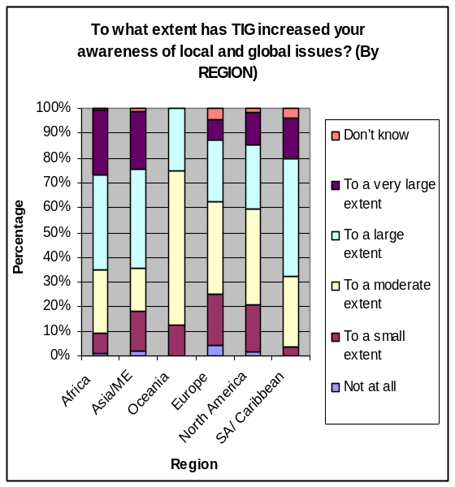
Variance by Region
Regional variance in this section was significant for questions 11 (increased awareness of local and local issues), 12 (increased awareness of different cultures and perspectives), and 14 (skills building). Respondents from Africa generally felt most positively impacted by TIG in terms of receiving information and having a platform for self-expression, followed by respondents from South America and the Caribbean, and Asia and the Middle East. Meanwhile, survey participants from Europe, North America, and Oceania felt usually that TIG made less of an impact on their lives. This discrepancy could be due to different levels in general of access to information and resources, as well as prior skills developed before joining TIG, for members in “developing” countries as opposed to “developed” countries.
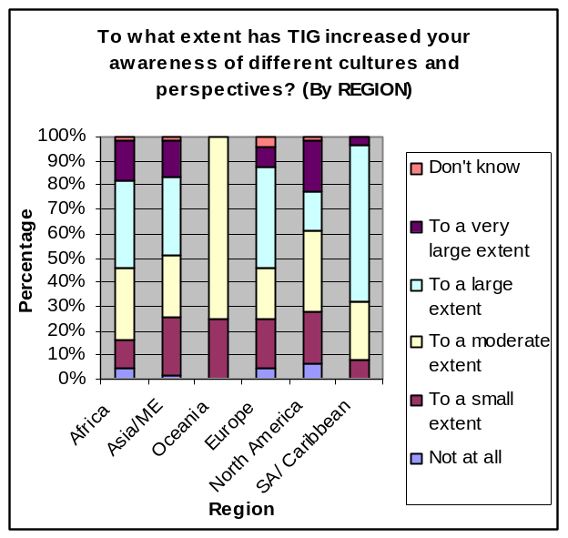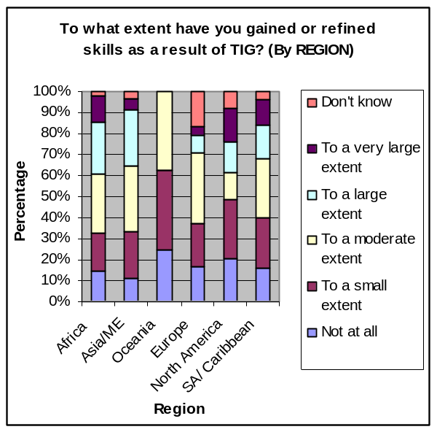
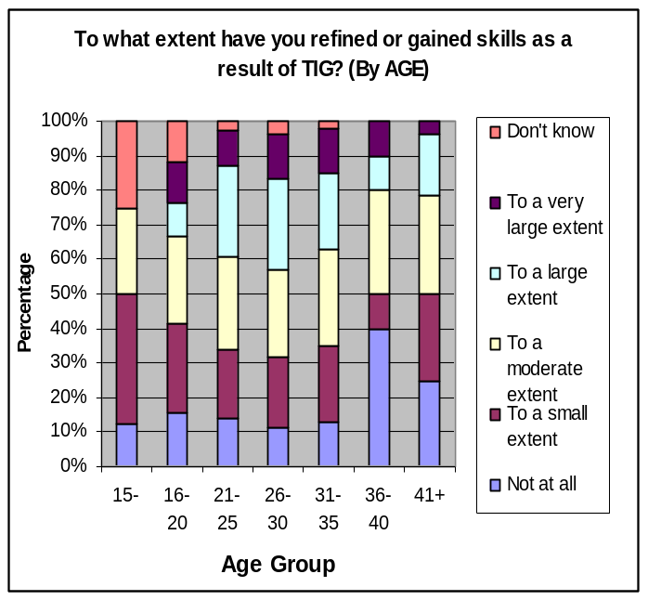
Variance by Age
The only statistically significant variance between age groups in this section occurred for question 14, regarding TIG’s impact in terms of helping members to build or refine skills. Those between the ages of 21 and 35 felt that TIG enabled them to refine or gain skills to a greater extent than survey participants aged 20 and under or 36 and over. Older members may already be equipped with sufficient skills before coming to TIG, so the variance is not surprising for older members. However, it is somewhat surprising that younger members, particularly those between the ages of 16 and 20, also felt TIG’s impact to a lesser degree with regards to skills building.

Variance by Sex
There was no significant variance between the sexes in this section, suggesting that both male and female respondents are relatively similarly impacted by TIG in terms of being informed and expressing themselves through TIG.

Discussion on Quantitative Responses
When asked to specify the skills that they enhanced or gained through TIG, if indeed they had, survey respondents largely cited communication skills (58). In line with communication skills, participants also cited writing and editing skills (24), networking skills (23), language and translation skills (10), and public speaking skills (7).

Survey respondents also expressed having developed the skills to increase their knowledge, including cultural skills (global awareness and cultural sensitivity) (14), research skills (7), and critical thinking skills (5). Participants also gained skills necessary to taking action, such as project/organization management and coordination skills (17), leadership and entrepreneurial skills (16), advocacy and engagement techniques (16), organization and planning skills (13), and team working skills (4). Finally, participants also developed ICT-related skills (24) and job/interest-specific skills and knowledge (19).

In the comments and suggestions section, several respondents felt that tools like TIGblogs, discussion boards, Panorama, and Global Gallery were important because they allowed not only for freedom of expression, but also fostered creativity. (Interestingly, the blogs were mentioned the most, followed by Panorama, the discussion boards, and then the galleries. Is there a preference for written expression, and beyond that, unimpeded and unmediated self-expression?) TIG’s international scope was also important for some survey participants, and they felt it allowed them to receive global visibility.

In terms of information, many more respondents cited learning and pulling ideas and resources from other members, as opposed to learning solely from content on TIG, suggesting that the online community is working well as just that – a social network where members interact and learn with each other. A few respondents also mentioned that the information they received on TIG helped to prompt or support action on the ground.

Quite a few survey participants wanted to see more information and more opportunities available on TIG, especially with regards to educational and financial opportunities. Some respondents also mentioned that they found it difficult to identify relevant information, and wished to see an easier way to navigate through the information and resources. Members also seemed to want TIG to be more proactive in terms of communicating opportunities through email (although interestingly, a couple of other comments acknowledged that it was up to members themselves to be proactive).

A number of respondents recognized TIG’s potential in providing information, but again, they raised the problem of ICT access in the global “South” and wished to see TIG accommodate for this by providing physical resources for organizations on the ground, offering more physical events, featuring best practices of youth working with ICTs in developing countries, etc.

A few interesting points that were not recurring themes were also raised. One member was particularly pleased that TIG’s resources are free of charge. Another pointed out that while TIG offered plentiful resources, the real challenge was turning thoughts and information into effective action on the ground. A couple of respondents also suggested making not only TIG content more multilingual, but also having member-generated content translated as well (à la TIGblogs).

  - Action

    - Quantitative Results

This section asked survey participants 5 questions regarding the extent of TIG’s impact in prompting members to take action. Participants were asked 4 yes-or-no questions about their participation in events, projects, and organizations. The last question asked respondents to evaluate the extent to which they are more engaged in their community as a result of TIG from a scale of: “not at all”, “to a small extent”, “to a moderate extent”, “to a large extent”, “to a very large extent”, and “don’t know”. The results are shown below in chart format.

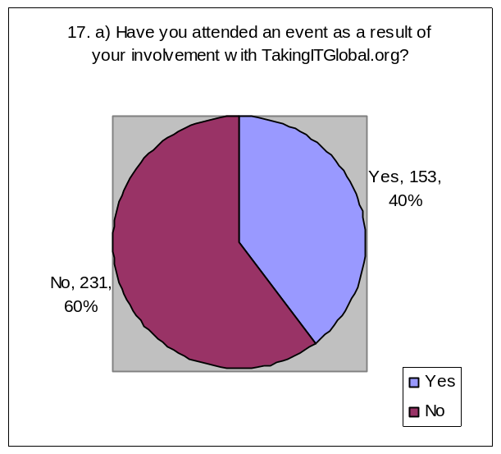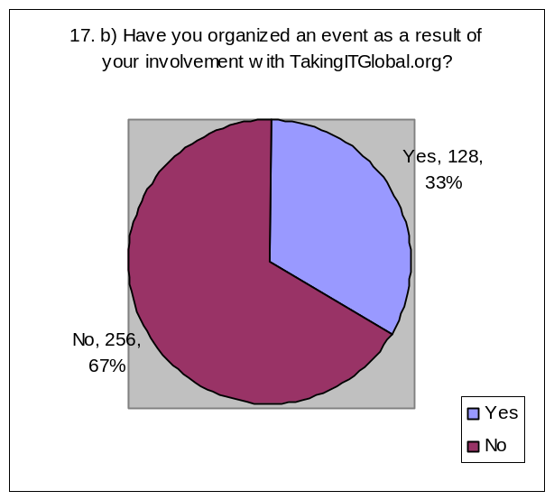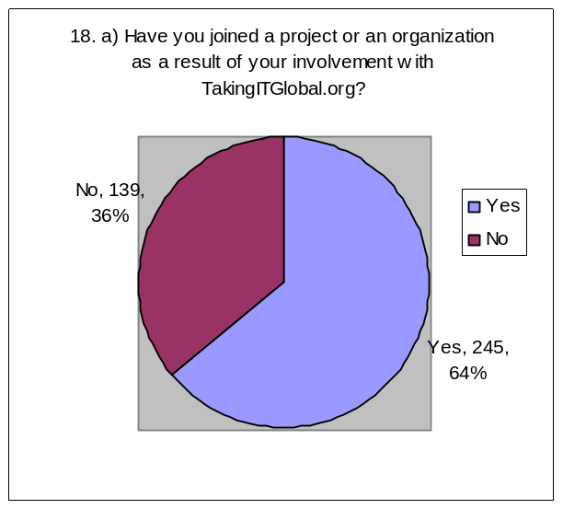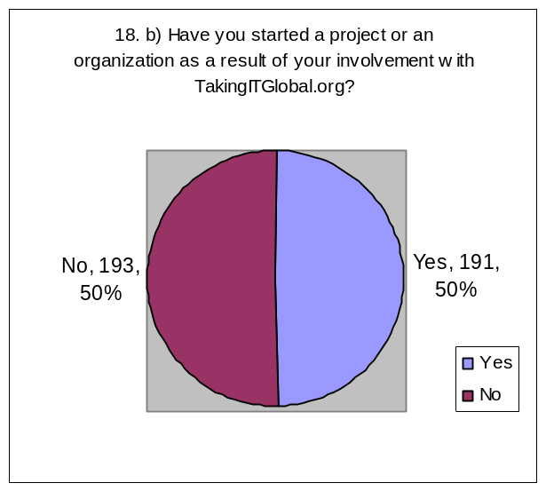

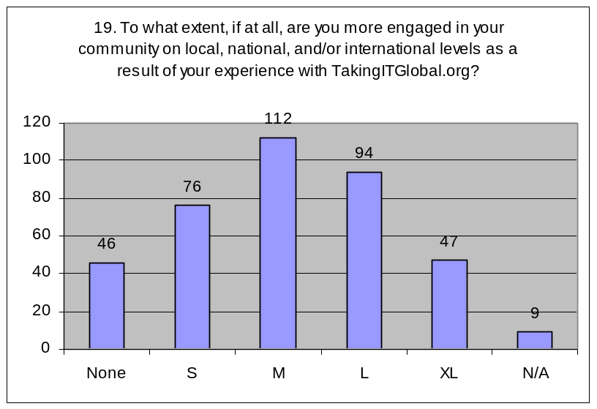

The following table illustrates the percentage of respondents who felt that TIG had a little or no impact (those who responded “not at all” or “to a small extent”) and those who felt that TIG had a strong impact (those who responded “to a large extent” or “to a very large extent”):

 | To little or no extent | To a large or very large extent
19. To what extent, if at all, are you more engaged in your community on local, national, and/or international levels as a result of your experience with TakingITGlobal.org? | 31.8% | 36.7%

Rough comparisons to 2004 Member survey
Statement (in 2004 survey) | 2004 (ratio between “agree” and “disagree” sides) | 2008 (ratio between “yes” and “no”)
I have attended an event as a result of TakingITGlobal (compared with Q. 17-a in 2008 survey) | 25.9% : 38.9%  = 0.67 : 1 | 39.8%: 60.2%  = 0.66 : 1

    - Qualitative Results

Survey respondents were also provided with the chance to voice any comments or suggestions that they had about TIG’s impact in the area of inciting action amongst youth in their communities.
Action | Other
- Have not used TIG to take/support action…  - Acknowledge possibility and want to, or plan to do so in the future (16)  - Have tried but to no success (finding partners, joining event or organization) + frustration (3)  - TIG inspired and prompted to take action for the first time (inaction before) (3)  - For those who were already active prior to TIG, using TIG to support or strengthen existing projects or organizations, or to broaden engagement (take more action) (24) – HOW?  - Resources (financial and capacity building opportunities, guide to action, member experiences, information) (12)  - Expanding network and outreach (7)  - Find partners (5) | What prompts action?  - Finding like-minded people and seeing what other youth are doing (6)  - Access to opportunities, projects, and organizations (4)  Suggestions  - Need more educative and financial opportunities to allow/support action (10)  - Need more on-the-ground reach (à la CLC) (partner with organizations that are organizing action on the ground, especially grassroots orgs in rural areas, getting TIGers together in person to encourage action/networking) (10)  Other  - Digital divide impeding TIG from being effectively used (6)  - Promoting TIG to involve other youth (5)  - Up to TIG members to use tools (3)

The following includes a sample list of quotations from survey participants responding to “Comments or suggestions regarding TakingITGlobal.org’s impact in the area of inciting action amongst youth in their communities” selected based on their relevance to reoccurring themes.

I would like to do more, but I haven't really had a chance yet. Please, continue to inspire and motivate!!

I have not involved or attended in any of the events because they are always far from me. they have not yet organized one in Ghana so I do not have the chance to take part, thanks Dahim

When I learnt what other youths around the world are doing, I was challenged and frankly I have done a lot ever since in my community.

Think I can say am proud of my self being one of the guys to introduce a number of friends to be members of TIG and be an adviser to one of youth organisations in my home village with experience from this website

I've done a lot of poetry, and through my poetry with this site, I’m mentoring 4-5 females in 5 different states. My poetry has opened a lot of doors. I've had a lot of youths come to your site not to only read my poetry but to see what your site is all about. I've been blessed in changing a lot of lives with my poetry and your help.

Although from Canada, I am currently involve on the front line of the Kenyan crisis, with someone whom I met here at TIG. Together and with a network called Minciu Sodas, we are helping with the Pyramid of Peace. A Google search should provide much info in that regard.

Well I have been helping the youth in our community with training and other social activities, which is indeed difficult without the help of outside support. Meeting with Taking It Global is an opportune time for us to associate ourselves with international body like yours.

We have acquired very valuable information from the site. We have discussed plenty of projects and programs to assist us generate enough funds which can enable us be financial stable to handle all our projects despite the current situation.

Help members attend more programs through facilitating participation to programs via scholarships

Youths should be given short term community based projects, for an award. I suggest that TIG initiate state meetings for members, to appreciate and motivate youths.

I'm quite new to TIG (joined Nov. last year) but TIG has been so helpful and has helped me connect with other youths wanting to make a difference in their communities, With time I know that I will be able to synergize forces with these youths through the collaboration tools which TIG provides. This synergy will enable me run projects that will have far reaching effects on my community and the world as a whole.

I have learnt to get more involved in activities and issues concerning my community. I have been able to mobilize youth in community affair. TIG has been a very useful tool for me while conducting workshop for youth of my Country.

Actually, youth in the SOUTH still have less access to ICTs, we are trying our best.. but also your approaches are adorable!

Increased rural youth involvement through offline projects like CLCWA

Its fairly positive, however, TIG is not very visible in communities but rather with the city youth, at least as is the case in Kenya. We may need to move further down through local contacts.

    - Discussion

General
Almost 2/5 (39.8%) of survey respondents have attended an event through TIG, and a third of participants (33.3%) have organized an event as a result of their experience with TIG. In addition, almost 2/3 of respondents (63.8%) have joined a project or organization as a result of TIG, while just under a half (49.7%) of survey participants started their own project or organization through TIG. This result is rather impressive if taken at face value.

It is important, however, to note that for questions 18-a and 18-b (joining/starting project or organization), there was no specification in the question regarding the level of engagement in the project or organization. For example, joining a project could be just as simple as clicking “join this project” on the online website and then sitting back and taking a completely apathetic approach, or it could be joining a project online and/or on the ground, then consecrating a significant portion of one’s time and energies to realizing the goals of the project. Similarly, one can attend an event and find it completely useless, or one can attend an event and become completely inspired to make a difference, or meet with individuals who can become one’s future partners. As a result, it will be extremely critical to specify this in the future and find out not only whether members are involved in events, projects, and/or organizations, but also how much they are involved and how much the initiative made a real difference in that person’s behavior, attitude, and/or actions.

The final question in this section asked members the extent to which they were more engaged in their community (on local, national, and/or international levels) as a result of their experience with TIG. While 36.7% of respondents felt they were more engaged to a large or very large extent, 31.8% did not feel more engaged at all, or only to a small extent.

Also, it would be interesting in the future to have a question asking youth how much action they were taking on the ground before joining TIG, and whether their involvement with TIG supported their action if they were previously active. (The 2008 survey only asks members how much more engaged they are in their community and therefore only measures a change in level of engagement).

Correlation
There was a strong correlation between question 10 (view of self as agent of change) and question 19 (engagement in community), suggesting that respondents who personally felt more able to effect change through TIG also became more involved within their local, national, and/or international communities as a result of TIG.

Surprisingly, the correlation between question 4 (contacting an organization) and question 18-a (joining a project or organization) was only 0.34 and therefore moderate at best (both questions used the same yes-no scale).

In terms of correlating questions 17 and 18 to other questions in the survey, the correlation coefficients will predictably be lower across the board, since questions 17 and 18 used a 2-point yes-no scale, whereas most of the other questions used a 5-point “to what extent” scale, and the first section utilized a 4-point agree-disagree scale. Therefore, any linear relationships between responses rated on two different scales will not be as strong as correlations between responses rated on one scale. As a result, the “standards” for strong correlations were re-evaluated: a correlation coefficient whose absolute value was greater than or equal to 0.35 was considered “strong” for a correlation between a question rated on the 2-point scale and a question rated on a 4-point scale, while a coefficient correlating a question rated on a 2-point scale and a question rated on a 5-point scale was considered to be “strong” if its absolute value was greater than or equal to 0.30.

From this standard, we can see that questions 17-a (attending an event), 17-b (organizing an event), 18-a (joining an organization or project) and 18-b (creating an organization or project) are all strongly correlated with question 15 (best practices). This is an interesting piece of information, as it suggests that members who exchange expertise and best practices through TIG are also likely to be members who take action as well (note that TIG’s impact at enabling members to share best practices was evaluated as relatively poor).

Results from question 18-a (joining a project or organization) were also found to be strongly correlated with questions 1 to 3 (making friends, forming [cross-cultural] partnerships, and connecting to leaders in government and organizations), as well as with questions 8 (sense of belonging), 13 (awareness of opportunities and resources), and 16 (self-expression). While question 18-b (starting a project or organization through TIG) was also strongly correlated with questions 2-a (forming collaborations) and 8 (sense of belonging), there were additional strong linear relationships between it and questions 5 (inspiration and motivation), 7 (self-confidence), 10 (view of self as change agent), and 14 (skills).

Comparison to 2004 Member Survey
The 2004 survey contained asked participants to evaluate how much they agreed or disagreed with the statement: “I have attended an event as a result of TakingITGlobal” on a five-point scale. The ratio of survey respondents who agreed or strongly agreed with the statement (25.9%) to those who disagreed or strongly disagreed (38.9%) was 0.67 to 1. In the 2008 survey, survey participants were asked the question “Have you attended an event as a result of your involvement with TakingITGlobal?” on a 2-point (yes-no) scale. The ratio of those who responded “yes” (39.8%) to those who responded “no” (60.2%) was 0.66 to 1.

Although both the questions and the scales were different, a rough comparison of results from the 2004 member survey and the 2008 survey suggest that TIG’s impact at getting members to attend events has stayed relatively the same.

Variance by Demographic Groups
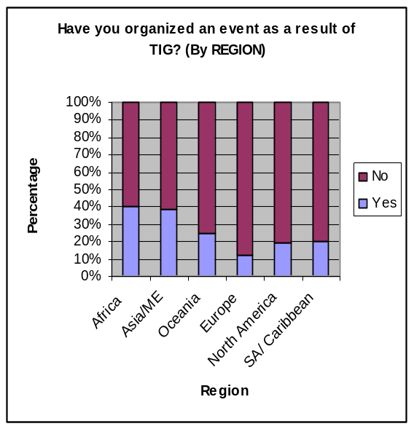
Variance by Region
Regional variance was not statistically significant for question 17-a (attending an event), but was significant for all other questions in this section. When it came to organizing events, participants from Africa (41%) and Asia/Middle East (39%) were significantly more active than participants from Oceania (25%), Europe (13%), North America (19%), or South America/Caribbean (20%). In terms of joining an organization or project, 73% of African respondents reported doing so, compared with 25% of respondents from Oceania (2 out of 8) and 54%-60% of respondents from other regions. A similar trend was observed when asking participants whether they had started a project or organization, although respondents from North America were least active in this respect (26%).
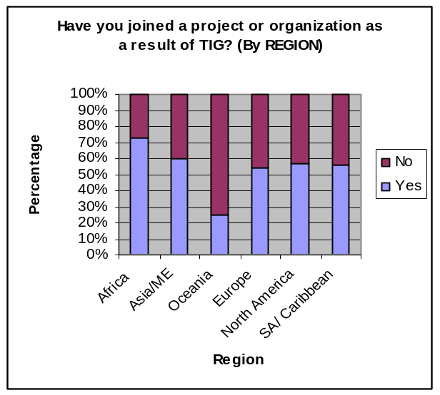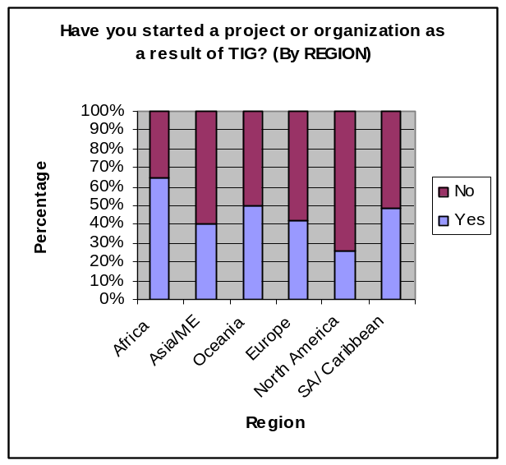
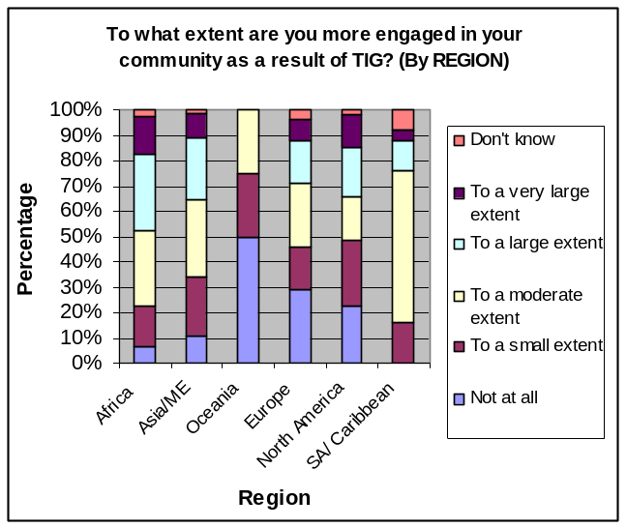
In terms of being more engaged in their communities (local, national, or international) as a result of TIG, African respondents were once again in the lead, followed by participants from Asia and the Middle East, while TIG’s impact was less significant for respondents from Oceania, Europe, and North America. It was also interesting to note that such a large majority of respondents from South America and the Caribbean (60%) felt that they were only moderately more engaged in their community as a result of TIG. In previous sections, survey respondents from South America and the Caribbean in general strongly felt that TIG had an impact on them in terms of enabling them to establish connections, get inspired, empowered, and informed. However, the transition to taking action seems to have been particularly stagnant amongst Latin American participants.

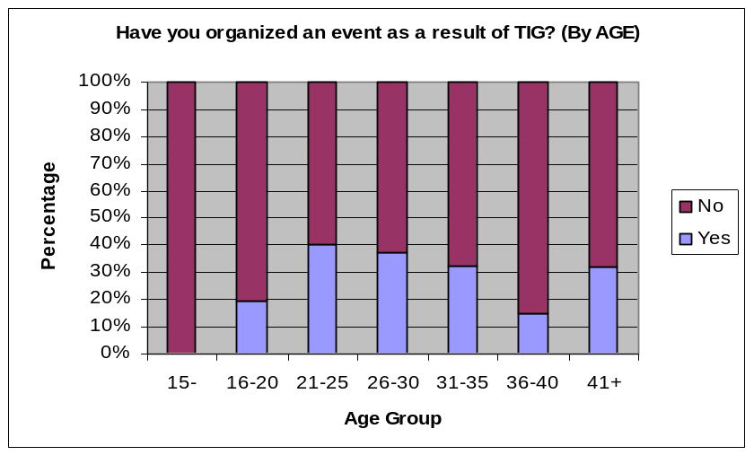
Variance by Age
Variance in this section was only statistically significant for question 17-b (organizing an event as a result of TIG). Those aged between 21 and 35 were the most active age groups in this area, followed surprisingly closely by those 41 years of age and older. It would be interesting to find out what types of events those aged 41 and older are organizing.

Variance by Sex
Variance between the sexes in terms of taking action through TIG was only significant for questions that related to participants taking on leadership roles and acting on their own initiatives (i.e. organizing an event or starting up a project or organization), with male respondents being notably more active than female participants. When it came to attending events, or joining a project or organization, responses between the sexes were comparable and variances were not statistically significant.

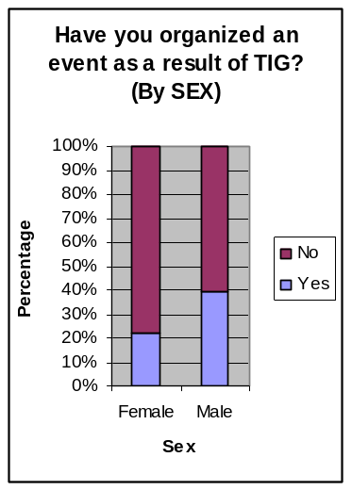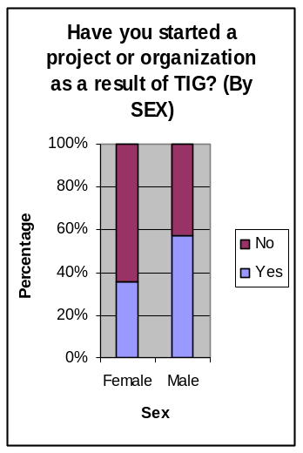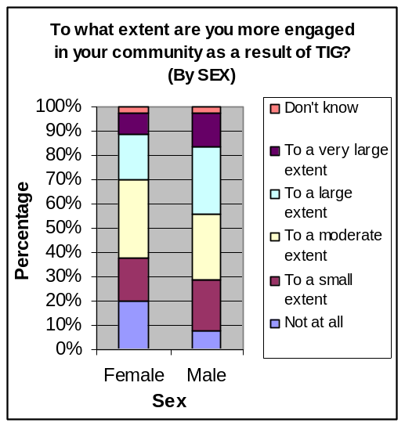

In terms of becoming more engaged in their communities, either on a local, national, or international scale, male respondents also tended to feel TIG’s impact to a greater extent than female respondents.

Discussion on Comments and Suggestions
Out of 46 comments in which survey participants situated their action (or lack thereof) with respect to their personal experience with TakingITGlobal, 24 respondents were active in their communities prior to joining TIG and were using TIG tools to support their activism; 16 respondents had not yet used TIG tools to become engaged or support their community engagement, but acknowledged TIG’s potential and hoped to use TIG tools to become (more) engaged in the future; 3 respondents expressed using TIG tools for the purpose of supporting/taking action, but without success thus far; and only 3 respondents commented on TIG inspiring them to take action for the first time.

Although, of course, these comments are not necessarily reflective of the general membership of TIG (not every participant commented on whether and how TIG was helping them to take action or become more engaged within their communities), it is interesting that for at least 50% of the 46 relevant comments, the participants were already active before joining the online network. In addition, there seems to be a disconnect between how TIG is used as a resource: while some members actively use TIG to support their community engagement, others, even though they may be aware of TIG’s potential as a resource to support and prompt youth action and engagement, primarily use TIG to connect with others, to get more information, etc. There seemed to be an attitude of “Wow, there’s all these great people doing great projects all over the world, and I’d like to become a part of that, but I don’t necessarily have the time, money, or initiative to actually go out, use the resources available to me, and take action myself.” It also seems that for these people, if the opportunity was brought directly to them (for example, if they received direct invitation from someone to attend an event), they might do so, but is that a role that TIG can occupy? More importantly, is that a role that TIG wants to occupy? (How involved should TIG get in guiding/directing its members?)

In terms of what prompts members to take action, several respondents pointed to reading about what other like-minded individuals on TIG were doing. Others thought that the databases of opportunities, projects, and organizations to led members to take action.

Several participants raised the issue of the digital divide: while they recognized the potential of TIG as a valuable resource for young people to get involved in their communities, they pointed to the fact that computers and Internet access are minimal in certain regions of the world. Numerous respondents thus suggested more on-the-ground reach (such as partnering with organizations that are organizing action on the ground, especially grassroots organizations in rural areas, or having face-to-face TIG networking meetings). Another popular suggestion, which has been reiterated through the survey, was for more educative and financial opportunities, which would allow and support youth action, either from TIG itself or on the TIG databases.

  - TIG’s Greatest Impact

The final question in the survey was an open-ended question, which asked, “What do you feel is the most important impact that TakingITGlobal.org has had on your life, if applicable?”

    - Results

Recurring themes and sub-themes
- Connecting to others (locally, nationally, internationally) (66)
  - Broadening networks
  - Finding partnerships
  - Friendships
- Recognition and Visibility (21)
  - Validating, promoting, showcasing personal work or organization’s works
  - International audience
  - Support for initiatives and work, being appreciated
  - Profile and ranking on TIG → finding jobs and getting awards
- Finding inspiration and experiencing positive growth or change in attitude (88)
  - Inspiration, motivation, and encouragement to act and/or do to more (30)
  - Hope and positive thinking: that there’s a world of young people out there who care, anything is possible (25)
  - Belief in self as agent of change (21)
  - Sense of belonging to worldwide community; solidarity, feeling not alone; being world citizen (14)
  - Self-confidence (10)
- Development of skills, creativity, and/or interests and passions (35)
- Learning, awareness and understanding (83)
  - Local and global issues and challenges; greater sense of social responsibility (30)
  - Cross-cultural awareness and understanding (26)
  - What other young people are doing across the world (experiences, strategies, projects, success stories and best practices) (25)
- Self-expression and sharing ideas and opinions (32)
- Access to opportunities and tools to make a difference (providing guidance, advice, and opportunities to show how to make a difference) (40)
- Enabling specific action (38)
  - Attend or start event
  - Start or join organization or project
  - Volunteering
  - Positively impact others
  - Strengthening existing initiatives or organizations

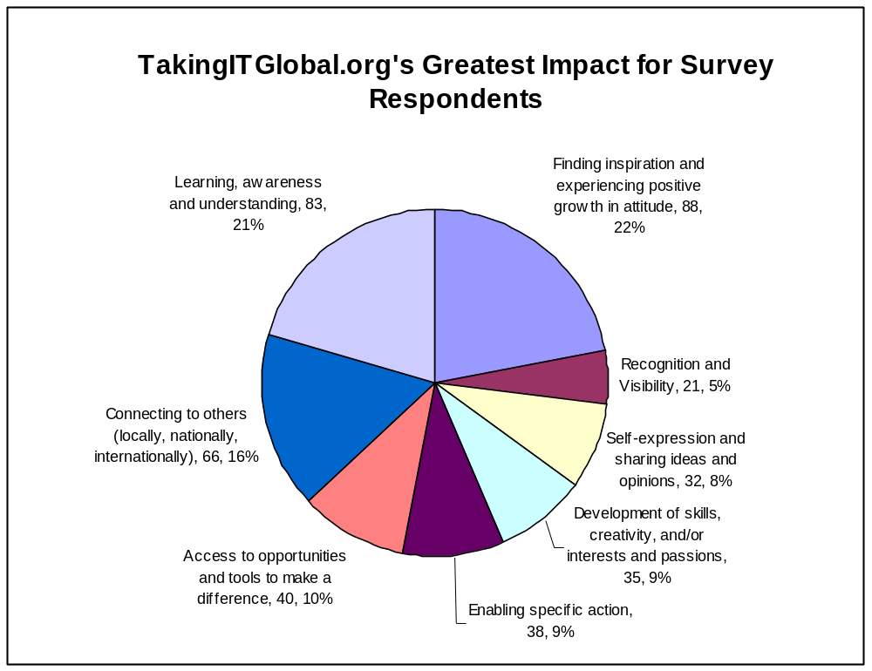

The following includes a sample list of quotations from survey participants:
Connecting to others (locally, nationally, internationally)
- TIG has exposed me to new friends both nationally and international and taught me the power of networking and living in a global world
- I am able to form the networks and create my own personal growth and change socially and systemically. There are groups that need to combine efforts and everyone needs to utilize the tools that support community growth and what that means.
- Being able to relationship build and network with people around the world; gaining insight as to different cultures; making new friends. I've recommended this sight to several others.
Recognition and Visibility
- I’m now in top 2nd active Rank because of TakingITGlobal. TakingITGlobal provide me platform and get position. Thanks TakingITGlobal.
- The most important impact that TIG has had on my life is that it has been there for the beginnings of the organization of a student group I'm involved with. It represents a solid foundation for the group to build on, and provides the group with a sort of special tangible existence outside of the meeting room.
- TIG has provided a global platform for me to share my experience and showcase successes. In 2004, I got a research partnership with a Professor from LSU as a result of my online profile on TIG
Finding inspiration and experiencing positive growth or change in attitude
- It has shown me that the world is not completely filled with apathy; there are people out there who care about serious matters, and who want to effect positive change in the world.
- Inspiration and motivation to start my own project and involving others to take part
- TIG has made me more confident of what I do and express myself to the public. This is in terms of speech, writing, and drawing among others.
- The impact that it has made in my life is this; I realised that I am important. I now think of myself of some one who can make a difference in the world rather than someone who can’t make a difference because the world is too big. I realised that you can reach every part of the world by sitting in front of a computer! It’s not that big! I realised that I can make a difference, and a big one to!
Development of skills, creativity, and/or interests and passions
- It has changed my life completely items of leadership skills which I have gained through the period I have been a member of TIG. Thank you TIG.
- It has offered me the ability to be creative, imaginative, and innovative with my communications strategies and initiatives. In addition, it has allowed me to grow as a leader and help develop a stronger cohesive Aboriginal youth community in Canada.
Learning, awareness and understanding
- It has made me much more culturally aware and has opened my eyes to problems that I never knew even existed and has given me the tools to help make a difference.
- I believe the main impact that TakingITGlobal.org has had is an awareness of modern global problems that need to be addressed, and I feel that TakingITGlobal is a way to bring some attention to issues that are worth discussing.
- It has broadened my mind to the realities of the other countries and to know and understand the diversity of the various cultures.
- Awareness about current issues and societies, through what participants post about; groups, organizations, projects or voluntary activities (translation from Arabic)
Self-expression and sharing ideas and opinions
- I feel most important impact that TakingITGlobal.org has had on my life is sharing different ideas from different people all over the World, knowledge, source of information and friends are great to me.
- Giving me the confidence to be part of a growing number of people who would like to change their communities for the better. Without being a member of TIG, I feel somehow that my voice would have been without any strength, but with TIG's backing, I am extremely pleased to be able to talk to people about issues I feel strongly about because I have the information, the knowledge, and most importantly the backing of an organization like TIG.
Access to opportunities and tools to make a difference
- It connects me with so many youth and people from all over the world. It helps me to know about newer opportunities available and also provides opportunity to start my own projects and plans on free which is quite good for young people won can't afford these technologies.
- After joining TIG, now even I believe that opportunities are equally available to every one. Before this I never used to know a source which can help me with information about issues, conferences and success stories/ projects.
Enabling specific action
- It allowed me to attend the International HIV/AIDS conference in Toronto with scholarships/expenses paid. This was fabulous and without TIG I would not have even known of the possibility. Sadly, that is about it.
- The biggest impact was the opportunity to attend the Global Knowledge Partnership (GKP) conference in Sri Lanka and to arrange a learning circle discussion in Colombo with Jennifer.
- Opened doors by providing invaluable experience. Also built lifelong friendships through the WSIS Youth Caucus. Very grateful and always looking for specific ways to give back!

    - Discussion

The most frequently cited impact of TIG by survey participants was in the area of helping members to find inspiration and experience positive attitude growth. Through TIG, respondents were inspired and motivated to take action or become more involved to make a change in their communities, and by being a part of a community of like-minded, conscientious, and active young people, they found hope and developed more positive thinking, started believing in themselves as agents of change, felt an increased sense of belonging to a global community, and became more self-confident.

The second most cited impact was TIG’s impact at building knowledge, awareness and understanding, whether it be about local and global issues, different cultures and perspectives, or international and grassroots experiences, realities, success stories, and best practices. The third most cited impact was simply being connected with other members from all over the world, for both professional (networking and finding partners) and personal (friendship) purposes.

Survey participants also cited TIG’s database of opportunities and tools as having an impact on them by showing them concretely how they can make a difference. For a number of participants, TIG’s greatest impact was in enabling them to take a specific action, such as attending or organizing an event; starting or joining a project, program, or organization; strengthening existing initiatives and organizations; becoming more active in volunteerism; or being able to personally positively impact other young people’s lives.

For other survey participants, TIG’s impact was greatest in terms of helping them to develop their skills, passions and interests, and creativity. Similarly, a certain number of respondents pointed to TIG’s tools and resources as effective platforms for self-expression and the exchange of ideas and opinions as the online community’s most significant impact. Finally, survey participants pointed to gaining recognition, visibility, support (and sometimes even jobs and awards) for their personal and professional works and achievements as a key impact of TIG.

As was expected, TIG’s impact is strongest at providing inspiration and information through connecting youth from all over the world together. While a relatively small portion of survey participants believed TIG’s impact to be greatest at enabling them directly to take specific action, it should be noted that many comments pointed to respondents being much more motivated, capable, and confident to becoming agents of change. Through all of the impacts listed above, TIG builds the potential of its members to taking action.

- GENERAL DISCUSSION

This section will focus on some of the key insights from the survey results.

  - Demographic Limits

It is important to point out that demographics of survey participants did not representative of the global TIG community. In particular, in terms of region of origin, proportionately, there were twice as many African participants in the survey than there are in the global TIG community, and half as many North American and European participants. In addition, the ratio of male to female survey respondents was also higher than the same ratio for the global TIG membership.

Since survey respondents from Africa generally felt TIG’s impact more strongly than participants from North America and Europe, and given that male respondents generally felt more strongly impacted by TIG than female respondents, the survey results may therefore not be entirely representative of the opinions of the general TIG population.

However, it is also important to point out that the demographics of survey participants were compared against the global membership of TIG, not the active membership on TIG (which is harder to determine based on what one considers to be the “active” membership). For example, while there are currently over 190,000 members on TIG, only about 57,000 have signed on within the last year.

  - General Insights from Data

General insights are presented in bullet-point format in order to highlight key aspects and results of the survey data.

- TIG seems to be doing an exceptionally good job at connecting members to each other and in creating both personal and professional relationships
  - Many of these connections are cross-cultural or international
  - In addition, compared to similar questions in the 2004 member survey, TIG’s impact in this area has noticeably improved
- TIG’s impact at connecting members to organizations is less strong (but still a majority with over 57% of respondents having contacted an organization through TIG), and its impact at connecting members to leaders in government or organizations is even less strong.
- TIG seems to have a strong impact at improving the views of its members of the ability of young people to effect change [average = 3.89 on a scale of 1 (no impact) to 5 (very large impact)] and at raising awareness amongst members about local and international issues (average = 3.64).
- TIG seems to have a moderate-to-strong impact at…
  - …providing inspiration and motivation (3.52)
  - …increasing members’ self-confidence (3.48)
  - …increasing members’ sense of belonging to a community (3.57)
  - …improving members’ view of themselves as agents of change (3.54)
  - …increasing members’ awareness of different perspectives and cultures (3.41) and opportunities and resources (3.40)
  - …and enabling self-expression (3.52)
- TIG seems to have a moderate impact at providing members with recognition and support for their ideas and initiative (3.07) and at engaging members more in their community on local, national, or international levels (3.05).
- TIG’s impact seems to be moderate-to-weak when it comes to helping members build skills (2.91) and even weaker when it comes to enabling members to exchange best practices and expertise (2.79).
- In terms of action, about 2/5 of survey respondents had attended an event, while 1/3 had organized an event. This is roughly comparable to 2004 survey results.
- Over 3/5 of survey participants reported having joined a project or organization, while slightly under ½ of respondents had started a project or organization
  - However, it is important to notice that the question did not distinguish between passive and active involvement with the organization/project

  - Reoccurring and/or Interesting Comments and Suggestions

Reoccurring and interesting comments and suggestions are presented in bullet-point format in order to highlight key results from the survey data.

- Increased TIG presence on the ground (like CLC)
  - More country- or region-based volunteers, coordinators, or chapters
  - More presence and promotion in local regions and communities (especially in schools and universities)
- More financial and educational opportunities
  - Grants or funding for member grassroots projects (either from TIG directly or have more information on TIG)
  - Capacity-building opportunities
  - These resources and opportunities also seem to be key at inspiring and involving youth
- More proactive role from TIG itself
  - More updates, encouragement, and communication from TIG staff or TIG as an organization (to inspire, motivate, connect, advise)
  - Also want TIG to be more proactive in terms of recommending partnerships and collaborations between members and groups or organizations (have like online matching system or something)
- Success stories and member experiences
  - Members are inspired by other members’ stories and experiences
  - More showcasing of success stories, role models
  - (This also seems to prompt action)
- Frustration with discrepancies between online information and offline real activity/status (with organizations, projects, and members)
  - Information online in TIG databases exaggerates or under-represents actual activity on the ground
- Making site multilingual is good initiative, but how to tackle language barriers between members since translation is not present with most user-generated content (i.e. communication, discussion boards, panorama, etc.)?
- Digital divide
  - Be aware of general lack of ICT access in the global “South” and react accordingly
  - Eg: resources for grassroots organizations on the ground, more physical events, more success stories featuring youth from the South working with ICTs, etc.
- Top skills gained or refined through TIG include…
  - Communication skills; writing or editing skills; and language skills
  - ICT-related skills
  - Job-specific or interest-specific skills
  - Project or organization coordination, management, and planning skills
  - Leadership skills; networking skills; advocacy skills
- Interestingly, a few survey respondents mentioned getting outside awards and jobs (partially or wholly) through their profiles and activity ranking on TIG.
- Which members are taking action
  - It seems from the comments that a large number of members who are using the site to take action were active in their communities already prior to their involvement with TIG, and are using TIG to become better or further engaged
  - Only a small number of comments pointed to action taken for the first time as a result of TIG
  - Another, significant portion of survey participants acknowledged the possibility of using TIG tools to become more involved, but have not yet acted upon it
  - It is also important to note that a small number of comments also pointed to frustration and dissatisfaction since they expected to find partners/attend events through TIG, but despite best efforts, have not yet succeeded.
- Miscellaneous
  - Develop an IM tool
  - Involve more government institutions in TIG

  - Variance by Demographic Group

Regional Variance
Variance between all demographic groups was most significant amongst different regions. In general, respondents from Africa, Asia/Middle East, and South America/Caribbean were more strongly impacted by TIG than respondents from Oceania, Europe, or North America. This variance was most significant for making friends, increased self-confidence, and improved view of self as a change agent. African participants were also significantly more likely to have started an organization or project, compared with all other regional groups.

It is also interesting to note that Oceania was a “wild card” in terms of the unpredictability of responses, perhaps because there were only 8 respondents from that region (however, there were only 8 respondents aged 15 and under, and that age group gave rather consistent answers). For example, while participants from Oceania were tremendously less likely to make friends or join a project or organization through TIG as other survey participants, the variance was insignificant in other cases, such as attending an event or improved view of self as change agent.

Age Variance
In general, respondents belonging to age groups between 21 and 35 were most strongly impacted by TIG than older or younger participants. It was interesting to note that the 16-20 age group was as positively affected by TIG as participants between 21 and 35 for all questions related to inspiration and empowerment, as well as information and self-expression, but lagged somewhat behind for all questions related to making connections and expanding networks, as well as taking action. Variance by age was most significant for making friends through TIG and for contacting an organization in the TIG organizations database.

Sex Variance
Although male respondents generally felt slightly more impacted by TIG than female respondents, usually the variance was not statistically significant. However, when it came to making friends, being connected to leaders in government and/or organizations, contacting an organization through TIG, having increased self-confidence and sense of belonging, as well as organizing an event, starting a project or organization, or becoming more engaged in their community as a result of TIG, male participants were significantly more active or successful than their female counterparts.

  - Correlation

What was particularly interesting about the correlation data was that all of the results for questions related to taking action (attending/organizing events and starting/joining projects or organizations) were strongly correlated with results of the question regarding best practices and exchange of expertise. In turn, correlation data suggested that survey respondents who exchanged expertise and best practices in the TIG community were also likely to have received support and recognition, became more self-confident, gained or refined skills, as well as expressed their ideas and initiatives through TIG.

Although the analysis was not full enough to establish direct links, it may be worthwhile to explore ways to boost the sharing of best practices on TIG in order to also encourage members to become more active and participate in events, projects, and organizations.

In addition, correlation data suggested that survey participants who had joined a project or organization were also likely to be members who had successfully made personal and professional connections through TIG.

- RECOMMENDATIONS

This section includes some suggestions on how the survey can be improved in the future to gather more specific and relevant data.

  - Survey Tool

It is highly recommended that the quantitative questions be made mandatory in future cases. Although 740 survey answers were logged, just over half of them were fully completed. In some cases of excluded responses, only 1 section out of 5 had been filled out, probably due to disinterest or lack of time, and it will be hard to capture these participants. However, over 70 surveys were almost completely filled out and lacked only responses for 1 or 2 questions, suggesting that the participant may have overlooked or forgotten to answer those particular questions. If there was a tool that would remind participants if they have forgotten any quantitative questions, I suspect more surveys would be duly completed.

In addition, it would be very useful if there were a tool that captured how long a member has been a part of the TIG online community when they sign on to the survey and/or how often they log onto the online community. This way, it would be possible to analyze variance between long-time members of TIG and newer members, and to see if the amount of time spent on the TIG community makes a difference in terms of the impact that TIG has on members.

  - Survey Questions

In retrospect, some of the questions in the survey could have been made more specific to avoid confusion. In particular, for question 6, “support” and “recognition” are not synonymous, so it may be worthwhile to pick the most relevant word for future surveys. Also, question 13 (awareness of resources and opportunities) is very wordy, cumbersome and potentially not very clear. In addition, for questions 18-a and 18-b (joining and starting a project or organization), it was not specified what entailed joining a project or organization. As was mentioned in previous sections, to one member, joining a project might mean the simple act of clicking “join this project” to give one’s support on the TIG website, but to another member, it might mean joining a project to which one then dedicates a good part of one’s time and energies. As a result, it will be very important in future surveys to specify exactly what is meant by joining or starting a project and/or organization.

Similarly, it will also be interesting to ask questions to assess members’ level of activism or community involvement (and perhaps also their level of knowledge, awareness, and personal motivation, etc.) before joining TIG. The current survey only asks for the difference that TIG has made in this area. As a result, it is difficult to determine, for example, out of the respondents who answered that their experience with TIG only increased their community engagement to a small extent, how many of those respondents were not active before in their communities and have only become marginally more engaged, and on the other hand, how many were already very engaged prior to TIG, and were thus less impacted by TIG.

Regarding the qualitative questions, I would recommend removing the “comments and suggestions” box after every section, as this resulted in a lot of repetition and not much participation. From the verbatim to the qualitative questions in this survey, there were most responses from the 2 specific qualitative questions (skills gained and TIG’s greatest impact) as well as the first qualitative question, the majority of which included suggestions. This suggests that participants want to a chance to provide their general advice and input, but that they also find it easier to answer a small number of more directed, specific qualitative questions. As a result, it may be more effective to have a single suggestions box at the end of the survey, and also one or two specific qualitative questions (instead of general comments related to section topics) in order not to bombard participants with too many questions.
Interviews with TakingITGlobal Stakeholders, 2008

- METHODOLOGY

At the start of the research project in January 2008, it was decided that there would be around 30 interviews in total, with about 20 active youth who are a part of the TIG community, 5 educators, and 5 organizations. After several consultations with TIG staff, including Jennifer Corriero, Nick Yeo, Luke Walker, Laura Kenyon, Kirsten Jordan, Kimia Ghomeshi and Emily Kornblut, an initial list of active youth, educators, and organizations to be interviewed was created.

Selection of active youth was based on several factors, including active ranking, amount of user-generated content on TIG, and TIG profiles and member stories (showcasing member backgrounds and experiences). In order to encompass the varied membership of TIG, youth were also selected to ensure regional representation, gender equity, and representation of the diverse age groups of “youth”. Educators were selected in terms of their involvement and activity with TIGed tools and resources, and regional representation was also taken into consideration, although this was somewhat difficult since many educators who use TIGed are based in North America. Organizations were selected based on their past and current collaborations with TIG.

Three sets of guiding questions for semi-structured interviews were drafted and revised in January following consultations with Jennifer Corriero, Nick Yeo, Luke Walker, John Horrigan, and Ellen Ratchye-Foster. Each set of questions was directed toward one of the three stakeholder groups.

Selected individuals were then contacted for interviews. Response rate was fairly positive, with roughly 2 out of every 3 individuals contacted agreeing to participate in an interview. (Additional youth and educators were also selected based on the same criteria and contacted throughout the process in order to ensure that the target of at least 20 youth, 5 educators, and 5 organizations was met.) Phone and Skype were preferred methods of conducting the interview, followed by instant messaging chat, especially since the interviews were only semi-structured, but due to various reasons such as time zone differences and poor phone or internet connections, interview by email was also an option. Phone, Skype, and instant messaging interviews typically lasted between 30 minutes and 1 hour each, and were conducted from January 24th to February 28th, 2008. The last email interview was received on March 4th, 2008.

In total, interviews were conducted and analyzed with 23 youth, 7 educators, and 7 organizations. When interview recordings were available, interviews were roughly transcribed; otherwise, interview notes or email responses were used for analysis. Common themes were identified for each group (members, educators, and organizations), and 1-page summaries were drafted for each interview.
- ACTIVE YOUTH

This section will look at the common themes identified in the interviews with active young members of the TIG online community.

  - Results

TIG’s IMPACT
Connections and Networks
- Friends on TIG with whom to share ideas | 8
- Other members and organizations search them out and contact them and/or ask about collaborating | 7
Inspiration and Motivation
- TIG network itself is inspiring in itself | 12
- TIG staff | 11
- International exposure and visibility (recognition) on TIG important | 10
- Encouragement and shows of support/appreciation from other members | 5
- Mentor important | 3
- Active ranking (measurable aim to work towards) | 3
Awareness and Learning
- Broadening perspectives and fostering international understanding and respect | 15
- Getting suggestions, best practices, and ideas from TIG members to inspire or strengthen own local projects | 10
- Showcasing local, on the ground work online | 8
- Learning about international realities and current events from direct sources | 7
- A place to express oneself and voice one’s opinions and what's going on locally | 6
- Spread awareness of local or international reality | 4
- Building capacity (e-courses, guide to action, CLCWA training) | 3
- Reading on TIG inspires to seek out further info and do research outside of TIG | 2
Action
- Joining in events, projects, organizations found on TIG | 14
- Tool/resource on TIG or project/group on TIG inspired a members’ own projects on the ground | 9
Important Resources (outside of “classic” tools and resource on TIG)*
- Multilingual feature | 6
- MDG resources on TIG important | 6
- Monthly and featured themes | 6
- Member Stories | 5
- Country Pages | 4

OTHER INTERESTING REOCCURRING THEMES
Actively promoting TIG to others | 12
Dormancy, then activism | 8
Being a part of the "TIG family" or "class/academy" | 4

INTERESTING INSIGHTS and LEARNINGS/TIPS
Initiative
- For project to be successful, you need to actively seek out who you think would be interested and invite them, can’t just sit back and wait
- Probability of getting response from people is high
International organizations seeing value in TIG and its members
- World Bank and their e-conference with youth on TIG
- UN MDG summit – selection committee browsed TIG forums during selection process

Evolution of Discussion Boards (and membership by extension)
- Before, more people with diverse opinions, now same few people who are there
- Level of discussion dropped in terms of being informed as opposed to just stating opinion

Growing out of TIG
- Getting older, less time to get involved with youth activism, but learnings and attitude/perspective changes that resulted from TIG remain
- Less contribution to site, but still accessing resources, found positive, global outlook as a person and addressing global issues (directly and indirectly)

SUGGESTIONS
- Increased local, on the ground TIG presence (for promotion and coordinator purposes) especially in schools and universities (CLCWA elsewhere, more funding or support for making ICTs more accessible) | 13
- Ensure site content is updated | 6
- Online training and capacity building (ICT training, how to start/manage projects) | 4
- More encouragement from TIG (mentoring program) | 4
- More updates about content on TIG or opportunities of interest | 2
- Try to control spam and scam | 2
- Need to better motivate and train online volunteers | 2
- More spotlights on local organizations, projects, and issues | 2
- Promote success stories (top 10 active members should form panel) | 2
- TIGed games should be advertised more
- More inter-linking between members and content (tags good)
- Online classifieds for volunteers or partners for member projects
- Instant messaging system
- Face to face TIG meetings with TIG youth to discuss international issues
- Make more resources available for download for those who want to share TIG content with others who don’t have ICT access
  - Discussions

    - TIG’s Impact

For ease of comparison, the themes that emerged from the interviews were grouped into similar sections as the member impact survey sections.

Connections and Networks

Like with survey participants, TIG enabled many of the interviewees to make friends from all over the world. For many of the youth interviewed, these friendships also seem to be quite close. Alejandra, talking about Damian, said that he was “more than a partner” for her project, but “a true friend”, and went on to say that “you can find friends for life through TIG.” It was also interesting to note that these friendships did not only cross countries and cultures, they also crossed radically different opinions. Arslan said, “I have made lots of friends through TakingITGlobal… I have friends in Malaysia, India, Canada, US, Egypt, many parts of the world… Luke [the top TIG discussion-board poster], I haven’t met him…, but we are eager to meet each other although our views are quite different.”

Also corroborating with survey participants, many of the participants had collaborated with other TIG members and organizations on projects. It is interesting to note that for a number of the active youth interviewed, while they were not actively searching for partners, other TIG members or organizations took the initiative to contact them and inquired about what they were doing and possible collaborations. Andy, for example, received emails and messages from several TIG members and organizations who had seen his discussion board posts, asking how they could get involved in his projects or work together on a new project. Delroy also regularly receives questions about Dominica through TIG, and also recently was contacted by a group in the US that was interested in collaborating with his organization to do a project on human rights. In addition, Akinbo was contacted through TIG by Greet, the founder of Save Children Now, who entrusted the coordination of the organization in Africa to him.

As a result, one theme from the interviews that had not been present in the survey responses was that many of the really active youth on TIG are attracting potential collaborators and partners without actively searching for them. This may seem self-explanatory, but it is important to keep in mind especially since there were several comments in the survey about members and organizations who had searched for collaborators but were frustrated because they had not succeeded. What the interviews seemed to suggest was that instead of just using TIG to search for members who could potentially complement your project, it may be worthwhile to complete your profile, set up a project or organization page, and generally become involved in the community first, so that others will want to come to you.

Inspiration and Motivation

Many of the youth interviewed were inspired by the TIG network itself. They expressed that the community of young people from all over the world who respect international perspectives, who care, and who are making a difference was a factor in motivating them. Jonas, for example, said, “To see that more people from over 200 countries are using it [TIG] is inspiring. I was checking out Micronesia: 11 members, you know! That’s really inspiring to have access to this global network. Whoever I want to know about, I can just send a message to them and the possibility of getting a reply is very high because people want to help each other out, because we’re all stuck in the same boat.” Joel also compared the TIG network to Myspace, and found that even though he may be doing the same things on both communities (i.e. uploading pictures and photos), he finds the TIG network so much more inspiring because of the different memberships. Mohammed agreed, “The general atmosphere of TIG is one of understanding, activism, and change, and that makes you want to take action and to be a part of this community and to step up and change things.”

What was particularly interesting about the interviewees’ responses in this section was that many of them had found inspiration, motivation, direction, and support through direct interaction with either TIG staff or volunteers. For example, Sarah and Andy cited Sessi (French Engagement Coordinator) as big inspiration and mentor for them; Victoria and Alejandra cited Damian (Spanish Community Engagement Coordinator) to be a role model and a motivator; Anu and Arslan cited Hayk (Discussion Board Moderator) as been a key actor in enabling them to participate in different Model United Nations events; Thomas and Esther cited Francis (CLCWA Global Coordinator) for having supported them; and Olga pointed to Laura (Online Community Engagement Coordinator) and Chiara (Multilingual Coordinator) as mentors. While of course this doesn’t mean that interaction with TIG staff is a cause for the activism and engagement of the youth interviewed, the interviews do seem to suggest that direct interaction and/or encouragement from TIG staff leaves an impact on members, either through providing guidance and support, or through simply inspiring and motivating them to reach higher and farther in their efforts.
Sources of Inspiration
Jen and Mike* (many times)
Simon*
Hayk* (3)
Sessi* (2)
Laura* (2)
Francis* (2)
Damian* (3)
Anu*
Ghazaleh*
Chiara*
Elaine*
Rodrigo
Amanda
Ajay
Cameron (IYPF)
Erick (Kenya)

Many members also cited recognition and international visibility and exposure as an important motivational factor for them to continue with their on-the-ground initiatives. Interestingly, 3 interviewees (Jaevion, Akinbo, and Esther) mentioned the active ranking on TIG to be a motivator in terms of encouraging them to contribute to the TIG community. Jaevion mentioned that one of his goals is to stay in the top 100 most active TIG members, and whenever he finds himself slipping in the ranks, he tries to contribute to the community though postings and submissions to increase his ranking. Esther, who ranked in the top 25 during the interview, commented that it wasn’t enough, and that she wished to be in the top 10. A few members also mentioned the “inspired by you” tool as a source of inspiration for them, and wanted to find out who were inspired by them. One member also mentioned the country map on their profile as motivation to visit other regions and explore different cultures.

Other youths interviewed also acknowledged gaining recognition and international visibility through TIG and cited it as a strong motivational factor. Yassir echoed this sentiment when he said, “Un impacte important de TIG, c’est de donner une dimension internationale à nos projets… par exemple, les profiles des membres sont visités par les jeunes partout au monde… [et] les travaux et projets sont reconnus par les jeunes de partout.” Anu agreed, noting, “TIG definitely boosts their [members of YFCI] confidence by giving them org status”. Other TIG tools, like the Global Gallery, the blogs and Panorama, also allowed youth to gain recognition for their work. Alejandra was contacted by several local and national newspapers after one of her blog posts on TIG attracted international attention. Similarly, Laura’s articles in Panorama were published by a local magazine in her community, kick starting her career as a writer, and now, she is writing for several local and national magazines across Mexico.

On a similar note, several members interviewed also found that encouragement and shows of appreciation from other TIG members was very important in terms of motivating them to be more active online and offline and even to further promote TIG. For example, Christabell said, “I get inspired when I see that whatever I do especially on TIG is recognized and noticed, and members actually appreciate everything that a fellow member does since I always get appreciation messages in my inbox that show that activities I’m involved in are recognized. This is a great inspiration and it give me an urge to be more active TIG members and to preach TIG every where I go.” Likewise, Fiona said, “When I run out of energy and say, ‘I’m not sure I can do this anymore,’ there’s at least 100 people around me [on TIG] who can say, ‘This is what’s happening to me, please keep doing what you’re doing’… hearing people’s stories and hearing their passion just makes me passionate again.”

Along the same lines, three members (Christabell, Esther, and Andy) noted the importance of having a mentor who can guide members both online and provide them with support and motivation for their work offline. Andy praised Sessi for acting as a mentor for him, and felt that “TIG doit essayer de trouver des mentors qui doivent motiver les jeunes.”

So in general, it seems that the youth who were interviewed are being inspired and motivated not only by the online network itself and the members within it, but they are also pushed to continue their work as they gain recognition and visibility for their achievements online and offline.

Awareness and Learning

Many of the youth interviewed felt that TIG helped them to broaden their perspectives from being locally-focused to globally-focused, as well as to foster an international understanding and respect for the different cultures of the world, like many survey participants. However, unlike survey responses, TIG seemed to have a significant impact in terms of allowing the active youth interviewed to collect and share ideas, advice, expertise, and best practices, whether through direct communication with other TIG members, who are, as Fiona put it, “fountains of knowledge”, or through TIG tools like the profile, event, project, or organization pages. Not only did many interviewees use the information obtained to build or strengthen their own local projects, they also shared their own work, processes, and success stories online for other TIG members to consult. For example, Sarah exchanged project methodologies and best practices with an active youth from the UK, while Efraim used TIG to be able to “ learn more on the experiences that occur outside of [his] place of performance, and thus to be able to apply [them in] more complete form in [his] region.” Similarly, Christabell said, “I was also able to highlight activities of what I am doing in my community and my country so that whoever feels like replicating the activities, they could go ahead.” Likewise, Andy shared the details of one of his projects with a member in Tunisia, and this member actually was able to replicate and adapt the project to his local community. Just like the correlation data in the survey suggested, it appears that TIG members who are active on the ground are also members who find and share best practices on the online community.

Quite a few youth interviewed also found that they were learning about international realities and current events through TIG from people who were going through those experiences. Jonas, for example, said, “[TIG] is a good way to get first-hand stories… [usually], a person from a news agency like AP or Reuters sees [the event], write [an article], then sell it to news magazines, who edits it and/or translates it, and then it comes to my attention.” Similarly, Fiona commented, “I’ve read some really truly tragic stories and hear people talk about things that I never thought I’d hear people talking about… TIG provides that and it provides access to a world I couldn’t get any other way, unless I traveled everywhere.”

Several interviewees also found TIG to be a great place to express their opinions, as did survey respondents. For example, Jaevion, who admitted to doing a lot of introspection and having a small communication problem, uses his TIGblog to express his thoughts: “I tell my friends: ‘If you really want to know what I am thinking, go on my blog at TakingITGlobal and you will know what I am thinking for the week.’” However, what was interesting was a couple of interviewees engaged in external research outside of TIG in order to establish a more informed opinion to voice either on the discussion boards or on the blogs. Arslan, for example, said, “[On the discussion boards], when I respond to my ‘opponents’, I do research, which is in itself a process of learning.” Sarah did the same thing, and summarized, “Le blog et les forums de discussion… me donnent la parole sur des sujets qui peuvent être intéressants, et en plus ça me permet d’élargir mon point de vue à travers l’opinion des autres membres: chacun donne son opinion et on peut se faire de ça une idée globale sur un sujet… Sur les forums, je lis les sujets et puis ça me fais réfléchir, et je fais de recherché sur l’Internet, j’essaie de me renseigner, et à partir de ça, j’écris des articles sur mon blog.”

Some of the young people interviewed also utilized TIG as a means to spread awareness and launch advocacy campaigns regarding local, national, or international realities. For example, Victoria used TIG to spread news about the environmental tragedy in her community caused by a neighboring pulp mill. Efraim is also using TIG as an outreach vehicle: “One interesting experience I had [with] TIG was the amount of people who visit[ed] the ECOBlog after my entry into TIG. I am happy because my blog well exceeds [reaches across] several border, which means that young people from other countries know the scores on the environmental issue in Brazil.”

It is worthwhile highlighting that while there are definitely similarities between the survey responses and the interviews, it seems that the youth who were interviewed (keeping in mind that they were selected based on their contributions and level of activity on TIG) are generally using TIG as a tool to share best practices to a larger extent than survey participants.

Action

Like survey participants, many of the interviewees had joined projects or organizations and attended events that they learned about through TIG. For a few, it was a first-time experience, like with Arslan and the Model UN that he attended, or like Maria Angela, and the organization for which she became an active volunteer. However, for most interviewees, however, the events, projects, and organizations found on TIG allowed them to supplement their activism with additional opportunities for capacity building and best practices sharing.

In terms of starting projects and events, resources and tools on TIG, as well as other projects and groups on the site, are inspiring members who were already active in their community to create new projects. Andy, for example, is currently working with his organization to produce a local HIV/AIDS guide to action like the TIG general one, but focused on Gabon communities; Jonas is working on building his Tellus magazine, while Delroy produced a Youth Voices newsletter for youth in Dominica, both of which are heavily inspired by Panorama; Alejandra and Mohammed, inspired by the TIG format, are working on incorporating ICT training for youth in their local communities; Joel is working to establish a youth center in Vanuatu after seeing what some other youth on TIG have accomplished; Victoria built her MDG awareness raising project with the MDG guide to action; and Sarah is currently planning to establish a physical support network for youth interested in development projects in France to complement the virtual TIG network.

It was interesting to note that even though all youths interviewed were considered “active” and were chosen for their engagement, a small number had not used TIG to started or joined a project or organization, or attended or organized an event (which were the criteria used to evaluate action in the survey), like Youxin and Olga, for example. However, Youxin and Olga were not disengaged youth; Youxin had participated in a cross-cultural summer program focused on youth and environmentalism, while Olga was translating content into Russian for TIG. But it is clear that different youth use TIG for different purposes, and for Youxin and Olga, their main rationale for being a part of the TIG community was to connect with other young people from around the world and to learn about international issues and perspectives.

This may seem like an obvious point, but it’s worth mentioning because several other extremely engaged youth, such as Jaevion and Akinbo, were also not using TIG with the primary objective of finding guides and opportunities for action. Instead, they were utilizing TIG primarily for the same reasons as Youxin and Olga: to connect with globally active youth and to gain some support and recognition for their efforts on the ground. Thus, it may be useful in future surveys, as was suggested in previous sections, to ask other questions which will help identify these groups of people, who are engaged in their communities but have not necessarily joined a project or attended an event through TIG.

Important Resources

Many of the youth interviewed mentioned the tools and resources available on TIG, such as the blogs, the discussion boards, Panorama, the Global Gallery, Understanding the Issues, and the events, projects, and events database, as being very useful for them. On top of the “classic” TIG tools and resources, numerous interviewees also mentioned the featured themes and monthly themes as very important, and wished for more content development. For example, when talking about featured themes and how there used to be many opportunities for TIG members to contribute, Jaevion noted: “I feel that TIG has lost some of its core focus that it had in the past, which it should revisit to have a more far-reaching impact and to keep young people focused and sustained. I was always so hopeful of contributing to monthly themes.”

It was also interesting that 6 interviewees also mentioned TIG’s work on the MDGs as significant. In addition, a number of youth mentioned the member stories as a key source of inspiration for them on TIG, and wished that more members would contribute. Yassir and Ilyes even mentioned that the member stories and member profiles were what attracted them to the TIG site in the first place, and what motivated them to become active on the site.

Also, some interviewees really liked the TIG country pages, but noted that their country pages (China, Sweden, and countries in the Caribbean and in the Pacific Islands, among others) were rather stagnant and hoped to see more opportunities. Finally, several interviewees also appreciated the multilingual feature on TIG, but a few like Yassir and Ilyes pointed out that many non-English speakers are not even aware that the site is available in different languages.

    - Other Reoccurring Themes

Not surprisingly, many of the youth interviewed were actively promoting TIG to their friends and to other youth within their community. It was interesting, however, that a few of these individuals considered TIG to be a second “family” or a “class” or “academy”.

What was really interesting was that a third of the youth interviewed (8 our of 24) described a dormancy phase that they went through after finding out about TIG and before becoming an active member of the online community. Interviewees talked about browsing around on the site, sometimes signing up for an account, but not being really engaged or interested. Then, some time later, they returned to the site and became more active. A couple of interviewees like Jaevion (who lost his password to his first account, on which he was not active) and Olga (who was inactive for a year before really starting to contribute on the site) didn’t specify exactly why they became re-engaged after their period of “dormancy”. Arslan became active on the TIG discussion boards after exploring other forums and finding them inadequate or inferior to TIG’s in terms of the level and quality of discussion. However, the other 5 interviewees were motivated to become active on the site after coming into direct contact with another TIG user who encouraged them to contribute. For Christabell, it was Erick (one of the most active TIG members), who mentored her on how she could benefit from TIG resources; for Thomas, it was his older brother Fred; for Jonas, it was meeting Jennifer in person; for Alejandra, it was meeting Damian and reading his blogs; and for Joel, it was receiving a personalized reminder from the folks at IYP who had signed him up which prompted him to actually explore the site further. This is interesting information, especially since there are such a large percentage of TIG members who have signed up and never logged in afterwards, and it may be worthwhile to have a strategy to re-attract any youth who did not immediately become engaged with the site on their initial login(s).

    - Interesting Insights and Learnings/Tips

Although not necessarily reoccurring themes, some of the youth interviewed had interesting insights and learnings from TIG to share.

Initiative
Ilyes noted that with his project on TIG, he actively searched for members who he thought would be interested and contacted them about joining his project. He commented that if one is looking for partners on a project, one has to actively do research and promotion on TIG to identify who one believes will be interested in collaborating. For him, he found that once he did take the initiative to contact those who would be good for his project, the response rate was quite positive. Similarly, Jonas commented, “Whoever I want to know about, I can just send a message to them and the probability of getting a reply is very high because people [on TIG] want to help each other out because we’re all stuck in the same boat.”

This is interesting because the interviews also revealed that many of the youth interviewed had also been personally contacted by other TIG members about collaborating on projects, and most had accepted. However, it does seem to contradict the comments of a few survey participants, who used TIG to look for partners but did not succeed. It would be interesting to find out what specifically these survey participants had done on TIG in terms of searching for partners, to see if patterns can be observed as to successful and unsuccessful ways to find collaborators on TIG.

International Organizations Seeing Value in TIG and its Members

Another interesting insight came from both Andy and Fiona’s interviews. Andy revealed that the selection committee for the UN MDG summit in New York had informed him that they browsed through the TIG discussion forums to see the comments and who had made them during the adjudication process for participants. In addition, Fiona, who had participated in the World Bank e-conference on TIG, noted that after the e-conference was over, all the TIG members who had participated received an invitation to attend the actual World Bank conference. Both Andy and Fiona’s experience suggest that important international organizations see value in TIG members and may hold them to a certain esteem.

Evolution of Discussion Boards (and Membership)

Both Arslan and Anu believed that the quality and focus of the TIG discussion boards (and somewhat by extension, the membership of TIG as well) had evolved since they joined TIG, and not necessarily for the better. Anu commented, “When I joined… [the discussion board] was much more interesting, but now the level of discussion has gone down, and hence my participation level… When I joined, there were members who did research on the topics and then presented their ideas, but now… many of the forums have been reduced to token words of personal opinion. I wouldn’t say that it is bad, because for many that can be a beginning, but for many of us, we do sometimes feel not as enthusiastic as we used to.” Similarly, Arslan said, “The [current] debates are not as active as in 2005-2006. Before, there were more people with diversity of opinions. Now every time I go [to the peace, conflict, and governance discussion board], there are now just a few members who are active an I basically know whose opinion on certain issues is what.” Arslan noted that many of the previously active members left, and that there aren’t quite as many new members actively involved in the discussion boards, and he also expressed frustration at the increased inflammatory and derogatory language and comments in the boards.

These comments call into question the larger evolution of TIG as a network and its focus for its new and old members. As the network expands, of course, the membership becomes more diverse and varied. As Anu said, such an evolution is not necessarily negative, but it should be something of which TIG is aware.

Growing Out of TIG

A final interesting insight was brought up by Laura and Delroy, both 27 years old at the time of their interviews. Both found themselves somewhat growing out of the TIG community as they got older and became more occupied with their jobs and other “adult” responsibilities. This “generation gap” is not news in itself, but Laura and Delroy were both quite positive on this topic. Delroy commented, “Even though I don’t necessarily post all of my activities now, I still communicate with other members, and I still follow up with projects and networks on TIG.” He also said, “As long as the website remains relevant, which it is, young people will be engaged and will feel the need to dialogue… as we get busier and older, that is something that we can take away.” Likewise, Laura noted, “When you’re young, you have all the time in the world. When you get older, you don’t have all the time, but you can do changes in the places you are… You are more conscious through TIG about all the issues, like environment, poverty, cultures, and religion, and it makes you a different person… When we become older, we become less involved in youth associations, but we can still be a good influence on other people in the palace where we are.” It was interesting to note that both Delroy and Laura were addressing global issues either directly or indirectly through their jobs (Delroy works on agricultural and sustainability projects, while Laura raises awareness on various international challenges through her newspaper articles and through giving motivational speeches to youth). It would be interesting to find out where other older TIG members who are “exiting” the online community stand on this issue.

    - Suggestions

A majority of interviewees wished to see TakingITGlobal have more on-the-ground, local presence, just like many survey participants. Many believed this would help to promote TIG and would attract more members and therefore more activity on the site, especially if TIG were to be more present in universities and schools. In addition, having a local, regional, or national TIG coordinator, chapter, or office (like CLC) would also help in coordinating and supporting projects and activities of TIG members in those locales, as well as creating more opportunities for youth to have access to ICTs. Several of the interviewees acknowledged the financial burdens of such a program, but hoped it would be feasible if local TIG chapters were supported by grassroots organizations and volunteers. Thomas summarized these ideas well: “I believe you guys need to solicit more funding and have representatives around the world. At least, getting connected with a national representative on an organizational level will give the organization [TIG] a clearer idea on how to engage some communities in other countries. Reports from a country coordinator will mean a lot for your organization, apart from what is been reported as a project. What happens is that every society differs, and if you must be an organization that wants to cover the world, as the nomenclature implies (GLOBAL), you need to be represented worldwide for greater impact.”

Another repeated suggestion was for more online training and capacity building opportunities. A number of interviewees felt that training on how to use TIG and ICTs, as well as how to start and manage a project, would be useful for all TIG members. In addition, it was interesting to note that even active members craved for encouragement and rewards from TIG: several interviewees suggested that TIG encourage, motivate, and reward its members (and its virtual volunteers), perhaps through a mentoring program or otherwise, and also to promote the active members and success stories of TIG. For example, Akinbo noted that “the need to sponsor awards of excellence and give out pin-badges is paramount.” A couple of youth interviewed also wanted to receive more communication from TIG regarding updates or opportunities that they may be interested in.

Other reoccurring suggestions include ensuring that content (like understanding the issues, opportunities) are up-to-date and better controlling spam and scams. Interestingly, a couple of interviewees also suggested having spotlights on local issues, organizations, and projects, which they felt was rather lacking, even on TIG country pages.

A few interviewees also suggested creating tools to permit more inter-linkage between members and content (tagging as an example and a good start, or creating an online classifieds or matching system where members seeking volunteers or partners could post what and who they were looking for, and when and where, and members looking to volunteer could do the same). Other suggestions that were echoed in the survey included creating an instant messaging tool and organizing face-to-face meetings for TIG members. Finally, a couple of unique suggestions pointed to increased promotion of TIG games and making more TIG resources available for download in order to facilitate the sharing of information with those who do not have access to ICTs.

- EDUCATORS

This section will look at the common themes identified in the interviews with educators who are actively using TIGed and incorporating TIG into their teaching.

  - Results

IMPACT of TIGED on EDUCATORS/STUDENTS
Creating and facilitating connections
- Connecting teachers and students to other teachers and students outside of their classroom (either in their community, nationally, or on a global scale)
- Facilitating distance education
- Connecting students to experts
Providing resources for a “global” education and facilitating “global” co-learning
- Informing students and teachers about international issues and realities
- Cultural exchange (identity, visions, beliefs) and encouraging international understanding and respect
Fostering personal and academic growth amongst students
- Students gain relevant skills; student achievement goes up – students work harder and put more effort into their work
- Students’ self-confidence boosted
- Positive behavioral change in students
Enhancing the learning (student) and teaching experience
- Providing new, innovative, and interesting ways to learn and teach (different media, featuring student output online)
- Resulting in…
  - Students are inspired to learn and to start projects/work
  - Teachers find (again) their motivation to teach
  - Both parties are more excited and enthusiastic about what happens in class

OTHER REOCCURRING THEMES
- Safety and ICTs
- Challenges: Difficulty in finding collaborations and access to technology
- Lack of awareness of the extent of TIGed’s tools and functionalities

SUGGESTIONS (bolded suggestions were suggested by more than 1 educator):
  - Make it easier to find classes with which to collaborate and encourage more classes to collaborate
  - Ability to upload documents and files (PowerPoint, video, picture and text, digital photo stories – photo and audio in one) + option to make it public or private
  - Ability to record LiveChats (for reviewing or showing others)
  - Make the TIG messenger more like Yahoo or MSN Messenger (live chat)
  - Different templates for different age/grade groups (e.g. more kid-friendly for younger groups, with simpler vocabulary, bigger fonts, brighter colours)
  - Option of allowing students to bookmark pages
  - Option of allowing educator to switch between instructor view and student view of online classroom
  - Ability of moderators to insert headings for specific groups of threads in discussion boards
  - Option to choose TIG inbox as homepage after login instead of bulletin board
  - Make it easier for administrators and moderators to register and add classes that are a part of a collaboration but not registered on TIG (maybe drag and drop)

  - Discussions

    - Impact of TIG/TIGed

Creating and Facilitating Connections

TIGed’s primary strength for educators interviewed seems to be its ability to create and facilitate connections between students and teachers. This occurs on three levels: first, between a teacher and his or her own students; second, between two or more different classes; and third, between a class and an outside expert.

First, educators appreciate the fact that TIGed’s online classroom provides a space to connect them with their students when face-to-face meetings are not possible, such as with distance education programs and when students or teachers are absent from the classroom for whatever reason. Jane Dougan, who coordinates distance education programs, uses TIGed to stay connected to her students even though they are scattered in different locations in Canada and the USA. Laurie Eaton finds the online classroom space particularly useful for informing absent students about assignments and resources and keeping them updated about what happened in class while they were gone. Similarly, Cecilia Estoque, who finds herself often called away from her classroom to give trainings and workshops to other teachers, uses TIGed to continue teaching her students even when she is away.

Secondly, educators find the collaborations tool very useful in terms of connecting their classes to other students and teachers, both locally and internationally. David Meehan, who teaches at a small, rural school in New Zealand, was able to connect many students in his local community in one online classroom so that they can learn together. Jane, who coordinates 5 similar distance learning degrees and certificates at two different universities, was able to connect all of her students together for discussion purposes. Jane, like Cecilia, Moses Zimbe, Jim Carleton and Mali Bickley, is also using the TIGed collaboration tools to link her students with other students from different countries around the world.

Thirdly, educators are using TIGed to connect their students to outside experts to enrich their learning experience. Jane found it much easier to invite external guests into her online classes through TIGed than through university websites like Blackboard and WebCT, where numerous permissions, procedures, and bureaucracies are required. Similarly, Cecilia was able to organize live chats between her students and several English speakers (most of whom were TIG members) from different countries to encourage her students to develop their English interviewing skills.

Providing Resources for a “Global” Education and Facilitating “Global” Learning

Another important impact of TIG/TIGed was providing a more comprehensive global education for students and facilitating global co-learning between students from around the world. Either through browsing TIG as a resource or through connecting with other classes, students became more aware of and informed about important global issues and realties, and also gained a sense of international understanding and respect for different cultures and perspectives.

Cecilia used TIG collaborative tools to run a project where students from different parts of the world could share their identity, culture, beliefs, and vision for their lives with her own students through creative art and writing. She finds that through these projects, her students become more aware of the reality and diversity of the world, and it opens a door towards cultural understanding. Moses, who teaches elementary school children at a community orphanage in Uganda, noted that his collaboration with a class in Canada “demystified their [his students’] perception of fellow students and learnt about the sharp disparities between them and fellow students from abroad.” Mali and Jim also felt that programs like TIGed and iEARN allowed their students to get to know different cultures and international challenges and made them globally aware and conscientious. In addition, although Dave has not yet collaborated with anyone outside of his community, he found that his students were personally contacting other TIG members from all over the world and really enjoying the experience: “We find that especially in a small rural community where you can become rather intrinsic…, but using a format like TakingITGlobal, we can actually change the students’ attitudes and mindsets and start thinking about a global village rather than the isolated little village that they’re currently living in.”

Fostering Personal and Academic Growth amongst Students

Educators also noticed that students were benefiting from both academic and personal growth through interaction with TIG and TIGed.

In terms of academic achievement, Mali and Jim, although not talking specifically about TIG, noted, “Studies have been done to show that kids’ levels of engagement go up using these [global education] projects, and as an offset, their student achievement scores went up as well.” Talking about a past project conducted through iEARN, Mali notes, “We find that their writing goes up because they want to produce something that’s worth being shown all over the world.” Similarly, Cecilia noticed her students improved their English and communication skills through TIGed collaborations. Dave commented that before TIGed, the main problem with teaching in a rural school was that children who were particularly gifted in one subject area had nobody with whom they could connect to develop their knowledge and skills. By linking all the children in the community together through TIGed, he found that like-minded children in different schools were able to support and motivate each other.

In terms of personal growth, Mali and Jim noticed that their students felt more self-satisfaction and excitement from their global education projects: “What we need to create is a sense of self… and with the stuff that you guys [TIG] have, it makes it so easy for kids to find something that they’re passionate about, help other people all over the world, make the world a better place to be, and as a huge unbelievably great side effect of that, they’re going to feel better about themselves.” Cecilia remarked that her students became more confident through collaborative projects on TIGed: “It [the project] made them [the students] boost their confidence… they never thought they could speak English, that they could learn something from other people, that they could do that using computers.” Likewise, Laurie has also seen some “dramatic changes” in her students as a result of their interactions with TIG. She personally witnessed one of her students, who attacking others at the beginning of the year, decide to become more positive after reading an article on Panorama: “Since then, his grades have gone up, he’s been helpful around the classroom… He’s Mr. Popular now!”

Enhancing the Learning and Teaching Experience

Lastly, educators also felt that TIG and TIGed’s tools and resources, by providing new, innovative, and interesting ways to learn and teach, enhanced both the students’ learning experience and their own teaching experience. One way in which TIG enhances the learning experience is through allowing students to upload and publish their work and share it with their classmates or with other students. Another way is simply allowing students to connect and interact with other students from around the world. As a result, both students and teachers became more inspired and motivated to work as a result, and found learning/teaching more enjoyable.

Cecilia notes that TIGed allows her students to chat live with classes from another side of the world and to publish and share their work with them. She finds that TIGed is “not just a classroom” since it includes different activities, and as a result, she finds that her students are always looking forward to using TIG and other online educational websites in order to learn more about the reality of life in other communities.

Laurie encourages her students to publish their work through Panorama, noting, “Just being able to see that you don’t have to be a published author to have something important to say… I want my students to reach out and to appreciate that they too can enhance the lives of others.” She notes that her students love using TIG and TIGed, so much so that she was willing to pay for another year of TIGed herself if the school would not.

Moses found that his students were inspired to work harder in their classes to emulate fellow students with whom they had communicated in Canada and are “enthusiastic as to when they will be able to have access [to] computers, Internet, and ICTs so that they are able to communicate direct[ly] to fellow students and not through proxy interviews by their teacher” even though “the computer is still a feared phenomenon in [their] area.” Through TIG, Moses has also found renewed motivation to continue running the community orphanage school despite the many challenges that he faces: “TIG has helped in educating me personally, I have made many friends both for myself and my students to an extent that some have managed to even fundraise for the school and as such there is a new impetus in me to never give up on my students.”

For Jane, TIGed’s ability to link students from different classes together really enhanced both her teaching and her students learning. Before TIGed, using WebCT and Blackboard, she felt that she was acting like a filter since students from different classes couldn’t directly communicate with one another, and the only way she could share student output was to spend hours copying and pasting all the posts into all of the individual classes. She also notes that she was very excited about the diversity of media on TIG, which was something she became concerned about ever since one of her colleagues from Zimbabwe, who came from an oral tradition, expressed his frustration at being evaluated in a written format. Her students also enjoyed using TIGed to learn together with other students internationally such that “even after the class had ended, some of the students were still using the site to talk and discuss.”

Mali and Jim, who are using the TIGed collaboration tool for the first time, note that their students are “really excited about it being live and posting their artwork so that everyone can see”. From their past experiences with using iEARN to run international collaborative projects, they find that both the students and themselves as teachers were investing more energy into their projects than with regular class activities simply because they cared more about their work and were motivated and excited about what they were doing. Mali also pointed out that these new and innovative tools and resources allowed her and Jim to start “teaching kids as opposed to teaching curriculum”, and as a result, they became re-engaged in their work.

    - Other Reoccurring Themes

Safety and ICTs

Particularly for educators who are teaching younger children, the safety of their students was a big preoccupation, in terms of ensuring that students are protected from online predators. Laurie and Cecilia were both appreciative of the level of security and protection for students within TIGed. In addition, Mali and Jim view TIG and other online educational tools as an opportunity to teach their students about how to stay safe and be respectful online: “I think it’s great that kids are getting those lessons because a lot of times, school boards tend to ban those types of tools from kids… rather than teaching them how to use them safely, respectfully, responsibly, meaningfully… It’s like Lord of the E-Flies… you have all these kids on e-fly island and they’re playing with this stuff anyway but there’s no one to guide them… I think as educators, we have to guide them.”

Challenges: Difficulty in finding collaborators and Access to ICTs

The two main challenges to TIGed were related: the first was difficulty in finding collaborations, and the second was access to ICTs. First, many educators were very interested in collaborating with other classes around the world, but had not had any success in finding a partner class. Laurie, Jane, and Dave are all interested in collaborating with other classes, but have yet to find anyone interested. Jane, who is teaching masters’ students, found that TIGed was more oriented towards K-12 students and was not aware of other university-level classes using TIGed.

The second challenge was access to ICTs. This was particularly a problem for Cecilia, who teaches in the Philippines, and Moses, who teaches in Uganda. While Cecilia was able to eventually get her students access to computers and Internet through personal initiatives, Moses is only able to bring the information and connections made through TIGed to his students with himself acting as a middle-man. Laurie, who teaches in the USA, noted as well that although her students have access to a computer lab, they don’t have a scanner and are thus limited in terms of the output they can upload to TIG and TIGed.

Lack of awareness of all the tools and functionalities that TIGed offers

Although not a reoccurring theme from the interviews (more of an observation), it seems that many of the educators interviewed, which includes essentially some of the most active teachers on TIG, are not aware of the full capabilities of TIGed and are looking for tools that already exist. For example, Cecilia was not sure whether she could upload pictures and text in one document, Laurie didn’t know she could share outputs between her own classes with the collaboration tool, and Jane, who wanted to invite experts on TIG to her classes, didn’t know that it was possible to search for TIG members by field of interest. Many of the educators interviewed admitted not knowing all the possibilities of TIGed, so would it be worthwhile to offer some sort of training on how to use TIG, or improve the virtual tour?

    - Suggestions

Most of the suggestions were technical in nature (see list in previous section). Two suggestions in particular were interesting. One was to make it easier to find classes with which to collaborate and to encourage more classes to be willing to collaborate. Despite the fact that the interviews showed that TIGed did have many positive impacts in classes that did not participate in collaborations, it seems that the collaborative tools do add another dimension to the learning/teaching experience, and that educators who have not participated in an international collaboration are looking to do so.

The second interesting suggestion (or concern) was that TIGed’s online classroom template does not necessarily suit all age groups, notably younger students. Dave Meehan, who teaches year 5 to 8 students in New Zealand, noticed that TIGed worked very well with his more senior students, but less well with his younger students. He suggested having a more kid-friendly interface or template with simple things like brighter colours, larger fonts, and a simpler vocabulary. Mali also noted that she had previously tried to incorporate TIG into her teaching with her 9-year old students, but found it hard to engage them other than through the Ayiti game and the galleries. It is true that TIGed is currently most popular with middle or high school classes, but is this because younger children are not interested in or ready for what TIG has to offer, or is it because the tools are too complex for younger students? (From speaking with Mali and Jim, who are running global education projects with 8-10 year-old children, I suspect it is the latter, so it may be worth looking into designing a more kid-friendly template for TIGed.)
- ORGANIZATIONS

This section will look at the common themes identified in the interviews with organizations that have extensively used TIG tools and/or partnered with TIG on a project, program, or event.

  - Results

IMPACT of TIG on ORGANIZATIONS
- Benefits from using specific TIG tools
  - Facilitating internal communications (TIG groups, blogs)
  - Getting feedback and ideas from active youth within TIG network
  - Using TIG pages as webpage (showcasing organization or work of members)
  - Fostering and continuing discussions (after members of the organization exit organization or after events)
- Technological and/or graphic design support
  - Building website and/or tools for organization/event
  - Designing promotional material
- Event Support
  - Virtual event (podcasting, blogging, galleries)
  - Media/communications and press-related materials
  - Organization and/or coordination committees
- Content Development
  - Sharing information on issues and best practices/case studies
  - Publications, resources, opportunities
- Leveraging TIG network for outreach
  - More exposure and promotion for organization (increase in membership, interest)
  - Promotion of events, opportunities and resources

SUGGESTIONS and AREAS for FUTURE COLLABORATION
RECURRING, non organization-specific suggestions
- New members overwhelmed with homepage – too much information, clutter, long to load with slow internet connection, don’t know where to start
- Simple user guide with clear steps on how to use TIG tools (with tips or tricks)
- Groups tool bugs (messages cut off, people randomly getting unsubscribed, blocked by Yahoo, people can’t figure out how to join)

AIESEC
- Have to sit down and work out action plan, especially for getting AIESEC members to become TIG members and vice versa
- More content development and co-creation
- More linkage between virtual platforms to facilitate connections, discussion and knowledge exchange between memberships
- How to create online products which are attractive to “sell” to stakeholders

CSD Youth Caucus
- How to make TIG tools other than groups attractive to coordinators and members of CSD Youth Caucus?

GYCA
- Who to approach, and when and how, when there’s a technology problem?
- GYCA homepage: have a cleaner first page that lists just general categories of things (easier direction and navigation, less overwhelming)
- Not clear that multilingual function exists, not eye-catching (button that says English doesn’t make sense to people who don’t speak English)
- With the merger process between GYAN and TIG, not clear where that leaves GYCA
- Integrating GYCA website even further into TIG to make it more interactive (current website not very interactive, good functionality wise, but would like to have things like member of the month, feature member blogs, e-course spot, etc.)
- Include a “Suggest a Feature” tool on TIG like they have on Gmail
- Export function for email addresses in groups tools

PCI
- Critically important = prioritization: let partners know what TIG’s priorities are
- Be the Change project experiences (information about how they started from ground-up, how things did work, challenges that they came across and how they got past them) in a browseable database (and perhaps integrating the info also onto TIG databases)
- Educational materials: need to sit and talk about this because we haven’t really gotten our heads around TIGed at all
- Infomercials and videos
- More interlinking and embedding with both sites

GAID
- Talk to TIG on a serious strategy instead of doing things in a haphazard/ad-hoc manner
- Establishing a youth coalition/network of young leaders to discuss promoting ICT4D and ICT4D projects for youth, with youth e-ambassadors directing the work of the coalition
  - TIG would have a big role to play in the steering committee of this coalition
- More leveraging of TIG’s network for future forums (consultations with youth and partners before events)

YES
- If TakingITGlobal can share best practices and lessons learned (especially with regards to evaluation) with partners organizations, that would be good

YSA/GYSD
- Communication between GYSD ICC members: should we have a space where they can communicate (wiki or something where they can share information)
  - May be possibility for TIG to step in and create platform to facilitate that
- More sharing of TIG news, resources and events with all of YSA’s different constituents
  - Especially TIGed newsletters, modules, toolkits, resource guides, etc.

  - Discussion

    - Impact of TIG on Organizations

Benefits from Using Specific TIG Tools

TIG has had an impact on organizations in various ways through providing them with access to all the tools and resources available at TakingITGlobal.org. The organizations interviewed have been using TIG tools to facilitate communication with members of their group, to get feedback and ideas from active youth within the TIG network, and to encourage and continue discussions after members exit the organization or after an event is over.

In terms of facilitating internal communication, GYCA, the CSD Youth Caucus, and YSA have all used the groups tool and TIGblogs to communicate with other members of staff or with the organization’s membership. The CSD Youth Caucus found the groups tool on TIG particularly useful because it was free of advertisement and came from a youth-led organization.

Secondly, both GYCA and GAID used TIG tools to get ideas and advice from youth members of the TIG community. GYCA did an e-consultation with TIG members to determine if there was a need for a network like itself, and other e-consultations to determine the type of advocacy materials that would be used at the International AIDS conference. GAID also consulted youth in the TIG online community for its global forum focusing on youth and ICTs for development, although GAID acknowledged that it did not do enough consultation due to time constraints, and would certainly leverage the network more extensively in the future.

Thirdly, a couple of organizations interviewed also used TIG tools to showcase the organization’s work, as well as that of its members. GYCA staff’s profiles, for example, are redirected to their TIG profile, and YES country networks use TIG project and organization pages as their web pages.

Lastly, several of the organizations interviewed also saw TIG as a place to continue discussions either after their physical events are over, or after their members exit the organization. AIESEC, for example, refers its members to join TIG so that they can continue to have meaningful discussions with other active youth from around the world even after their international internships with AIESEC are over. TIG also acts as a forum for follow-up to events, and Daniel Hatcher, of YSA, uses TIG project pages to continue discussions after YSA events and conferences are over: “I think you guys [TIG] should definitely market yourselves as a place where discussions can continue and be fostered.” Similarly, Dacil Acevedo Riquelme, from YES, said, “It’s important to have face-to-face meetings and workshops and follow up with virtual platforms.”

Technological and/or Graphic Design Support

Most of the organizations interviewed also cited TIG’s technological and/or graphic design support as a key factor to producing positive outcomes. Joya Banerjee, from GYCA, noted, “Actually, the best features of our website are things that TIG has built.” In addition, TIG built the youth website for the International AIDS Conference (Toronto and Mexico City) and the website for the 2008 World Youth Conference for PCI, as well as a wiki for the Global Forum for Youth and ICT4D for GAID. All parties appeared to be satisfied with the results produced.

It seems that TIG has built a reputation for itself as a source of quality technical and technological support. AIESEC sees TIG as a “great partner in developing our [AIESEC’s] virtual platform”; PCI mentioned possibly collaborating with TIG to develop PCI videos and infomercials; and YSA has been discussing with other GYSD ICC members about creating a space where ICC members can share information, perhaps in the form of a wiki, and looked to TIG as a potential creator of such a platform.

Event Support

TIG’s support for specific events, whether in an organization, coordination, or technical capacity, is also valued by organizations. For the Toronto International AIDS Conference, Joya notes that TIG provided a lot of support (in terms of providing space, working on media and communications, developing advocacy materials, etc.) and put in a “massive amount of work” as the local partner to ensuring the success of the Youth Force at the conference. GAID also noted that TIG was “very active in the organizing committee of the Youth Forum” and during the event itself, while YSA pointed to TIG’s presence on the ICC for GYSD and TIG’s technological contribution to the event (in terms of registration, etc.). Lastly, although the WYC in Quebec City has not yet occurred, the staff at PCI were very excited about having TIG’s support in running the virtual conference in terms of handling the podcasting, the uploading visuals, etc.: “We recognized that the WYC depends not just on having people flying around the world and raising their carbon footprint to get to the congress… [so] we want to be very, very sure that we do have a bigger and better virtual congress and that’s one of the things that we’re going to be developing starting this year in Canada.”

Content Development

Organizations also value TIG’s vast databases of resources, opportunities, and member experiences and projects. On a strategic level, AIESEC and PCI are both looking to increase content sharing and development with TIG on their virtual platforms. On a more ad-hoc level, YSA is able to bring many more opportunities and resources to its membership in the USA through accessing the content and databases on TIG, while the CSD Youth Caucus has adopted a TIG/GYAN resource on youth and the MDGs as a part of their strategy and lobby document. Finally, although not specifically related to TIG helping to provide an organization with resources, opportunities, and/or content, it is interesting to note that GAID found TIG’s ability to translate “some very jargon-oriented UN work in simple language” to be a “very unique opportunity” for them.

Leveraging TIG Network for Outreach

All seven organizations acknowledged TIG’s impact in terms of increasing their outreach and network or membership building capacity. By leveraging the TIG network, organizations were able to gain more exposure and promotion, and interest and/or membership in the organizations increased as a result. Organizations were also able to tap into the TIG community to promote their events and opportunities.

For PCI, TIG’s promotion of the 2008 WYC in Quebec City was a key factor in getting 14000-15000 people to apply to attend the congress. Likewise, GAID found that the Global Forum on Youth and ICT4D attracted a “huge audience that we [GAID] couldn’t have reached without leveraging the TIG network”, and that TIG’s outreach was “extremely critical and proved to be extremely critical to the success of the Global Forum.” Similarly, Daniel from YSA promoted the Disney Minnie Grant extensively on TIG and ended up receiving more than 600 applications, which was double or even triple the number of applications normally received: “I credit a lot of it to TIG, [although] of course, I can’t say that there’s an actual correlation.”

Emmanuel Gavert from AIESEC considers a key outcome of the relationship between AIESEC and TIG to be the mutual promotion of both organizations to each other’s membership. He notes, “Anyone visiting the TIG site will find information about AIESEC… for recruitment purposes, that is really, really good.” Similarly, Matthew Carroll, a former coordinator of the CSD Youth Caucus, said, “I’ve wondered whether we get more people through TIG than we would otherwise… That’s something that I don’t know if it’s possible to quantify… [but] I suspect that it is the case.” Dacil from YES found too that the campaign gained visibility from its presence on TakingITGlobal, and likewise, GYCA noted that they are currently in 150 countries all over the world, and that this “wouldn’t be possible without the social networking aspect of TIG.”

    - Suggestions and Areas for Future Collaboration

Several organizations felt that when their membership tried to access the TIG site, they were overwhelmed by the amount of information and weren’t sure about how to proceed. Other organizations noted that they themselves did not know everything that the TIG website had to offer, and thought it would be useful if TIG were to produce a user-guide to show new members how to navigate through the site. On a technical level, organizations that rely heavily on TIG for internal communications (GYCA and CSD Youth Caucus, mainly) pointed out several bugs with the groups tool.

The following includes the most pressing concerns that organizations interviewed had for strengthening the relationship between their organization and TIG.

AIESEC is most interested at this point in working out an action plan with TIG about how the conditions in the MOU can effectively be fulfilled (i.e. getting members of AIESEC to become members of TIG and vice versa, and more linkage between AIESEC and TIG virtual platforms to facilitate discussion between AIESEC and TIG memberships). This also seems to be GAID’s main concern: GAID is interested in developing a more strategic partnership with TIG and establish a clear outline and objectives so that GAID knows where and how to collaborate with TIG.

GYCA had many concerns (see list in results section), but their main concerns seemed to be making the GYCA website more interactive and engaging, as well as establishing a framework with TIG to determine a process for solving any technological problems GYCA staff encounters: “I’m never sure [what to do] when tech problems happen, because I don’t want to bother you [TIG] for every tech problem.” The staff felt that having a procedure for addressing tech problems (for example, calling the office for some tech bugs, emailing for others) as well as a time frame as to when they can expect to have the bug fixed would be helpful.

For PCI, the most important concern was regarding TIG’s priorities. David, the founder of Peace Child, felt that it is critically important for TIG to let its partners know what its priorities are: “Is TIG’s priority in GYSD, or the HIV/AIDS network, or the CLC programs? Where, if push came to shove, would TIG actually really bust a gut to keep a project going? […] If we knew that, then we’d know when we’ve got something you would really be interested in and not bother you with stuff that isn’t on your priorities list.” David felt that TIG tries to be everything to everyone, and that it would be more helpful for PCI and for other partner organizations if TIG were to have more focus.

Daniel from YSA expressed a desire for TIG to share more of its resources with its partners, especially with regards to TIGed (in terms of modules, toolkits, etc.), so that he can then disseminate the information through the YSA network. Similarly, Dacil from YES wanted TIG to share its own best practices and lessons learned, particularly with regards to internal operation and evaluation, with its partner organizations.

With the CSD Youth Caucus, the main issue seemed to be that the Youth Caucus’s only significant involvement with TIG was through the groups tool. Both Matthew (a former coordinator) and Vidar felt that there was potential for the Youth Caucus to utilize other tools on TIG, such as the project pages to act as a webpage, but there has been no real push from anyone to get the Youth Caucus more present on TIG, and that’s also not necessarily the best option to pursue.

General Synthesis

- OVERALL DISCUSSION

From both the interviews and the survey results, it seems that TIG’s ability to connect conscious-minded individuals from all over the world is its biggest asset to members. TIG members are making friends and finding partners with whom to collaborate quite successfully.

Another key impact of TIG is in inspiring members and improving their attitudes and mindsets. TIG’s potential at giving members encouragement and recognition also seems to be great at motivating members to become more active in their communities, but not all members believe they are receiving adequate support from TIG. The interviews suggest that connection with TIG staff (or TIG as an organization) is highly valued by active youth and motivates them to continue their work. Survey respondents also expressed wanting to receive more updates, encouragement, and communication from TIG staff or TIG. Most participants in the impact of TIG research wanted TIG to play a more proactive role, both online and also on the ground in local communities and regions (essentially, having TIG represented physically all over the world).

In addition, both survey respondents and interviewees thought it would be a good idea to showcase the “success stories” and “role models” of TIG, which would not only further inspire and motivate the TIG community, but also guide members in terms of how they can take advantage of TIG tools and resources. In addition, this would also recognize and reward active members, which was also identified by both interviewees and survey participants as important.

In terms of TIG’s impact at providing information, one key result that emerged was that the TIG community was generally not very effective at enabling the exchange of best practices. While the active youth interviewed seemed to be actively engaged in sharing expertise with other TIG members and applying the information gained to their own initiatives and work on the ground, most survey participants were only marginally or moderately at best engaged in exchanging best practices on the TIG network. Since the sharing of best practices was also correlated with taking action (and this was supported by the interview results), it may be important to think about how to better encourage best-practices sharing on TIG.

In addition, both interviewees and survey participants wished to see more educational and capacity building opportunities (how to start and manage a project) as well as financial grants and or funding for their own projects.

When it came to taking action, TIG seemed to be doing relatively well in terms of getting members to join or start their own projects and/or organizations, and while only around a third of survey participants had participated in an event, this is not a terribly disappointing number. However, it was interesting to note that there seemed to be few examples of youth, both from the interviews and from the survey comments, who went through a complete transformation from apathy to activism through TIG. A large portion of survey and interview participants were already engaged in their communities prior to joining TIG, and came to TIG to showcase their efforts or to get more involved. Another significant portion (especially of survey respondents) seemed to youth who were participating in the TIG online community to connect with other people from around the world and to broaden their awareness of global issues. These youth have not yet used TIG tools to become more engaged in their communities, although they are aware of the potential. Only a very small number of youth who were interested in global issues and who wanted to get involved expressed having done so for the first time through TIG.

- CONCLUSION

The impact research has shown that TakingITGlobal has had an impact on its stakeholders, although the impact for each individual stakeholder varies in form and intensity. Since the survey generated mostly benchmark data, it is difficult to gauge whether TIG’s impact has become greater than in prior years, but it will be interesting to see how TIG’s impact evolves in future years. Certainly in terms of the interviews, it is clear that TIG has played a role in helping young people from around the world to achieve their potential. The question is finding out how the successes of this group of active youth can be replicated and echoed for the general membership of the TIG community. As Delroy put it, “The tagline of TakingITGlobal [inspire, inform, involve]: TIG does accomplish that… What we need more now is to promote success stories so that members can see significant on the ground achievement.”
Appendix 1: Survey Questions

Section 1: Expanding Networks and Connections

This section includes 4 statements about your experience with networking within TakingITGlobal.org. Please indicate for each of the statements how much you agree or disagree.

- I have formed new friendships through TakingITGlobal.org.
  - Strongly agree
  - Agree
  - Disagree
  - Strongly disagree
  - Don’t know

- I have formed collaborations and/or partnerships through TakingITGlobal.org.
    - Strongly agree
    - Agree
    - Disagree
    - Strongly disagree
    - Don’t know

  - I have formed <i>cross-cultural</i> collaborations or partnerships through TakingITGlobal.org.
    - Strongly agree
    - Agree
    - Disagree
    - Strongly disagree
    - Don’t know

- I have connected with leaders in government and/or organizations as a result of my involvement with TakingITGlobal.org.
  - Strongly agree
  - Agree
  - Disagree
  - Strongly disagree
  - Don’t know

- Have you contacted an organization listed in the TakingITGlobal.org organizations database?
  - Yes
  - No

Comments or suggestions regarding TakingITGlobal.org’s impact in the area of expanding networks and connections:
Section 2: Inspiration and Empowerment

- To what extent, if at all, has your experience with TakingITGlobal.org provided you with a source of inspiration and/or motivation to take action in your community?
  - Not at all
  - To a small extent
  - To a moderate extent
  - To a large extent
  - To a very large extent
  - Don’t know

- To what extent, if at all, has your experience with TakingITGlobal.org provided you with a source of support and recognition for your ideas and initiatives?
  - Not at all
  - To a small extent
  - To a moderate extent
  - To a large extent
  - To a very large extent
  - Don’t know

- To what extent, if at all, has your involvement with TakingITGlobal.org increased your sense of self-confidence?
  - Not at all
  - To a small extent
  - To a moderate extent
  - To a large extent
  - To a very large extent
  - Don’t know

- To what extent, if at all, has TakingITGlobal.org increased your sense of belonging to a community on a local, national, or international level?
  - Not at all
  - To a small extent
  - To a moderate extent
  - To a large extent
  - To a very large extent
  - Don’t know

- To what extent, if at all, has TakingITGlobal.org improved your view of the ability of young people to affect change?
  - Not at all
  - To a small extent
  - To a moderate extent
  - To a large extent
  - To a very large extent
  - Don’t know

- To what extent, if at all, do you feel personally more able to affect change as a result of TakingITGlobal.org?
  - Not at all
  - To a small extent
  - To a moderate extent
  - To a large extent
  - To a very large extent
  - Don’t know

Comments or suggestions regarding TakingITGlobal.org’s impact in the area of providing inspiration and empowerment:

Section 3: Information and Expression

- To what extent, if at all, has TakingITGlobal.org increased your awareness of local and global issues?
  - Not at all
  - To a small extent
  - To a moderate extent
  - To a large extent
  - To a very large extent
  - Don’t know

- To what extent, if at all, has TakingITGlobal.org increased your awareness of different cultures and perspectives?
  - Not at all
  - To a small extent
  - To a moderate extent
  - To a large extent
  - To a very large extent
  - Don’t know

- To what extent, if at all, has TakingITGlobal.org increased your awareness of available resources and opportunities (e.g. organizations, events, professional and financial opportunities, etc.) of interest to you?
  - Not at all
  - To a small extent
  - To a moderate extent
  - To a large extent
  - To a very large extent
  - Don’t know

- To what extent, if at all, have you refined or gained skills as a result of your involvement with TakingITGlobal.org?
    - Not at all
    - To a small extent
    - To a moderate extent
    - To a large extent
    - To a very large extent
    - Don’t know

  - <i>If applicable</i>, please specify which types of skills you have gained or refined:

- To what extent, if at all, has TakingITGlobal.org enabled you to exchange expertise and best practices with other members?
  - Not at all
  - To a small extent
  - To a moderate extent
  - To a large extent
  - To a very large extent
  - Don’t know

- To what extent, if at all, has TakingITGlobal.org enabled you to express your ideas and thoughts?
  - Not at all
  - To a small extent
  - To a moderate extent
  - To a large extent
  - To a very large extent
  - Don’t know

Comments or suggestions regarding TakingITGlobal.org’s impact in the area of providing resources for information and self-expression:

Section 4: Action

- Events
  - Have you attended an event as a result of your involvement with TakingITGlobal.org?
    - Yes
    - No
  - Have you organized an event as a result of your involvement with TakingITGlobal.org?
    - Yes
    - No

- Projects and organizations
  - Have you joined a project or an organization as a result of your involvement with TakingITGlobal.org?
    - Yes
    - No
  - Have you started a project or an organization as a result of your involvement with TakingITGlobal.org?
    - Yes
    - No

- Involvement in the Community
  - To what extent, if at all, are you more engaged in your community on local, national, and/or international levels as a result of your experience with TakingITGlobal.org?
    - Not at all
    - To a small extent
    - To a moderate extent
    - To a large extent
    - To a very large extent
    - Don’t know

Comments or suggestions regarding TakingITGlobal.org’s impact in the area of inciting action amongst youth in their communities:

Section 5
- What do you feel is the most important impact that TakingITGlobal.org has had on your life, if applicable?

Thank you very much for completing this survey!

Would you be interested in sharing your experiences with TakingITGlobal.org in more detail by participating in a follow-up interview?
  - Yes
  - No
Appendix 2.1: Survey Results by Frequency

Expanding Networks and Connections | Strongly agree | Agree | Disagree | Strongly disagree | Don't Know
1. I have formed new friendships through TakingITGlobal.org. | 158 | 157 | 35 | 11 | 23
2. a) I have formed collaborations and/or partnerships through TakingITGlobal.org. | 92 | 184 | 61 | 11 | 36
2. b) I have formed cross-cultural collaborations or partnerships through TakingITGlobal.org. | 90 | 160 | 84 | 9 | 41
3. I have connected with leaders in government and/or organizations as a result of my involvement with TakingITGlobal.org. | 59 | 117 | 131 | 31 | 46
 | Yes | No
4. Have you contacted an organization listed in the TakingITGlobal.org organizations database? | 221 | 163
Inspiration and Empowerment | Not at all | To a small extent | To a moderate extent | To a large extent | To a very large extent | Don't know
5. To what extent, if at all, has your experience with TakingITGlobal.org provided you with a source of inspiration and/or motivation to take action in your community? | 15 | 41 | 120 | 134 | 67 | 7
6. To what extent, if at all, has your experience with TakingITGlobal.org provided you with a source of support and recognition for your ideas and initiatives? | 42 | 72 | 122 | 96 | 44 | 8
7. To what extent, if at all, has your involvement with TakingITGlobal.org increased your sense of self-confidence? | 34 | 42 | 92 | 123 | 83 | 10
8. To what extent, if at all, has TakingITGlobal.org increased your sense of belonging to a community on a local, national, or international level? | 21 | 60 | 77 | 124 | 98 | 4
9. To what extent, if at all, has TakingITGlobal.org improved your view of the ability of young people to affect change? | 12 | 31 | 68 | 140 | 125 | 8
10. To what extent, if at all, do you feel personally more able to affect change as a result of TakingITGlobal.org? | 12 | 64 | 94 | 117 | 86 | 11
Information and Expression | Not at all | To a small extent | To a moderate extent | To a large extent | To a very large extent | Don't know
11. To what extent, if at all, has TakingITGlobal.org increased your awareness of local and global issues? | 6 | 47 | 106 | 139 | 81 | 5
12. To what extent, if at all, has TakingITGlobal.org increased your awareness of different cultures and perspectives? | 14 | 64 | 113 | 128 | 60 | 5
Information and Expression (cont’d) | Not at all | To a small extent | To a moderate extent | To a large extent | To a very large extent | Don't know
13. To what extent, if at all, has TakingITGlobal.org increased your awareness of available resources and opportunities (e.g. organizations, events, professional and financial opportunities, etc.) of interest to you? | 21 | 66 | 110 | 103 | 78 | 6
14. To what extent, if at all, have you refined or gained skills as a result of your involvement with TakingITGlobal.org? | 59 | 82 | 103 | 82 | 42 | 16
15. To what extent, if at all, has TakingITGlobal.org enabled you to exchange expertise and best practices with other members? | 67 | 99 | 97 | 74 | 40 | 7
16. To what extent, if at all, has TakingITGlobal.org enabled you to express your ideas and thoughts? | 21 | 52 | 104 | 102 | 92 | 13
Action | Yes | No
17. a) Have you attended an event as a result of your involvement with TakingITGlobal.org? | 153 | 231
17. b) Have you organized an event as a result of your involvement with TakingITGlobal.org? | 128 | 256
18. a) Have you joined a project or an organization as a result of your involvement with TakingITGlobal.org? | 245 | 139
18. b) Have you started a project or an organization as a result of your involvement with TakingITGlobal.org? | 191 | 193
 | Not at all | To a small extent | To a moderate extent | To a large extent | To a very large extent | Don't know
19. To what extent, if at all, are you more engaged in your community on local, national, and/or international levels as a result of your experience with TakingITGlobal.org? | 46 | 76 | 112 | 94 | 47 | 9

Appendix 2.2: Survey Results by Percentage

Expanding Networks and Connections | Strongly agree | Agree | Disagree | Strongly disagree | Don't Know
1. I have formed new friendships through TakingITGlobal.org. | 41.1% | 40.9% | 9.1% | 2.9% | 6.0%
2. a) I have formed collaborations and/or partnerships through TakingITGlobal.org. | 24.0% | 47.9% | 15.9% | 2.9% | 9.4%
2. b) I have formed <i>cross-cultural</i> collaborations or partnerships through TakingITGlobal.org. | 23.4% | 41.7% | 21.9% | 2.3% | 10.7%
3. I have connected with leaders in government and/or organizations as a result of my involvement with TakingITGlobal.org. | 15.4% | 30.5% | 34.1% | 8.1% | 12.0%
 | Yes | No
4. Have you contacted an organization listed in the TakingITGlobal.org organizations database? | 57.6% | 42.4%
Inspiration and Empowerment | Not at all | To a small extent | To a moderate extent | To a large extent | To a very large extent | Don't know
5. To what extent, if at all, has your experience with TakingITGlobal.org provided you with a source of inspiration and/or motivation to take action in your community?  (Average = 3.52) | 3.9% | 10.7% | 31.3% | 34.9% | 17.4% | 1.8%
6. To what extent, if at all, has your experience with TakingITGlobal.org provided you with a source of support and recognition for your ideas and initiatives?  (Average = 3.07 | 10.9% | 18.8% | 31.8% | 25.0% | 11.5% | 2.1%
7. To what extent, if at all, has your involvement with TakingITGlobal.org increased your sense of self-confidence?  (Average = 3.48) | 8.9% | 10.9% | 24.0% | 32.0% | 21.6% | 2.6%
8. To what extent, if at all, has TakingITGlobal.org increased your sense of belonging to a community on a local, national, or international level?  (Average = 3.57) | 5.5% | 15.6% | 20.1% | 32.3% | 25.5% | 1.0%
9. To what extent, if at all, has TakingITGlobal.org improved your view of the ability of young people to affect change?  (Average = 3.89) | 3.1% | 8.1% | 17.7% | 36.5% | 32.6% | 2.1%
10. To what extent, if at all, do you feel personally more able to affect change as a result of TakingITGlobal.org?  (Average = 3.54) | 3.1% | 16.7% | 24.5% | 30.5% | 22.4% | 2.9%

Information and Expression | Not at all | To a small extent | To a moderate extent | To a large extent | To a very large extent | Don't know
11. To what extent, if at all, has TakingITGlobal.org increased your awareness of local and global issues?  (Average = 3.64) | 1.6% | 12.2% | 27.6% | 36.2% | 21.1% | 1.3%
12. To what extent, if at all, has TakingITGlobal.org increased your awareness of different cultures and perspectives?  (Average = 3.41) | 3.6% | 16.7% | 29.4% | 33.3% | 15.6% | 1.3%
13. To what extent, if at all, has TakingITGlobal.org increased your awareness of available resources and opportunities (e.g. organizations, events, professional and financial opportunities, etc.) of interest to you?  (Average = 3.40) | 5.5% | 17.2% | 28.6% | 26.8% | 20.3% | 1.6%
14. To what extent, if at all, have you refined or gained skills as a result of your involvement with TakingITGlobal.org?  (Average = 2.91) | 15.4% | 21.4% | 26.8% | 21.4% | 10.9% | 4.2%
15. To what extent, if at all, has TakingITGlobal.org enabled you to exchange expertise and best practices with other members?  (Average = 2.79) | 17.4% | 25.8% | 25.3% | 19.3% | 10.4% | 1.8%
16. To what extent, if at all, has TakingITGlobal.org enabled you to express your ideas and thoughts?  (Average = 3.52) | 5.5% | 13.5% | 27.1% | 26.6% | 24.0% | 3.4%
Action | Yes | No
17. a) Have you attended an event as a result of your involvement with TakingITGlobal.org? | 39.8% | 60.2%
17. b) Have you organized an event as a result of your involvement with TakingITGlobal.org? | 33.3% | 66.7%
18. a) Have you joined a project or an organization as a result of your involvement with TakingITGlobal.org? | 63.8% | 36.2%
18. b) Have you started a project or an organization as a result of your involvement with TakingITGlobal.org? | 49.7% | 50.3%
 | Not at all | To a small extent | To a moderate extent | To a large extent | To a very large extent | Don't know
19. To what extent, if at all, are you more engaged in your community on local, national, and/or international levels as a result of your experience with TakingITGlobal.org?  (Average = 3.05) | 12.0% | 19.8% | 29.2% | 24.5% | 12.2% | 2.3%

Legend |  | 2.1 | 2.2 | 3 | 4 | 5 | 6 | 7 | 8 | 9 | 10  Appendix 3: Correlation Coefficients for Survey Responses by Question
Strong correlation (|x|≥0.5) | 1 | 0.76 | 0.62 | 0.68 | 0.23 | -0.37 | -0.32 | -0.43 | -0.42 | -0.26 | -0.38
Strong correlation (|x|≥0.5) | 2.1 |  | 0.78 | 0.59 | 0.28 | -0.360 | -0.35 | -0.36 | -0.416 | -0.30 | -0.41
Strong correlation (|x|≥0.5) | 2.2 |  |  | 0.62 | 0.31 | -0.32 | -0.41 | -0.38 | -0.47 | -0.34 | -0.43
 | 3 |  |  |  | 0.29 | -0.24 | -0.28 | -0.27 | -0.33 | -0.260 | -0.33
Medium-strong correlation (0.45<|x|<0.5) | 4 |  |  |  |  | -0.25 | -0.16 | -0.15 | -0.20 | -0.22 | -0.20
Medium-strong correlation (0.45<|x|<0.5) | 5 |  |  |  |  |  | 0.51 | 0.53 | 0.44 | 0.495 | 0.504
Medium-strong correlation (0.45<|x|<0.5) | 6 |  |  |  |  |  |  | 0.47 | 0.48 | 0.36 | 0.39
 | 7 |  |  |  |  |  |  |  | 0.65 | 0.497 | 0.49
 | 8 |  |  |  |  |  |  |  |  | 0.51 | 0.49
 | 9 |  |  |  |  |  |  |  |  |  | 0.58

 |  | 11 | 12 | 13 | 14 | 15 | 16 | 17.1 | 17.2 | 18.1 | 18.2 | 19
Strong correlation (|x|≥0.35) | 1 | -0.32 | -0.36 | -0.29 | -0.37 | -0.45 | -0.39 | 0.26 | 0.28 | 0.40 | 0.28 | -0.43
Strong correlation (|x|≥0.35) | 2.1 | -0.29 | -0.22 | -0.31 | -0.42 | -0.435 | -0.38 | 0.28 | 0.26 | 0.37 | 0.38 | -0.42
Strong correlation (|x|≥0.35) | 2.2 | -0.34 | -0.34 | -0.37 | -0.48 | -0.48 | -0.40 | 0.33 | 0.27 | 0.376 | 0.30 | -0.45
Strong correlation (|x|≥0.35) | 3 | -0.23 | -0.224 | -0.31 | -0.35 | -0.39 | -0.30 | 0.31 | 0.302 | 0.38 | 0.34 | -0.36
 | 4 | -0.16 | -0.10 | -0.23 | -0.10 | -0.21 | -0.20 | 0.25 | 0.22 | 0.34 | 0.25 | -0.33
Strong correlation (|x|≥0.30) | 5 | 0.45 | 0.40 | 0.42 | 0.41 | 0.43 | 0.44 | -0.15 | -0.21 | -0.29 | -0.31 | 0.44
Strong correlation (|x|≥0.30) | 6 | 0.36 | 0.38 | 0.41 | 0.44 | 0.52 | 0.55 | -0.19 | -0.12 | -0.27 | -0.18 | 0.36
Strong correlation (|x|≥0.30) | 7 | 0.54 | 0.49 | 0.41 | 0.56 | 0.51 | 0.53 | -0.17 | -0.21 | -0.25 | -0.31 | 0.45
Strong correlation (|x|≥0.30) | 8 | 0.46 | 0.47 | 0.44 | 0.54 | 0.47 | 0.47 | -0.21 | -0.19 | -0.312 | -0.31 | 0.49
Strong correlation (|x|≥0.30) | 9 | 0.48 | 0.35 | 0.38 | 0.35 | 0.35 | 0.38 | -0.20 | -0.17 | -0.28 | -0.25 | 0.41
Strong correlation (|x|≥0.30) | 10 | 0.45 | 0.36 | 0.36 | 0.44 | 0.43 | 0.41 | -0.16 | -0.27 | -0.25 | -0.37 | 0.51
Strong correlation (|x|≥0.30) | 11 |  | 0.59 | 0.43 | 0.34 | 0.41 | 0.49 | -0.15 | -0.12 | -0.23 | -0.18 | 0.39
Strong correlation (|x|≥0.30) | 12 |  |  | 0.40 | 0.40 | 0.45 | 0.498 | -0.14 | -0.09 | -0.19 | -0.09 | 0.37
Strong correlation (|x|≥0.30) | 13 |  |  |  | 0.46 | 0.48 | 0.40 | -0.22 | -0.19 | -0.31 | -0.27 | 0.45
Strong correlation (|x|≥0.30) | 14 |  |  |  |  | 0.64 | 0.44 | -0.26 | -0.29 | -0.23 | -0.30 | 0.45
Strong correlation (|x|≥0.30) | 15 |  |  |  |  |  | 0.58 | -0.33 | -0.30 | -0.33 | -0.31 | 0.45
Strong correlation (|x|≥0.30) | 16 |  |  |  |  |  |  | -0.20 | -0.20 | -0.34 | -0.22 | 0.36
 | 17.1 |  |  |  |  |  |  |  | 0.37 | 0.34 | 0.23 | -0.34
 | 17.2 |  |  |  |  |  |  |  |  | 0.26 | 0.45 | -0.35
 | 18.1 |  |  |  |  |  |  |  |  |  | 0.35 | -0.41
 | 18.2 |  |  |  |  |  |  |  |  |  |  | -0.42
*Although the coefficients in pink and blue don’t indicate strong correlations by normal standards (when scales are the same), since the scales are different (2-point scale vs. 4- or 5-point scales), these relatively high coefficients are noteworthy.
Appendix 4: Survey Results by Region

 |  | 1. Friendships | 2 a) Collaboration | 2. b) Cross-cultural collaboration | 3. Leaders in government/ organizations |  | 4. Contacted organization?
Africa
 | Agree | 91% | 77% | 69% | 50% | Yes | 63%
 | Disagree | 4% | 17% | 22% | 41% | No | 37%
Asia/Middle East
 | Agree | 90% | 73% | 70% | 48% | Yes | 66%
 | Disagree | 9% | 16% | 17% | 43% | No | 34%
Oceania
 | Agree | 25% | 63% | 63% | 38% | Yes | 63%
 | Disagree | 63% | 25% | 25% | 38% | No | 38%
Europe
 | Agree | 63% | 58% | 54% | 33% | Yes | 38%
 | Disagree | 17% | 21% | 29% | 33% | No | 63%
North America
 | Agree | 60% | 63% | 55% | 39% | Yes | 40%
 | Disagree | 32% | 31% | 36% | 47% | No | 60%
South America and Caribbean
 | Agree | 80% | 72% | 56% | 40% | Yes | 48%
 | Disagree | 8% | 8% | 32% | 44% | No | 52%

 | 5. Inspiration and Motivation |  | 6. Support and recognition |  | 7. Self-confidence? |  | 8. Sense of belonging |  | 9. View of the ability of youth to affect change? |  | 10. Personal ability to affect change
Africa | 3.76 |  | 3.1 |  | 3.92 |  | 3.75 |  | 4.06 |  | 3.9
Asia/Middle East | 3.44 |  | 3.17 |  | 3.37 |  | 3.58 |  | 3.89 |  | 3.39
Oceania | 3.38 |  | 2.86 |  | 2.75 |  | 3 |  | 3.75 |  | 3.63
Europe | 3.09 |  | 3.09 |  | 2.77 |  | 3.04 |  | 3.26 |  | 2.91
North America | 3.22 |  | 2.92 |  | 2.85 |  | 3.23 |  | 3.58 |  | 2.98
South American and Caribbean | 3.29 |  | 3 |  | 3.24 |  | 3.8 |  | 4.12 |  | 3.43
 |  | 11. Awareness of issues |  | 12. Awareness of cultures and perspectives |  | 13. Awareness of resources and opportunities |  | 14. Skills |  | 15. Exchange expertise and best practices |  | 16. Express ideas and thoughts
Africa |  | 3.81 |  | 3.5 |  | 3.57 |  | 3.03 |  | 2.89 |  | 3.63
Asia/Middle East |  | 3.67 |  | 3.37 |  | 3.41 |  | 2.93 |  | 2.84 |  | 3.44
Oceania |  | 3.13 |  | 2.75 |  | 3 |  | 2.13 |  | 2.57 |  | 3.38
Europe |  | 3.13 |  | 3.3 |  | 3.13 |  | 2.55 |  | 2.5 |  | 3.32
North America |  | 3.3 |  | 3.25 |  | 3.13 |  | 2.75 |  | 2.46 |  | 3.32
South America and Caribbean |  | 3.79 |  | 3.64 |  | 3.25 |  | 2.83 |  | 3.08 |  | 3.68

 |  | 17. a) Attended an event? | 17. b) Organized an event? | 18. a) Joined a project or organization | 18. b) Started a project or organization? | 19. More engaged in community?
 | Yes | 43% | 41% | 73% | 65%
Africa | No | 57% | 59% | 27% | 35% | 3.33
 | Yes | 42% | 39% | 60% | 40%
Asia/Middle East | No | 58% | 61% | 40% | 60% | 2.99
 | Yes | 38% | 25% | 25% | 50%
Oceania | No | 63% | 75% | 75% | 50% | 1.75
 | Yes | 21% | 13% | 54% | 42%
Europe | No | 79% | 88% | 46% | 58% | 2.57
 | Yes | 36% | 19% | 57% | 26%
North America | No | 65% | 81% | 44% | 74% | 2.74
 | Yes | 36% | 20% | 56% | 48%
South America and Caribbean | No | 64% | 80% | 44% | 52% | 3.04

Appendix 5: Survey Results by Age

Age |  | 1. Friendships | 2 a) Collaboration | 2. b) Cross-cultural collaboration | 3. Leaders in government/ organizations |  | 4. Contacted organization?
15- | Agree | 25% | 50% | 63% | 25% | Yes | 25%
 | Disagree | 25% | 13% | 25% | 13% | No | 75%
16-20 | Agree | 78% | 61% | 55% | 33% | Yes | 43%
 | Disagree | 10% | 27% | 31% | 55% | No | 57%
21-25 | Agree | 86% | 78% | 69% | 48% | Yes | 65%
 | Disagree | 11% | 14% | 20% | 39% | No | 35%
26-30 | Agree | 89% | 77% | 66% | 50% | Yes | 60%
 | Disagree | 9% | 15% | 25% | 41% | No | 40%
31-35 | Agree | 91% | 76% | 74% | 50% | Yes | 72%
 | Disagree | 7% | 15% | 15% | 39% | No | 28%
36-40 | Agree | 60% | 55% | 55% | 40% | Yes | 45%
 | Disagree | 25% | 35% | 35% | 50% | No | 55%
41+ | Agree | 64% | 61% | 57% | 39% | Yes | 43%
 | Disagree | 25% | 32% | 32% | 46% | No | 57%

Age | 5. Inspiration and Motivation | 6. Support and recognition | 7. Self-confidence? | 8. Sense of belonging | 9. View of the ability of youth to affect change? | 10. Personal ability to affect change
15- | 2.86 | 3 | 2.14 | 2.88 | 2.63 | 2.75
16-20 | 3.7 | 3.02 | 3.18 | 3.48 | 4.04 | 3.44
21-25 | 3.61 | 3.08 | 3.63 | 3.62 | 3.91 | 3.61
26-30 | 3.64 | 3.2 | 3.71 | 3.58 | 4.04 | 3.7
31-35 | 3.46 | 3.37 | 3.44 | 3.91 | 3.87 | 3.47
36-40 | 3.11 | 2.47 | 3.26 | 3.32 | 3.35 | 3.25
41+ | 3.11 | 2.75 | 3.04 | 3.36 | 3.81 | 3.22

Age | 11. Awareness of issues | 12. Awareness of cultures and perspectives | 13. Awareness of resources and opportunities | 14. Skills | 15. Exchange expertise and best practices | 16. Express ideas and thoughts
15- | 3.25 | 2.63 | 2.75 | 2.17 | 2 | 3.13
16-20 | 3.63 | 3.66 | 3.48 | 2.73 | 2.69 | 3.57
21-25 | 3.66 | 3.34 | 3.48 | 3 | 2.86 | 3.62
26-30 | 3.67 | 3.43 | 3.41 | 3.1 | 2.94 | 3.6
31-35 | 3.71 | 3.31 | 3.47 | 3 | 2.87 | 3.33
36-40 | 3.35 | 3.4 | 3.15 | 2.4 | 2.45 | 3.1
41+ | 3.71 | 3.68 | 3.14 | 2.5 | 2.43 | 3.44

Age |  |  | 17. a) Attended an event? | 17. b) Organized an event? | 18. a) Joined a project or organization | 18. b) Started a project or organization? | 19. More engaged in community?
15- | Yes | 13% |  | 0% | 50% | 38%
 | No | 88% |  | 100% | 50% | 63% | 2
16-20 | Yes | 29% |  | 20% | 59% | 33%
 | No | 71% |  | 80% | 41% | 67% | 3.02
21-25 | Yes | 42% |  | 40% | 68% | 54%
 | No | 58% |  | 60% | 32% | 46% | 3.11
26-30 | Yes | 45% |  | 37% | 68% | 52%
 | No | 55% |  | 63% | 32% | 48% | 3.3
31-35 | Yes | 43% |  | 33% | 67% | 57%
 | No | 57% |  | 67% | 33% | 43% | 2.98
36-40 | Yes | 35% |  | 15% | 35% | 30%
 | No | 65% |  | 85% | 65% | 70% | 2.7
41+ | Yes | 36% |  | 32% | 57% | 54%
 | No | 64% |  | 68% | 43% | 46% | 2.75

Appendix 6: Survey Results by Sex

 |  |  | 1. Friendships |  | 2 a) Collaboration |  | 2. b) Cross-cultural collaboration |  | 3. Leaders in government/ organizations |  |  | 4. Contacted organization?
 | Agree | 88% |  | 75% |  | 68% |  | 52% |  | Yes |  | 62%
Male | Disagree | 8% |  | 16% |  | 21% |  | 38% |  | No |  | 38%
 | Agree | 71% |  | 65% |  | 60% |  | 34% |  | Yes |  | 48%
Female | Disagree | 20% |  | 24% |  | 30% |  | 50% |  | No |  | 52%

 | 5. Inspiration and Motivation |  | 6. Support and recognition | 7. Self-confidence? |  | 8. Sense of belonging | 9. View of the ability of youth to affect change? | 10. Personal ability to affect change
Male |  | 3.55 | 3.08 |  | 3.66 | 3.69 | 3.92 | 3.64
Female |  | 3.46 | 3.06 |  | 3.11 | 3.34 | 3.84 | 3.35

 | 11. Awareness of issues | 12. Awareness of cultures and perspectives | 13. Awareness of resources and opportunities | 14. Skills | 15. Exchange expertise and best practices | 16. Express ideas and thoughts
Male | 3.68 | 3.43 | 3.44 | 3.02 | 2.88 | 3.51
Female | 3.55 | 3.38 | 3.33 | 2.69 | 2.60 | 3.53

 |  | 17. a) Attended an event? | 17. b) Organized an event? | 18. a) Joined a project or organization | 18. b) Started a project or organization? | 19. More engaged in community?
Male | Yes | 42% | 39% | 64% | 57%
 | No | 58% | 61% | 36% | 43% | 3.19
Female | Yes | 36% | 22% | 63% | 35%
 | No | 64% | 78% | 37% | 65% | 2.79

Appendix 7: P-Values by Demographic Groups

Highlighted values are less than 0.05, indicating that the variance is significant and therefore not due to random distribution.

 | P Values
Question | Region | Age | Sex
1 (Friendships) | 2.3E-09 | 3.22E-07 | 6.96E-05
2-a (Collaborations) | 0.032001 | 0.04524 | 0.104593
2-b (Cross-cultural collaborations) | 0.166891 | 0.604388 | 0.112266
3 (Leaders) | 0.082421 | 0.035691 | 0.002489
4 (Contacted organization) | 0.003918 | 0.005805 | 0.006901
5 (Inspiration/ motivation) | 0.000205 | 0.003243 | 0.377422
6 (Support/ recognition) | 0.16503 | 0.515745 | 0.131695
7 (Self-confidence) | 9.97E-07 | 0.077744 | 0.000335
8 (Sense of belonging) | 0.000453 | 0.187954 | 0.013397
9 (View of young people as change agents) | 0.024235 | 0.003041 | 0.356954
10 (View of self as change agent) | 3.82E-06 | 0.128586 | 0.208753
11 (Awareness of issues) | 0.048285 | 0.677561 | 0.596266
12 (Awareness of cultures/ perspectives) | 0.010238 | 0.252597 | 0.605249
13 (Awareness of opportunities and resources) | 0.072869 | 0.11698 | 0.216732
14 (Skills) | 0.02809 | 0.039476 | 0.095687
15 (Exchanging best practices) | 0.080622 | 0.095731 | 0.058054
16 (Self-expression) | 0.691653 | 0.556697 | 0.897102
17 a) Attended an event | 0.368028 | 0.341836 | 0.252557
17 b) Organized an event | 0.003281 | 0.022477 | 0.000802
18 a) Joined project/ organization | 0.012034 | 0.087244 | 0.72072
18 b) Started project/ organization | 2.72E-06 | 0.079131 | 3.66E-05
19 (Community engagement) | 0.000117 | 0.186534 | 0.005934

Appendix 8: Guiding Questions for Interviews

Guiding Interview Questions: Youth

- Can you tell me a little bit about yourself?
(Where were you born/where did you grow up? Where have you traveled? What were some of the significant experiences/defining moments in your life, and how did they affect you? )

- a. What issues are you passionate about? What are your goals and dreams?
- Has there been a turning point in your life which made you decide to act upon that passion? If so, which actions have you taken?

- How did you first learn about the TakingITGlobal website?

- a. How are you involved in the TakingITGlobal online community?
- Which parts of TakingITGlobal.org have you found most useful? Why?

- a. What inspires you on or about the TakingITGlobal online community?

- What have you learned as a result of your involvement with TakingITGlobal.org? (For example, are you more aware or knowledgeable about certain issues, organizations, projects, events, best practices, etc.? Have your perceptions on the role of youth, on different cultures, on certain issues, etc., changed?)

- a. How has TakingITGlobal.org helped you to take positive action in your community, if at all?
- Has TakingITGlobal led you to join any organizations or projects, or attend any events? Has any member or any project, event, or organization on TakingITGlobal led you to start any of your own initiative?
- If you haven’t done so already, can you briefly say a few words about each of the organizations and projects in which you are involved?

- a. Is TakingITGlobal.org helping you to achieve your goals and passions?
  - If so, which actions have you taken? How has TakingITGlobal.org been helpful?
  - If not (and also if so), do you have any suggestions for improving/enhancing TakingITGlobal so that it can more effectively support and help you to achieve your goals?

- Here’s your chance to tell us an interesting story! Can you describe a particularly memorable experience as a result of interacting with TakingITGlobal.org?
For example, connecting with someone that particularly inspired you, reading about an issue that changed your perspective, participating in an event or project, or even starting up your own group or project after being inspired by best practices/other members on TIG, etc.

- What do you think is the greatest way in which TakingITGlobal has, or can impact young people in your country? What about youth in the world?
Guiding Interview Questions: Educators

  - Can you tell us a little bit about yourself – where you’re from, where you teach, what you teach, your goals and aspirations?
  - Why did you decide to become an educator? What inspires/motivates you?

  - Can you tell us a little bit about your teaching style/philosophy?
  - What do you think about the concept of “global education”?
  - What do you think about the role of information and communication technologies in the learning/teaching process?

  - How did you learn about TakingITGlobal/TIGed?/ How did you become involved with TakingITGlobal/TIGed?

  - How have you used TIGed in the classroom?
  - Which features TIGed do you find useful (For example, the secure space, social networking tools, thematic classrooms, activities etc.)?
  - Have you collaborated with other educators through TIGed?
  - If so, can you reflect on the collaboration? Did it meet your needs and expectations?
  - If not, would you be interested in collaborating in the future?

- How have students responded to TakingITGlobal/TIGed?
  - Do you know whether students are using TakingITGlobal/TIGed for non-class related activities?
  - What kind of feedback are students giving regarding TakingITGlobal/TIGed, or using ICTs in the classroom in general?

- Is TIGed helping you to better achieve your teaching goals? Is TIGed helping to enrich your students’ learning experience?
  - If so, how? And which aspect of TakingITGlobal has been of most use?
  - If not (and also if so), how do you think TIGed could be improved upon to better meet your teaching needs and interests or the learning needs and interests of your students?

  - What do you think is the greatest impact that TIGed has had on you and your students?

Guiding Interview Questions: Organizations

- Can you tell us about your organization – when and how it began, the inspiration behind it, its goals and objectives/action plan?

- What do you think of the role of ICTs and online networking in youth engagement and social activism?

- How would you describe the relationship between your organization and TakingITGlobal?

- Can you reflect on past collaborations (projects, events, ICT development, etc.) between your organization and TakingITGlobal?
  - What was successful?/What were some of the highlights of this collaboration?
  - What was less successful?/Were there lessons learned from this collaboration?

- How is your organization using the TakingITGlobal website (for example, using Groups to reach interested youth, listing events and opportunities, uploading resources to organization page)?

- How do you think the relationship between your organization and TakingITGlobal could be strengthened to benefit stakeholders from both organizations?

- What do you think are some of the greatest outcomes of the partnership between your organization and TakingITGlobal?
  - What do you think is the greatest impact that TakingITGlobal can have through its partnerships with other organizations?

Appendix 9: Interviewees

YOUTH

Name | Gender | Age* | Language | Country | Region | Format
Esther Agbarakwe | F | 23 | English | Nigeria | Africa | Phone (VoIP)
Christabell Opudo | F | 28 | English | Kenya | Africa | Instant messenger
Thomas Julo Barlue | M | 22 | English | Liberia | Africa | Email
Andy Roland Nziengui Nziengui | M | 23 | French | Gabon | Africa | Phone (VoIP)
Akinbo A. A. Cornerstone | M | 25 | English | Nigeria | Africa | Email
Youxin Kong | F | 18 | English | China | Asia | Phone (VoIP)
Anu Maheshwari | F | 23 | English | India | Asia | Instant messenger
Arslan Jumaniyazov | M | 28 | English | Turkmenistan | Asia | Phone (VoIP)
Jaevion Nelson | M | 21 | English | Jamaica | Caribbean | Phone (VoIP)
Delroy Nester Williams | M | 27 | English | Dominica | Caribbean | Phone (VoIP)
Sarah Toumi | F | 20 | French | France | Europe | Phone (VoIP)
Olga Pavlova | F | 22 | English | Russia | Europe | Email
Jonas Eriksson | M | 25 | English | Sweden | Europe | Phone (VoIP)
Mohammed Saeed | M | 24 | English | Iraq | Middle East | Email
Laura Müller | F | 27 | English | Mexico | North America | Phone (VoIP)
Yassir and Ilyes El Ouarzadi | M | 18 | French | Canada | North America | Phone (VoIP)
Fiona McKenzie | F | 23 | English | New Zealand | Oceania | Phone (VoIP)
Joelle Kalpram | M | 25 | English | Vanuatu | Pacific Islands | Phone (VoIP)
Alejandra Gaviria | F | 20 | English | Argentina/Columbia | South America | Phone (VoIP)
Victoria O | F | 24 | English | Chile | South America | Email
María Ángela Guzmán | F | 26 | English | Colombia | South America | Email
Efraim Batista de Souza Neto | M | 22 | English | Brazil | South America | Email

EDUCATORS

Educator | Class(es) taught | Country | Region | Format
Jane Dougan | Environmental distance education program, university Master’s level | Canada | North America | Phone (VoIP)
Mali Bickley and Jim Carleton | Elementary school | Canada | North America | Phone (VoIP)
Cecilia Estoque | ESL and English literature, high school | Philippines | Asia | Phone (VoIP)
Moses Zimbe | Headmaster and teacher, elementary school | Uganda | Africa | Email
Laurie Eaton | Language arts, grades 7 and 8 (middle school) | United States | North America | Phone (VoIP)
Dave | Grades 5-8 | New Zealand | Oceania | Email

ORGANIZATIONS

Organization | Interviewee(s) | Format
Global Youth Coalition on HIV/AIDS (GYCA) | Aleza Summit, Caitlin Chandler, Joya Banerjee | Phone (VoIP)
Peace Child International | David Woolcombe, Adam MacIsaac, Matthias Schmidt | Phone (VoIP)
Youth Employment Summit | Dacil Acevedo Riquelme | Phone (VoIP)
Youth Service America (GYSD) | Daniel Hatcher | Phone (VoIP)
Global Alliance for ICT and Development (UN–GAID) | Nahleen Ahmed, Robert de Jesus and Serge Kapto | Phone (VoIP)
Commission on Sustainable Development Youth Caucus (CDS Youth Caucus) | Vidar Ekehaug, Matthew Carroll | Phone (VoIP)
AIESEC | Emanuel Gavert | Phone (VoIP)

Appendix 10: Interview Stories and Summaries

YOUTH

Last year I was ranked as the third most active member on TakingITGlobal. It always gives me a reason to go back and to continue exploring and contributing to the community. One of my proudest achievements is having my “Npower,” be an inspiration to many other projects now tagged under the “Nigerian Dream.” I have begun to see TakingITGlobal as an academy of leaders-in-waiting and as the master key to the global village.

Akinbo A. A. Cornerstone (pscornerstone)
Male, 25 from Ile-Ife, Nigeria
Joined TIG: July 20, 2004

My name is Akinbo. I was born in Abeokuta, Nigeria, and I spent most of my childhood years traveling around my country with my parents. I have been to the United States and Italy as a teenager, and I have also visited neighboring countries like Niger and Ghana. On such occasions, I have come to realize that “all fingers are not equal.” As a result, I am passionate about development, democracy and good governance. In my first year of secondary school, I led my seniors and colleagues in a debate that made me understand what it means to know your rights and obligations. That set me off. I decided to read more about human rights and obligations.
In university, I was the scribe of the Students’ Union, and I lobbied extensively for a Cyber Café or Telecenter on campus. In this light, some Cafés allowed me to use their services explore the net. I was planning an event on ICTs and I needed a platform to showcase it. July 20, 2004, when I came across and joined TakingITGlobal, was a day that has turned my life around.
I remember that I used to be ranked as the third most active member on TakingITGlobal just last year! TIG always gives me a reason to go back and to continue exploring and contributing to the community. It keeps me updated and informed and motivates me to constantly improve. I’ve used my TIGblog quite extensively, as I would rather tell the world what’s going on and what I think by going to my blog rather than hide it. I have also used TIG to search for and attend events and to learn about ICTs and other cultures.
I have always been really active in my community – I guess you can call me a workaholic! I am involved with Statesmen Foundation Inc. (SFI), a leadership outfit which aims to help train the youth of the world on politics and people, as well as their role and civic duty. I also preside over the Council of Nigerian Youths, which focuses on academic pursuit and the development of research papers that could propel Nigeria to the next level. I’ve also been engaged in an array of projects and organizations related to ICTs, HIV/AIDS and health, and peace and conflict resolution. I’ve used TakingITGlobal to coordinate and promote our activities and projects. Ever since I joined TIG, I have made it a rule to ensure that my registration for any seminar, workshop, action or e-meeting is done thorough this platform.
I have had the opportunity to join several organizations through TakingITGlobal as well. Greet, the founder of Save Children Now (SCN), an international organization that acts like a megaphone to inform the world and world leaders of the need to pay attention to orphaned and vulnerable children, actually recruited me through TIG! Currently, I am the Continental Director of SCN-Africa, and I’ve been entrusted with the coordination of the organization in Africa. Also, quite recently, I received an email from Dr. Ron Krate, who had found out about me through TIG. He asked me to join his team with the International Professors Project (IPP), which is making a wave currently amongst scholars as a network aiming to improve education in developing countries by sharing research and ideas and through mentoring new professors and lecturers. I found his project really interesting, so I accepted and am the current IPP Nigeria Country Head. For these opportunities, I’m grateful to TakingITGlobal for eradicating all forms of idleness in my life.
Through TakingITGlobal, I have participated in more events than I can count, and as a result, I have traveled the length and breadth of Nigeria. TIG has also provided me with the platform to showcase my wealth of experience and to inspire others and, hopefully, to change lives as well. One of my proudest achievements is having a personal product of mine, which I have dubbed “Npower,” be an inspiration to many other projects now tagged under the “Nigerian Dream.” “Npower” seeks to teach Nigerian youth on the need to be empowered, and it is an important aspect of the work that we do at the Council of Nigerian Youths. I have encouraged other projects to adopt “Npower” and like to help adapt it to cross-cultural approaches.
TakingITGlobal has improved my perception of the ways in which youth can affect the world. It has also shown me diverse ways and opportunities to be heard, to be seen and to be accepted. Wherever I go, whomever I talk to, I always take the opportunity to introduce TIG. I think so many Nigerian youth are active on the site because there’s no other free platform that can beat TIG in terms of allowing youth to meet others and to showcase their initiatives to youth around the world who are also taking action on global issues. I have begun to see TakingITGlobal as an academy of leaders-in-waiting and as the master key to the global village.

Through TakingITGlobal, I have mostly been contributing to Panorama, as my biggest passion is writing. I have become more knowledgeable about global issues like the environment, poverty and the MDGs, different cultures and religions, and how I could personally make a difference. It gives me so much hope and inspiration just to know that a network like TakingITGlobal exists, where thousands and thousands of youth making change in all corners of the world can connect with each other.

Laura Müller (Mullertime)
Female, 27 from Chihuahua, Mexico
Joined TIG: November 24, 2005

My name is Laura. I was born in Chihuahua, which is in the northern part of Mexico. As a child, I found it hard to concentrate on anything, but when I joined the girl scouts, it really turned my life around. I learned how to be responsible, how to love nature, and after that experience, I started really getting involved in youth organizations at school and at church. When I finished high school, I participated in a Rotary youth exchange program in Brazil, where I met 68 students from 18 different countries and learned about other cultures and ways life. This experience had a huge impact on me, and I decided from there on that I wanted to travel – to meet people from all over the world. It helped me to learn that we are all fundamentally the same despite our religion or race.
I heard about TakingITGlobal for the first time in 2005 at the World Youth Congress in Scotland. Jennifer and Mike gave a presentation on TIG, and I thought it was really interesting, so the first thing I did when I returned to Mexico was sign up on TIG. Through TIG, I have mostly been contributing to Panorama, as my biggest passion is writing. My grandmother, whom I always wanted to emulate, was a writer, and I have always been a huge fan of Jules Verne and his novels since childhood. Not to mention Lois Lane, of course, who was also big inspiration for me to get into writing. She was intelligent and pretty, and she had a man in red underwear that would take her to the moon! Who wouldn’t want to become a reporter like her?
One of the first articles that I wrote was published by TIG, and then published for a local magazine. Then I wrote again for Panorama, and it was subsequently published by another magazine. And now, I am writing for about six different newspapers! TakingITGlobal was the first organization that published my work, so I have a deep appreciation for TIG. When I become famous, I will remember that!
Through TIG, I also became more conscious and knowledgeable about global issues like the environment, poverty and the MDGs, different cultures and religions, and how I could personally make a difference. As I get older, I am less involved with youth organizations as I used to be, but TIG has helped me to realize that we can still make a difference no matter where we are in life. For example, I always incorporate and promote global issues into my articles, and I try to be a positive influence on people, to transform their mentality, and to let them know that they can make a change; I think that’s why my section of the newspaper has been really successful
On top of my writing, I also work as a professional speaker, and almost all of my speeches are for youth. One of my speeches focuses on the Millennium Development Goals. Talking about issues like eradicating poverty and promoting universal education really inspires the high school and university students who listen to my speeches: they get really passionate and want to take action to change the world. So, at the end of my presentation, I always give them a few websites and Mexican associations with which they can get involved, and TIG is always on that list. I always tell them, “Okay guys, if you want to participate, if you want to get involved, go visit TakingITGlobal,” because I know that on TIG, they can find other youth who are also working passionately on global issues; they can find projects; they can learn; they can find opportunities.
I know because I have personally accessed these opportunities. A year ago, I worked for a social association that focused on promoting good values. I set up a profile for this organization on TIG and I also contacted other organizations in the TIG database, and eventually I got in touch with a similar organization in New Zealand. I got in touch with them and we exchanged ideas and documents, and this connection wouldn’t have been possible without TakingITGlobal.
I was also able to connect with Victor del Rosal, a fellow Mexican TIG member, through TakingITGlobal. Victor is very involved with youth associations and also gives speeches. My university was looking for a professional speaker, so I told them about him, and he came to Chihuahua. We chatted, and we have been in touch regularly ever since, and are getting involved in each other’s projects. TIG is a great platform for members who have similar interests and careers to get together to share ideas.
It gives me so much hope and inspiration just to know that a network like TakingITGlobal exists. When you’re striving so hard to make a difference within your community, sometimes you can get tired or discouraged, and sometimes you think you’re all alone. But in a place like TIG, where thousands and thousands of youth making change in all corners of the world can connect with each other, you see that you’re not alone, and that there’s a huge sea of people and opportunities to support and motivate you in your projects. In my case, I live very far from the centre of Mexico, so it’s frustratingly difficult for me to attend the major events and gatherings that take place in Mexico, as they are usually around an 18-hour drive away. But this is TakingITGlobal’s strength: it connects me with other youth leaders who are working for amazing causes in my country and around the world, even though geographically, we are so far apart.

By supporting language and translation, people can promote their unique culture and share experiences with other nations! My dream is to contribute to this process and TakingITGlobal, which is now available in 12 languages, has been a great platform to support this goal. It is wonderful that I can contribute to the content on TakingITGlobal in Russian and translate the information and resources on the site in order to make them accessible to Russian-speaking members, who can then use them to get informed and involved.

Olga Pavolva (Roness)
Female, 22 from Kemerovo, Russia
Joined TIG: May 29, 2005

My name is Olga. I grew up in Kemerovo, Russia, and I have never been anywhere abroad. It is a little strange for a person who has been learning and studying languages for about 11 years, but it is true. Moreover, I have never been anywhere in Russia, except in one neighbouring city. However, I think it’s possible to stay at home and, at the same time, to communicate with people from other countries and even continents or to learn about other places right from your armchair.
When I was a child, I heard a story by Jules Verne. As far as I know, he never travelled anywhere, yet he wrote long novels about the most amazing and incredible trips, using only his inquisitiveness and his imagination. This changed my perspective of a person living and acting on the global level. When I entered university, I got Internet access from home and I was given a lot of opportunities to prove that this “Verne’s pattern” can be successfully followed today. There are a lot of virtual communities, such as TakingITGlobal, which bring people together just as well as any real workshop or organisation!
I learned about TakingITGlobal by accident in 2005. A lecturer at my university mentioned different online communities for youth and in particular, the TIG Global Gallery, during a class. I liked the idea and decided to register. At first, I was not very involved in the community. About a year after my registration, though, I became more active through the discussion boards and the Global Gallery. There are great opportunities to communicate with other people who have similar passions on TIG, and I remember in particular connecting with Hayk, a fellow TIG member and a discussion board moderator. In 2006, I posted a thread on the discussion boards about the European Day of Languages and how it could potentially be celebrated on TakingITGlobal. As a result of the discussion, I got acquainted with Hayk, with whom I also developed a concept plan. Last year, TIG was seeking a new staff member and Hayk referred my name, and in October 2007, I became the Russian Language Coordinator on TIG!
This position is an absolutely new experience for me. As a philologist, I am passionate about the “linguistic” issues of the world. Most of all, I am concerned about mutual understanding and problems of translation and interpretation, as well as the issue of cultural and linguistic diversity. There are a lot of languages and cultures that are on the verge of becoming extinct today. However, through supporting language and translation, people can promote their unique culture and share experiences with other nations! My dream is to contribute to this process, and TIG, which is now available in 12 languages, has been a great platform to support this goal. For me, it is wonderful that I can contribute to the content on TakingITGlobal in Russian and translate the information and resources on the site in order to make them accessible to Russian-speaking members, who can then use them to get informed and involved.
Personally, I have learned many things through TakingITGlobal. I am an assistant lecturer and what I read at TIG is a source of new ideas for teaching. Now I am trying to inform my students about global issues, ask them to share their views, and make them think about problems and challenges that concern the world’s youth. TIG helped me to broaden my mental horizons to a great extent: living in Siberia does not mean living in isolation, and learning does not mean cramming for exams. My students can become a part of the world by getting involved and using their knowledge and abilities to contribute to solving global problems. Information means empowerment!
TIG has also changed my perspective of how people react to diverse cultures and countries. For example, I participated in the Global Gallery contest dedicated to the world’s indigenous peoples. I wished to show everybody the uniqueness of Kuzbas’ indigenous culture and the measures that are being taken to preserve it. However, I did not really expect anyone to pay much attention since this particular subject is not exactly “popular” or well known abroad. Frankly speaking, I was surprised that I was the first runner-up! It showed me that people are not as indifferent towards the “new and unknown” as I had expected them to be. In addition, I was also glad to learn that visual art can influence people. It is so great that we can send messages through artwork, without using any words. They are so expressive that might say much more than even a splendid poetic metaphor!
I am inspired by the general atmosphere of the TakingITGlobal community. The individuals on TIG are friendly and supportive, and they believe firmly in the ability of youth to affect change. Although I personally have not orchestrated any “huge” change in terms of organizing an event or initiating a project, I try as much as I can to promote cultural and linguistic diversity. I translate everything I can, especially when it is a literary work, and try to spread information about Russia and its culture through communicating with people from other countries, both through TakingITGlobal and through other means. I hope it can make a difference, at least a little bit!

It’s really inspiring when I see what some of the TIG members have done, and it’s reassuring to see such a large number of young, global-minded people who care about the world. There are Iraqi youth who are really passionate about certain issues, but they haven’t been taking action because they don’t know how and this is where TakingITGlobal can have the most impact in our country.

Mohammed Jaafar Saeed (Hammodi)
Male, 24 from Baghdad, Iraq
Joined TIG: April 17, 2004

My name is Mohammed. I was born in Baghdad, Iraq and have lived in Iraq all my life. I was seven when the Gulf War began in 1991, and I remember on the first night of the war, I was awakened from my sleep by loud bangs, the sounds of airplanes and missiles. Things also became hard economically due to the embargo: the Iraqi currency deteriorated from 3 to 2000 Iraqi dinars for 1 US dollar, while salaries remained the same. After the oil-for-food and drugs agreement, things got better, but you could still feel a constant pressure. My parents were always telling us not to talk about religion and politics in public because one could get jailed for saying the wrong things. Then, there was the war in 2003 and the violence that occurred after that: all these things made me think about injustice and violence, and how we can stop it.
I am particularly interested in human rights, especially women’s and children’s rights. In Iraq, we have many problems in this regard: there is domestic abuse, gender discrimination and child abuse. Human rights are not respected, but nobody talks about these issues. For me, education is key to making improvement on these issues. Currently, the Iraqi educational system has many problems: students are rarely involved in class, the focus is on theory, not on practice, and most students just memorize material and write exams and learn nothing about peace and conflict issues. I want to help change the Iraqi educational system and to see more students who believe in themselves and who believe in change.
After the war in 2003, satellite receivers were allowed for the first time in Iraq, and I watched a program called “Chat the Planet” where groups of youth from two countries talk via satellites. I liked the idea so I looked for Chat the Planet online and learned about TakingITGlobal through their website. I have mostly been active in the discussion boards and I think I have become more open-minded as I was exposed to different ideas and thoughts through TIG. I decided to volunteer with TIG about a year ago because I wanted to contribute more to making TIG more universal. I help to translate the content on the website into Arabic, and I also recently became one of the Arabic community connectors to try to encourage more Arabic youth to be active on the TIG community.
For me, it’s really inspiring when I see what some of the TIG members have done, and it’s reassuring to see such a large number of young, global-minded people who care about the world. In addition, through TIG, I have learned about certain issues like the Millennium Development Goals and the current situation of the world with regards to these goals. I also like to look up the country pages of my friends and read about the country and its history, as a result, I have learned about different cultures.
Before the war in 2003, I had little contact with the outside world: traveling was very hard, and the Internet was very limited. TakingITGlobal was the first site that I really connected with, and it allowed me to interact with people from around the world. For once, I felt I was connected to the world. On the discussion boards, we would often discuss controversial issues like politics and Iraq, and there were several members with whom I would disagree all the time. However, over time, we became friends and we still keep in touch regularly.
Shortly after joining TIG, another Iraqi girl named Nour joined also, and we talked on TIG and discussed some issues. Later, we discovered that we were actually in the same class at college! Nour is a really inspiring young person, she is a part of many projects and together, we worked on a project together at our college to provide handbooks for students. Sometime ago, we both applied for the World Youth Congress in Canada, and we both got accepted. I am very excited about this.
The general atmosphere of TIG is one of understanding, activism and change. That makes you want to take action, to be a part of this community and to step up and change things. My first attempts at taking action in my community didn’t work out well: I tried to initiate a few projects, but due to the security levels and bureaucracy, they didn’t work out. But I think ultimately, if one just keeps trying, then things will work out. That’s what happened with me: after joining an online project on TIG called Student Voices, I learned a lot about new educational methods and integrating ICTs in education. From that, I am now working on a project with a local school to provide them with ICTs.
The old-fashioned educational system, the terrible security levels, and the red lines in society concerning religion and politics all play factors in discouraging youth from getting involved and taking action. There are Iraqi youth who are really passionate about certain issues, but they haven’t been taking action because they don’t know how. What Iraqi youth need is to be exposed to youth-led projects and examples of stories where youth made a change and took action, and this is where TakingITGlobal can have the most impact in our country.

I was able to help develop the Stay Alive Youth Support Group (SAYS-G), which provides a space for youth affected by HIV/AIDS to come together to share their experiences and empowers youth in the fight against HIV/AIDS. TakingITGlobal helps me achieve my goals and has shown me that youth can achieve incredible things.

Christabell Opudo (copudo)
Female, 28 from Nairobi, Kenya
Joined TIG: Nov 29, 2006

My name is Christabell. I was born in Nairobi, Kenya. Up until three years ago, I had never really been involved in any youth programs, and my main focus in life was doing business and making money. However, while in the process of completing paperwork to work in the UAE, I decided to get tested for HIV. It turned out like I never expected: I was HIV+. I locked myself in my house for a month afterwards.
At my first hospital appointment, I was absolutely shocked to see so many young people, all affected by HIV/AIDS. This made me realize the general lack of awareness and information available around the issue of HIV/AIDS among young people in my country. I decided then and there to get involved with youth activities.
I was referred to a youth support group for young people living with HIV/AIDS. Originally, this group was an informal gathering where several young people chatted about their situation. With my background in business, I was able to help develop this group into the Stay Alive Youth Support Group (SAYS-G). The group provides a space for youth affected by HIV/AIDS to come together to share their experiences and, through information sharing and capacity building, empowers youth in the fight against HIV/AIDS.
I came across TakingITGlobal in 2006 through the Global Youth Coalition on HIV/AIDS (GYCA). At first, I was a rather dormant member as I wasn’t quite sure of what to do on the site. Then, I met Erick Ochieng Otieno, one of the most active members on TakingITGlobal, and he showed me how I could dissect TakingITGlobal to explore opportunities of which I had not been aware. He was a great mentor, and he made me realize the potential capacity of TakingITGlobal to help me achieve my goals. Now, I always have something to do on TakingITGlobal when I sign in.
In the beginning, I worked primarily on building my capacity through TakingITGlobal and GYCA: I applied to e-courses and eventually completed all three online courses on political advocacy, project management, and grant writing. The e-courses gave me a deeper understanding of youth issues and how to get involved. Today, with the post-election violence in Kenya, I am using the information and skills that I gained from the e-courses to coordinate a project (a UN-HABITAT and Red Cross initiative) to mobilize youth leaders around peace building initiatives and training.
I also started to connect with other young people from around the world through TakingITGlobal. From there on, I concentrated more on exchanging information and turning the knowledge that I gained through TakingITGlobal into practical solutions. I was really thrilled in particular with the “Take Action” and “Browse Resources” sections of TakingITGlobal, where once can access and upload events, projects, workshop kits, and toolkits; I have uploaded several projects and events myself. These tools are really exciting for me, as I am able to highlight activities of what I am doing in my community and my country and learn about what others are doing in theirs.
I get really inspired and motivated when I see that my projects and initiatives are recognized; other members on TakingITGlobal actually appreciate everything that their fellow members are doing, and I have gotten great feedback on my initiatives. Very recently, in December 2007, I decided to get more involved with TakingITGlobal through volunteering as an editor for Panorama and have found the experience interesting so far.
Through TakingITGlobal, I learned that youth can achieve incredible things when they are informed and inspired to reach levels that they had not previously reached. There is one thing that I always tell my colleagues: “If one is not on TakingITGlobal, one can never know what is going on.”

I am actively involved in the Youth For Change International (YFCI) project, for which I volunteer as the Editor-in-Chief. TakingITGlobal definitely boosts the confidence of youth by recognizing their initiatives and by providing them with essential tools to shape their ideas and projects.

Anu Maheshwari (anuriandima84)
Female, 23 from Mumbai, India
Joined TIG June 14, 2005

My name is Anu. I was born in Kerala, India. Since my father is in the military, we had to move every two or three years to a different corner of the country. As a result, I have lived all over India, and this experience has made me very broad-minded. In addition, having travelled to several conflict-ridden areas India, I became passionate about peace and conflict-related issues, as well as education and gender-related issues. As a child, I observed that other children around me did not have equally open-minded parents like mine, and that their lives, especially the girls’, were bound by decade-old stereotypical frames.
In 2001, I was introduced to the concept of street plays during a University Arts Festival in Kerala. Although I did not participate, I was very much inspired by the idea of street plays after seeing the impact they had on the audience. So my friends and I decided to use street plays to spread awareness regarding some very pertinent issues. I began to get involved in local youth clubs where we created street plays to spread awareness on these issues.
I first learned about TakingITGlobal through an Afghani friend at the First South Asian Summer University in 2005. As soon as I saw what TakingITGlobal was about, I was glued. The very idea of a platform where youth can not only express their ideas but also learn to respect differences of opinion is really inspirational. The online community gives us immense opportunities to create international networks and exchange ideas, and I have made so many friends from different countries on TakingITGlobal.
The discussion boards especially interest me, and in February 2007, I decided to volunteer as a discussion board moderator with TakingITGlobal. In this role, I have been able to get more insight into different perspectives on issues with a global impact. I have always been very open-minded, but TakingITGlobal has helped me to discover why people have different belief systems and how we can work around them and within them to achieve common goals. For example, Hayk Hakobyan (a fellow TakingITGlobal discussion board moderator) and I organized an open discussion on MSN messenger for American and Jordanian members to talk about the Arab-Israeli conflict. As a mediator during this discussion, I realized how effective proper communication can be in helping to remove misconceptions and foster better understanding.
I also like the projects tool that TakingITGlobal offers, which gives youth the opportunity to create and join a project they believe in. I am actively involved in the Youth For Change International (YFCI) project, for which I volunteer as the Editor-in-Chief. TakingITGlobal definitely boosts the confidence of youth by recognizing their initiatives and by providing them with essential tools to shape their ideas and projects.
One of my goals in life is to work for the United Nations. Hayk, whom I met through TakingITGlobal, told me about Model United Nations and inspired me to participate in them. I have subsequently organized MUNs in Mumbai to familiarize students here with the work of the UN. I am teaching at an engineering college in Mumbai University, and most of my students don’t have a clue about the UN or the Millennium Development Goals. However, I have been telling them about TakingITGlobal, and once they joined, they were hooked. I think they are able to better relate to the content on TakingITGlobal, since it is made for youth by youth, and they can gain more exposure to international issues and organizations.
Currently, I am working with seven other Indian youth on establishing the Young Leaders Forum (YLF) in India. Our aim is to increase youth participation in the political process in India, and I have been hunting for resources through TakingITGlobal to support the YLF. Although it is still at the starting stages, I am sure TakingITGlobal can be of great help in forming a network.

Short quote to go here (to summarize the story).

Andy Roland Nziengui Nziengui (anziengui)
Male, 23 from Libreville, Gabon
Joined TIG: August 5, 2004

Je m’appelle Andy Roland Nziengui Nziengui. Je suis né à Libreville, au Gabon. Depuis le lycée, je me suis lancé et engagé dans la vie associative, notamment dans le Club francophonie Nyanga et le Club Nzimba francophonie de l'Université Omar Bongo. En juillet 2004, j’ai participé au Parlement international de la jeunesse d’Oxfam à Sydney, en Australie, et là, j’ai fait la connaissance de plusieurs jeunes leaders dans le monde entier qui m’ont permis de mutualiser mon expérience et de créer beaucoup de réseaux. Et c’est d’ailleurs à Sydney où j’ai pu entendre parler pour la première fois de TakingITGlobal, et je suis devenu membre à la suite.
Je suis passionné de la lutte contre la pauvreté, notamment sur les Objectifs du Millénaire pour le Développement (OMDs) en tant que jeune ambassadeur des Nations unies. Je suis aussi passionné des nouvelles technologies de l’information et de la communication (NTICs) et de l’éducation. En Afrique, beaucoup de jeunes ne maîtrisent pas vraiment même les outils de base, donc actuellement, avec le Campus numérique francophone de Libreville, nous formons plusieurs jeunes sur les NTICs (par exemple sur les initiations informatiques, sur l’Internet, sur la création des sites webs). Au sein du réseau des Jeunes volontaires francophones (JVF), nous avons aussi lancé une campagne de vulgarisation des jeunes par rapport au site de TIG pour que les jeunes puissent se familiariser avec le site et s’informer davantage. D’après moi, si on doit sortir de la pauvreté, on doit partir de l’éducation, et les NTICs sont très importantes parce que plus on étudie et utilise les NTICs, plus on peut plus facilement s’informer sur le développement et des programmes qu’on ne maîtrise pas. Et les sites comme TakingITGlobal sont une porte ouverte aux jeunes pour tous ces programmes-là.
TakingITGlobal offre beaucoup d’outils et de ressources qui me sont très utiles : les forums de discussions, par exemple, sont vraiment interactifs : les jeunes discutent et essaient d’apporter des solutions. Panorama, aussi, permet aux jeunes de présenter leurs visions et leurs opinions. Toutes les opportunités sur TIG, comme les événements, les bourses, permettent aux jeunes de s’informer davantage et de comprendre qu’il existe des opportunités pour s’impliquer. La section de « Member Stories » est aussi très importante, car même en lisant les inspirations, les implications, et les expériences des autres jeunes, on est inspiré. Il y a une prise de conscience que nous, les jeunes, pouvons apporter un changement dans le monde, à travers notre localité et à travers nous-mêmes.
TakingITGlobal fournit aussi une plate-forme pour l’échange entre les jeunes sur leurs projets et leurs programmes. Lorsque nous avons lancé des forums de discussion sur TIG, il y avait des autres jeunes qui se sont rejoints à notre projet, et même des groupes et des organisations qui ont vu notre forum et qui nous ont écrit : « Comment est-ce qu’on peut vous aider ? Comment est-ce qu’on peut s’impliquer ? » Nous avons même obtenu le soutien du Fonds des Nations unies sur le Développement notamment sur notre projet sur « la jeunesse en action contre les grossesses précoces et le VIH/SIDA » en voyant ce que nous avons fait à travers le site de TakingITGlobal. Il y a aussi des réseaux régionaux de jeunes très dynamiques sur TIG qui nous écrivent pour voir comment nous pourrions collaborer ensemble sur des projets. C’est vraiment une harmonie et un inter échange entre les jeunes. Par exemple, au Gabon, nous avons travaillé sur un projet sur les jeunes dans l’économie du savoir à travers les forums de discussions de TIG. Ce projet a été repris par des jeunes Tunisiens qui ont pu élaborer un projet lors du Sommet sur la société de l’information à Tunis en 2005, et il nous a impliqués dans ce projet, et nous avons assisté même à ce rencontre au Tunis.
Depuis que je suis devenu membre de TakingITGlobal, j’ai aussi eu l’opportunité d’assister à d’autres sommets. Pour le Sommet panafricain des jeunes leaders de 2005 au Maroc, j’ai reçu une lettre d’information de TIG qui a soutenu mon projet, et là, j’ai gagné le premier prix. J’ai également participé au Sommet mondial des Jeunes leaders des Nations unies à New York en 2006, et là encore il a fallu que nous organisions plusieurs forums de discussions sur TIG avec Sessi, la coordinatrice Afrique-francophone de TakingITGlobal, qui avait invité plusieurs personnalités internationales. A la suite de ces discussions, nous avons pu travailler encore au niveau local avec la jeunesse gabonaise sur notre projet. Arrivés à New York au Sommet, puisque nous étions suffisamment outillés et forts, et nous étions surtout inspirés de tous les programmes mises en place sur TIG (notamment le guide sur les OMD et les forums de discussion), nous avons pu présenter un projet crédible, et suite à cela, j’ai été nommé ambassadeur des Nations unies pour les OMDs.
Au niveau du Gabon, avec le réseau des JVF, nous essayons de voir à ce moment, en nous inspirant des guides à l’action de TIG sur le VIH/SIDA (pour lequel nous avons aidé à traduire en français), sur le changement climatique, et sur les OMDs, comment nous pourrions créer des guides sur le plan local avec des données locales. Pour moi, l’action sur le niveau local est aussi importante que l’action au niveau mondial, et c’est ce qu’on peut tirer des outils et des ressources sur TakingITGlobal. En commençant petit, on peut ensuite travailler pour créer une dynamique mondiale.

I have seen first hand the benefits of youth empowerment as the chairman of the Caribbean Youth Summit Association. TakingITGlobal has shown that as long as we are serious, consistent, and positive about the work we do, young people can achieve amazing things.

Jaevion Nelson (jaevion4u)
Male, 21 from Kingston, Jamaica
Chairman, Caribbean Youth Summit Association
Joined TIG: October 19, 2004
Active Rank: #93

My name is Jaevion. I grew up in York Town, Jamaica. I have always been a very positive, determined person, and from a young age, I have been involved with working with other youth in my country. I am really passionate about youth empowerment and development because in my opinion, that is the main vehicle, especially in Jamaica, to eliminate social ails like crime, violence, and poverty. We need to minimize any negativity, cynicism or feelings of alienation among youth and to help them have a more positive outlook on life, so they can better contribute and be more involved in their community.
I have seen first hand the benefits of youth empowerment. The Jamaica Youth Advocacy Network, with which I am involved, ran a pilot project called the “Youth Help Project” in three schools in Clarendon, Jamaica. This project focused on rechanneling the energies of school bullies into more positive actions, and the impact has been quite positive. Also, as the chairman of the Caribbean Youth Summit Association, which seeks to empower youth to get involved in their communities, I visited various boys’ homes in Jamaica to talk to the youth there. Most of these boys don’t have any family, and some don’t even have any friends. However, just by visiting them, I could feel their energy: “Wow, somebody really cares; they came all the way up here to visit me.” Just by spending a few hours with them, we were getting them to be more positive about life.
I joined TakingITGlobal in October 2004 after a friend whom I had met at the Cable & Wireless Childnet Academy in London referred me to the website. At that time, I was really looking for a greater opportunity to learn some new ideas on youth empowerment, to involve new media for youth advocacy, and to develop my own capacities. I wanted to meet new people, to launch my projects, and to learn about best practices and strategies from all over the world. TakingITGlobal provided the tools and resources that I was searching for, and that is why I joined and stayed as an active member of the online community.
Lately, I’ve been using my TIGblog quite a bit: I call it “In My Mind’s Eye” because it allows me to open myself up and to let others know what I am thinking, as I do a lot of introspection. My TIGblog allows me to express my thoughts, and I tell my friends: “If you really want to know what I am thinking, go on my blog at TakingITGlobal and you will know what I am thinking for this week.” I have also tried as much as possible to explore and to participate in all parts of the TIG online community, such as the discussion boards and panorama, as well as all the resources and information available on the site.
Even though I am a very self-motivated person, TakingITGlobal has provided me with a lot of inspiration and recognition for my work and initiatives. Through the online community, I have met lot of people from all over the world who are inspired and encouraged by my actions, and I am also inspired and encouraged by their actions. Reading the Member Stories and the profiles of some members who are doing incredible things in their country has opened my eyes even wider to realize that young people can and do affect meaningful positive change in their communities and must be recognized and involved in the decision-making process. Despite the red-tape and bureaucracies of governments and organizations, there is hope, and TakingITGlobal has shown that as long as we are serious, consistent, and positive about the work we do, young people can achieve amazing things.
I love that TakingITGlobal provides youth with the tools to showcase what they’re doing in their country, and in turn, inspire other youth to go out and do amazing things in their communities. In particular, I remember connecting with Ghazaleh on TIG a while ago; she added me as a friend and told me, “Wow, you have done so much! I am so inspired by you.” We talked a lot, and now Ghazaleh has launched herself so much into her community that she has hardly any time to talk to me anymore! I am really pleased and happy that TakingITGlobal allows youth to inspire and empower others to pursue their passions and goals.

I have been working on developing an online magazine called “TellUs” to feature success stories of development from developing nations. This magazine is very inspired by the Panorama magazine in TakingITGlobal and will allow youth from all around the world to describe what they are doing to further development in their communities. Through TIG, I can learn directly about what’s happening all over the world and how people are living their lives.

Jonas Eriksson (Joney)
Male, 26 from Stockholm, Sweden
Joined TIG: October 25, 2005

My name is Jonas. I grew up in Avesta, Sweden, which is a small town of about 25000 people. Like in most small towns, you need to find your own amusement on evenings and weekends, so I first got involved in my local community through organizing concerts and film festivals with my friends when I was 14 or 15. Organizing these events helped me to I realized that youth can achieve a lot of things by working together, and I joined several youth councils in my local community.
Two or three years ago, I started really getting interested in international issues. In autumn of 2005, I worked for an NGO in Sweden called Globetree and helped to organize the World Championship in Cooperation (World CiC) in Stockholm. This event brought together children and youth, as well as decision makers from around the world to discuss why TV, and other media, focus so much on the bad in the world when there is also so much good. From working on this event, my interest in media and poverty reduction evolved into a passion for communicating about international development and raising awareness about the best practices of development work around the world. I wanted to show the “good news”, so to speak: that development is not only possible, it’s happening as we speak. Having had past experience working in the media as a journalist, I started asking myself: what can I do on this issue?
I have been working, as a result, for almost two years on developing an online magazine called “TellUs” to feature success stories of development from developing nations. This magazine is very inspired by the Panorama magazine in TakingITGlobal and will allow youth from all around the world to describe what they are doing to further development in their communities. I want to contradict the cynicism portrayed in mainstream media in Europe and North America: that everything is hopeless. Real development is happening worldwide, and I want to give a voice to the people who are making it a reality but who are ignored by the media. Currently, I’m in South Africa, and I will be going from Cape Town to Cairo to learn more about some of the good practices in Africa and to collect contacts for TellUs.
I first learned about TakingITGlobal while I was working for Globetree. One of my roles was to inform youth organizations about the World CiC event and to encourage them to attend. I remember Googling youth organizations in China, and the first hit was the Chinese country site of TakingITGlobal! I joined TIG and have been quite an active user since.
I started blogging extensively on TakingITGlobal just to raise awareness: I was writing about the issue of global development and that we could actually meet and achieve the MDGs. I also exchanged ideas on the discussion boards about the possibility of an online exhibition on this issue. TIG has also been especially useful for me to get contacts for the TellUs magazine. I’ve been meeting people in Sweden in person that I talked through TIG and I’m also going to meet up with TIG members during my current trip in Egypt, Kenya, and Uganda. It’s really inspiring to be a part of this global network with active members from over 200 countries. Just the other day, I was checking out the country page for Micronesia – and Micronesia has 11 TIG members! I can send a message to any member in the world, and the possibility of getting a reply is very high, because people on TIG want to help each other.
TakingITGlobal has helped to me acquire not only more international contacts, but also more international understanding. I’ve been reading all of the themes in the Understanding Issues section, as well as the organizations and projects databases, to get some new ideas and new inspirations. There are also 4 or 5 people that I connected with through TakingITGlobal with whom I talk almost every day, both on TIG and on MSN messenger. It’s a great way to get first hand insight as to what’s happening all over the world. Normally, we only have access to indirect reports: someone from a news agency like AP or Reuters writes the article, which gets sold to a news magazine, which then edits the article before it comes to our attention. Through TIG, I can learn directly about what’s happening all over the world and how people are living their lives.
It’s hard to pinpoint how much of an impact TakingITGlobal has had on me, but during the years that I’ve been a part of TIG, I live a completely different life. Before, I was focused primarily on local issues. Since then, I’ve been always been working always with a global perspective, and even when I’m tackling local issues, I see the links to the global society.

TakingITGlobal really inspires and encourages me to learn more about specific topics as well as the views and opinions of youth from around the world. By reading and listening to what other people think, we can learn to be more respectful of other cultures.

Arslan Jumaniyazov (Arslanik)
Male, 28 from Dashoguz, Turkmenistan
Joined TIG: May 13, 2004

My name is Arslan. I was born in Dashoguz, in Turkmenistan, when it was still a part of the Soviet Union. When I was 11, the Soviet Union collapsed, and that had a huge impact on my country and on my family. There was an identity crisis, and people thought education wasn’t important. I was a big fan of chess and was a candidate for a master’s degree, but suddenly we were cut off from Russia and most available literature. That’s why I started my undergraduate degree fairly late, at the age of 23, when I entered into the American studies program at the American University in Central Asia in Kyrgyzstan. As a junior student, I was invited to deliver a paper at a conference in Turkey, where I met a delegate from Purdue University. I later applied to the American studies program at Purdue. I was admitted, and I’ve been studying here since August 2007. I love the campus here, especially the library and all the books and journals, and I’ve come to realize that my intellectual curiosity is so far ahead of my ability to learn.
When I was still a freshman in Kyrgyzstan, I unintentionally came across the TakingITGlobal website. I joined TIG and posted a few messages on the discussion boards, but I wasn’t really active. In my sophomore year, I joined other online forums, but those discussions were not very open or active, so I decided to really jump into the TakingITGlobal forums in late 2005. That’s when I started posting regularly, and now I look at the Peace, Conflict and Governance forums almost every day on TIG.
To date, I have over 1150 posts on the TIG discussion boards, mostly on Peace, Conflict and Governance threads. I find that the forums allow me to express my own opinions and to get to know other perspectives. I post for various reasons: sometimes, I will read something encouraging in international affairs and want to share it with other members on TIG; other times, I get frustrated or even angry with other posts on the discussion boards and will respond to express my views.
TakingITGlobal really inspires and encourages me to learn more about specific topics as well as the views and opinions of youth from around the world. When I respond to posts on the discussion boards, I do research through books, journals and Internet sources before I reply. Actually, when I wrote some of my papers for my classes, I referred back to my posts on TakingITGlobal because I usually give links to my sources in my posts! In addition, debating with other members from all over the world has definitely broadened my perspectives. When I first started actively participating on TIG, I posted almost exclusively about America and was overwhelmingly critical. I received many accusations of being “anti-American”, and it was irritating, but at the same time, it made me reflect on my posts and on my focus. At some level, I began to understand that I was perhaps unfair and biased. I am probably still biased now, and maybe everybody is, but at least I think about these things now.
Sometimes, people are convinced that their values and ideas should be universal, but by reading and listening to what other people think, some of these individuals can learn to be more respectful of other cultures. I think TIG is good place for people to not only learn about different views and ideals, but also to accept and respect these differences. For example, Luke (the most active participant on the TIG discussion boards) and I have quite different views and opinions. However, throughout the years, we have communicated frequently through email and chats, and we are eager to meet each other. I have also made a lot of friends through TakingITGlobal, and today, I have friends in Malaysia, India, Canada, the United States, Egypt and many other parts of the world.
About two years ago, I started chatting with Hayk and Anu, the moderators on the Peace, Conflict and Governance discussion boards. They told me about the Geneva International Model United Nations, and encouraged me to attend. The reason that Hayk was interested in bringing me to the Model UN was because of my posts on TIG! They helped me with the application and recommended me to the program, and I ended up participating in the GIMUN in 2007. Ironically, as a critic of American foreign policy, I was the representative of the USA at the GIMUN. It was quite a challenging experience, but also enjoyable and fun. This was all thanks to TakingITGlobal, because without it, I wouldn’t have met Hayk and Anu, or the countless other wonderful people in the community.

I rely on TakingITGlobal to spread information and to promote events and projects to encourage other youth to become more engaged. For example, I uploaded an events page for the Third Africa Conference on Sexual Health and Rights, and I also talked about the event in my TIGblog. TIG has such a wealth of tools and resources that not only inform youth about important issues, but also provide them with opportunities to get involved.

Esther Agbarakwe (estyc)
Female, 23 from Nigeria
Joined TIG: April 27, 2006

My name is Esther. I was born and raised in Calabar, in Nigeria. I grew up in a community where a lack of education, unemployment, and teenage pregnancy were rampant. I wanted to make a change on these issues, so I decided to take action in high school, where I was elected as a peer health educator on adolescent sexuality. Since then, I have continued to work with issues related to health, sexuality, and HIV/AIDS. I am also passionate about the environment, because in my country, we can see and feel the impacts of global warming, deforestation, and environmental degradation. I also strongly believe that youth have great potential to contribute to the development of their countries, and that ICTs are a great tool to spread awareness among youth about local and global issues like HIV/AIDS and climate change.
I learned about TakingITGlobal in 2006, through GYCA, and have been an active member ever since. The part that I like most about TIG is the Understanding Issues section. I have gained a lot of ideas and learned so much about issues like health, the environment, the arts and media, etc., that are affecting young people around the world. TIG has also helped me to spread information and to promote events and projects to encourage other youth to become more engaged. For example, I uploaded an events page for the Third Africa Conference on Sexual Health and Rights, and I also talked about the event in my TIGblog. During the conference, a young man came up to me and told me that he had found my profile on TIG, was inspired by what I had done, read my TIGblog, found out about the event, and decided to apply to go to the conference! I was very happy and also inspired by him. After the event, I also blogged and uploaded documents related to the content of conference in order to share what had been discussed with those who were interested in the issues but couldn’t attend the conference.
The greatest thing that happened to me through TIG was finding out about Creating Local Connections West Africa (CLCWA) and getting involved. I first joined the CLCWA group on TIG in March 2007, and I was so interested in the program that I decided to become the Volunteer Youth Engagement and Programmes Officer with CLCWA-Nigeria Project in September 2007. My role is to encourage more Nigerian youth to become involved within their communities. I coordinate most of the ICTs and leadership training workshops for youth, which aim to build the capacity of young people. The last workshops we conducted were with local youths in Calabar. These young people had never used a computer before, and we were able to teach them how to use a computer and how to use ICTs to increase their awareness of global issues and to further their goals and passions. Working with CLCWA has been so rewarding. It’s absolutely inspiring to see young people smile when they use a computer!
During these training workshops, I always introduce the youth to the TakingITGlobal website and give them the tour because I know what TIG holds and what it has to offer for youth. TIG has such a wealth of tools and resources that not only inform youth about important issues, but also provide them with opportunities to get involved in their communities through the projects, events, and organization pages. TIG is also a great place for youth to find inspiration, so they can go to their communities to create their own initiatives based on the projects and organizations that they have seen on the TakingITGlobal website.
I’m so motivated and inspired by the youth that I have met through TIG and CLCWA, and I’m very happy that I can motivate and inspire others too! There are so many youth in Nigeria who want to affect change in their country no matter how hard it is. They are very committed young people, and with sites like TakingITGlobal and programs like CLCWA, they can start to see things from different perspectives, speak up and take control of their situations to become engaged development actors in their communities and in their country.

We can share information with others and broaden our own way of thinking through discussion and debates on TakingITGlobal. For me, dialogue and self expression is very important to spreading information. Recently, we launched Youth Voices, an online newsletter focused on agriculture in the Caribbean that allows young people to write articles, share their ideas and activities, and promote their projects – and it was partly inspired by TIG’s Panorama magazine.

Delroy Nester Williams (Sewotoy)
Male, 27 from Roseau, Commonwealth of Dominica
Joined TIG: October 5, 2004

My name is Delroy. I was born in the small capital of Roseau, in the Commonwealth of Dominica. My mother was 15 and my father was 18 when I was born, so I was raised by my grandmother. I was lucky enough to be sponsored by the Dominica Save the Children fund, which paid for my high school fees and books, and enabled me to receive quality education. In high school, I got involved with youth groups, and that’s also when I really took an interest in environmental and agricultural issues. I received a French government scholarship to study at a college in Guadeloupe, and while I was there, I joined a group called Club d’Afrique. With this group, we went to Benin where we visited a number of villages, schools and youth groups. This experience had a big impact on me because before, I had thought that I was really poor and helpless, but in Benin I saw so many people who were much less fortunate than me. This really propelled me to get involved in development activities in my country and as much as possible in the Caribbean, and internationally.
Today, I am a member of the National Youth Council of Dominica, where we are currently focusing on encouraging social dialogue among Dominican youth on the issues that are plaguing our country. I am also involved with the National Association of Youth in Agriculture of Dominica, because we need to promote agriculture to young people to ensure food security, especially in our country. I am also an active member of several environmental groups, including the Dominica Youth Environment Organization, where we are doing a number of things to raise awareness of environmental issues among young persons in my country.
I first learned about TakingITGlobal at a workshop in Holland organized by the CTA (Centre technique de coopération agricole et rurale). A member from Nigeria did a presentation on TakingITGlobal, and as soon as I got back home, I went through the site, joined and became an active member.
I really get inspired when I see other people doing wonderful work toward improving their communities, and I want to emulate their initiatives. TIG has really inspired and motivated me in this respect: not only has it allowed me to better understand international issues like climate change, HIV/AIDS, and the ethics behind diamonds, I can also see that other young people all around the world are concerned about issues and are taking action. We can share information with others and broaden our own way of thinking through discussion and debates on TIG. For me, dialogue and self expression is very important to spreading information. Recently, we launched Youth Voices, an online newsletter focused on agriculture in the Caribbean. Youth Voices allows young people to write articles on agricultural issues, share their ideas and activities, and promote their projects, and it was partly inspired by the Panorama magazine.
TIG also informs youth about opportunities to get involved in their communities, and this is the part of TIG I really like. I wanted to engage more youth from my country, so I was promoting local issues, organizations, projects and events in Dominica through TIG tools and resources. I also like finding out about local opportunities through TIG and how I can be more personally active. For example, once I was browsing the TIG website and I saw an activity related to HIV/AIDS in my country that I didn’t even know about, and I immediately got involved. Afterwards, with my organization, we organized several camps in rural areas to raise awareness about HIV/AIDS and different environmental issues. By providing information about something that was happening locally in Dominica, TIG assisted me in not only getting involved in that one initiative, but also in spreading my own activities within my country.
TIG also provides further opportunity for local and global engagements by connecting members and organizations. I have received a number of queries from groups regarding opportunities for global partnerships. Recently, a group in the USA contacted me to inquire about doing a project on human rights with the National Youth Council in Dominica. In addition, I communicated regularly with a Jamaican member on TIG about environmental issues. I actually met her in person at a workshop on climate change and sustainable development in the Caribbean. After exchanging a lot of ideas in person, she then convinced a development organization to organize a workshop on environmental law in Dominica and contacted me to facilitate this workshop! So as a direct result of our interaction on TIG, we were able to hold this workshop last November in my country.
As a website that allows youth from various corners of the world to network and to dialogue on world issues, TakingITGlobal is strongly becoming the site that I rely on for information and for discussion. The fact that the site is accessible in 12 languages really astonishes me. But the youth on TIG aren’t only discussing about local and global issues, they’re also contributing themselves to improving their communities, and that’s really inspirational.

I’ve used TakingITGlobal to find information, and I’ve browsed activity sites in China and also abroad. I think it’s very important to be informed not only about what’s happening all over the world, but also what youth from different countries think of these events and issues. It has helped me to realize that by having access to information and connecting with each other, youth can definitely be effective agents of change.

Youxin Kong (Airmail)
Female, 18 from Guangzhou, China
Joined TIG: June 16, 2007

My name is Youxin. I was born in Chengdu, but my family moved to Guangzhou when I was 4, and now I am attending university in Tianjin in the very northern part of China. I have traveled quite extensively across China, and I have also visited the USA, France, and Italy. During my travels, what amazed me the most was not the differences between countries, but the similarities: we really do live in a global village, and it’s all about communication, working together, and taking humanity as a whole.
I remember when I was 7, I went to the Natural History Museum in Beijing for the first time. I was shocked and amazed, and this trip really fostered my passion for nature, science, and ecology and the environment. This year, many parts of China are facing snowstorms and extremely cold weather, which is unusual and represents for me a clear indication of the impact of global warming and the climate change crisis. In Chinese, the word “crisis” is made up of two characters, one representing danger and the other opportunity. We have to focus on the opportunity, and now is the chance for people from all over the world to step forward and work together to protect the environment for future generations.
My first big foray into environmentalism was during high school in 2005, when I took part in the Green across the Pacific exchange program. Several other Chinese students and I traveled to Vermont, USA, and together with other American high school students, we visited forests, mountains, factories, and treatment plants, worked on ecological projects, made presentations, and wrote articles on protecting the environment. The program focuses mainly on exchanging information, ideas, projects, resources, and friendships between American and Chinese students who are passionate about environmental protection, and it was a really great experience for me. I have since continued to be active in environmentally related groups and projects in China, including city-cleaning and tree-planting projects, promotional and awareness projects regarding climate change, and green volunteer groups.
I heard about TakingITGlobal quite recently, in June 2007. As with many other Chinese students, I didn’t have much free time in high school, but after graduation, I found out about the website through a random search on Google. I thought it was really cool that it provided a stage for youth from all over the world, so I decided to join. Personally, I have never had the opportunity to visit or to even have pen pals from countries in Africa or in Latin America, which I am really interested in, but TIG gave me a platform to get to know people from around the world. Although life is so radically different in different countries, I was really thrilled to find so many youth who are concerned about global issues and who are just as eager as me to learn more and to make a difference. It’s really inspiring to see that issues like ecology and environmentalism are important to youth in different communities all over the world, and it’s great to be a part of this big global family.
On TIG, I have taken part in the discussion boards, and I’ve submitted photos to the Global Gallery, but I’m most excited about meeting youth from different countries. I’ve made many good friends on TIG, including Ronaldo from Kenya. Ronaldo is really interested in China, and personally, I really love Kenya because of its gorgeous natural landscape and wildlife, so we chat regularly about China and Kenya. I also connected with a youth Nepal who’s working with ICTs and getting Internet and TV to be available in rural areas in Nepal. We shared ideas on establishing a similar project in Tibet, which is quite similar to Nepal in various ways. I love TIG because it allows me to exchange ideas and understanding with youth from different parts of the world.
I’ve also used TIG’s resources to find information, and I’ve browsed activity sites in China and also abroad. I think it’s very important to be informed not only about what’s happening all over the world, but also what youth from different countries think of these events and issues. On TIG, I can visit many people’s blogs and discover their opinions about local and global concerns. I’ve also been finding that even though there are so many engaged youth on the website, not many people are aware about what is happening in China, and I would love to be able to help them to get to know my country.
I want to see more Chinese youth become active on the TIG website, and I have told my friends about TIG and promoted it online. TakingITGlobal promotes the sense of global belonging that is very widespread amongst Chinese youth today. The spirit of establishing a harmonious society is one of TIG’s strengths. TIG inspires youth to leave prejudice and misunderstanding behind, and to stand up and to think and work together. It has helped me to realize that by having access to information and connecting with each other, youth can definitely be effective agents of change.

quote to go here (summarizing the story)

Ilyes et Yassir El Ouarzadi
Males, 18 from Montréal, Canada

Nous sommes Ilyes et Yassir, des jumeaux identiques. Nous sommes d’origine marocaine et actuellement nous résidons à Montréal, au Canada. Etant des jumeaux, nous partageons beaucoup d’intérêts en commun, tels que la littérature et la poésie, la science, l’échange culturelle, et la protection de l’environnement. Depuis un jeune âge, nous nous sommes lancés dans notre communauté. Ensemble, nous avons créé un club d’astronomie pour promouvoir la vie scientifique dans notre collège. Nous faisons partie de plusieurs projets et organisations : Yassir s’est engagé avec la promotion du don de sang au sein de Héma-Québec, tandis que Ilyes s’est engagé avec l’Association pour la Création Littéraire chez les Jeunes et Amnesty International. Nous avons tous les deux participé au programme Shad Valley, quoique dans les universités différentes, où nous avons fait des amitiés avec des jeunes de divers coins du Canada.
Etant tous les deux des webmestres, nous avons découvert TakingITGlobal par hasard il y a presque 2 ans. Nous faisons de la recherche sur l’Internet sur les communautés s’adressant à l’engagement des jeunes, et nous avons trouvé TIG. Dès le début, nous étions inspirés par des histoires des autres membres de TIG. Depuis, nous avons continué à parcourir les profils des membres actifs qui ont réalisé des choses formidables grâce à TIG. En les contactant, nous avons créé beaucoup de nouvelles amitiés et partagé plusieurs idées pour organiser des projets ou événements ensemble. Par exemple, récemment, un membre du nord de l’Afrique qui a rejoint l’événement du CMJ au Québec a contacté Ilyes, et ils ont discuté sur TIG. Ilyes est maintenant membre de l’association écologique de ce jeune membre, qui vise à prévenir les dégâts. En voyant comment les autres jeunes ont réussi avec TIG, nous essayons de profiter de leurs expériences afin de prendre d’action pour notre propre part.
Le site de TakingITGlobal offre vraiment beaucoup de ressources quoi que soit les intérêts particuliers des jeunes. Ilyes aime bien lire des articles écrits par des auteurs de divers coins de la planète sur Panorama, et Yassir s’intéresse aux pages des pays afin de connaître d’autres cultures, ainsi qu’à prendre des engagements précis avec d’autres jeunes à travers les « commitments ». Nous aimons aussi les forums de discussion, puisque ceux-ci nous permettent de donner notre point de vue sur les enjeux internationaux, d’échanger avec d’autres jeunes sur un sujet d’actualité, et d’ouvrir l’esprit. Surtout, nous nous intéressons aux pages de groupes et de projets : nous pouvons facilement trouver des groupes et des projets chez nous, recevoir des newsletters et des diffusions, nous rejoindre aux projets qui nous intéressent, et nous y impliquer.
Effectivement, nous avons tous les deux démarré nos propres projets sur TIG. Il s’agit d’un poème sans fin. Celui de Yassir s’appelle « Vivement la Poésie », et le but est de promouvoir les vertus de la poésie dans le monde afin de voir comment la poésie peut aider les gens à s’exprimer et comment la poésie peut devenir efficace pour aider à résoudre les problèmes auxquels les jeunes font face. Celui d’Ilyes s’appelle « Poème Sans Fin », et vise à promouvoir le thème de la culture et de l’échange culturel. Nous pensons que pour qu’un projet sur TIG réussisse, il faut juste prendre d’action par soi-même pour promouvoir son projet et pour l’orienter vers ceux qui seraient intéressés. Alors, nous avons fait de la recherche sur TIG pour identifier les membres les plus actifs et les inviter à se joindre à nos projets. Nous avons eu des réponses très positives jusqu’à date, et plusieurs membres se sont joints aux projets. Maintenant le travail commence pour organiser les vers !
Récemment, nous nous sommes engagés avec le programme de Liaisons Locales Canada (CLC Canada) à travers TakingITGlobal. En tant que l’agent de liaison de la communauté virtuelle de Québec (Ilyes) et le coordinateur d’engagement des jeunes à Montréal (Yassir), nous essayons de promouvoir l’engagement des jeunes au Québec en réalisant des partenariats avec les organisations qui partagent des buts et projets en commun avec TIG. Nous sommes en train d’encourager les organisations au Québec de créer leur propre profil organisationnel sur TIG et de le mettre à jour en promouvant leurs opportunités professionnelles et financières qui peuvent être intéressantes pour les jeunes. Nous coordonnons aussi des ateliers et des projets de groupes sur des thèmes importants pour les jeunes. Enfin, nous essayons de transformer les ressources « offline » dans la vraie vie sur le site de TIG, et nous allons essayer de faire exploser le nombre de membres francophones canadiens qui vont se joindre à TakingITGlobal.
La vision de TakingITGlobal, « Inspirer, Informer, Engager » est une vision vraiment noble, et nous trouvons qu’elle s’articule dans la vraie vie. Personnellement, nous nous sommes inspirés par des autres membres ; nous nous sommes informés sur les sujets d’actualité, sur les projets, et sur diverses opportunités; et nous nous sommes engagés avec plusieurs organisations, projets et congrès grâce à TakingITGlobal. En plus, puisque nous parlons l’arabe, le français, l’anglais et l’espagnol, nous trouvons vraiment fantastique que TIG est disponible en 12 langues et qu’on peut s’y impliquer dans sa langue maternelle. TakingITGlobal montre aux jeunes qu’ils ont du potentiel pour contribuer de leur façon et de s’engager dans leur communauté, et il nous donne les ressources nécessaires afin de laisser notre propre empreinte.

TakingITGlobal provides such an amazing platform to share ideas and information, as everyone on TIG is really passionate about the world and making a difference, and this just blows my mind. In 2005, I became one of New Zealand’s youngest electorate and party list candidates to stand for parliament at the general election. I know that if I run out of energy, there are at least 100 people around me on TIG who can say, “This is my story” or “This is what’s happening to me; please keep doing what you’re doing.”

Fiona McKenzie (fi)
Female, 23 from London, UK
Joined TIG: September 29, 2003

My name is Fiona. I was born in Auckland, New Zealand, and I traveled quite a lot with my family throughout my childhood. When I was 10, I witnessed in person the first democratic elections in South Africa: I had never seen so many people so passionate about the right to vote, and this experience developed into a passion for politics and the role that people can play in changing their country. When I returned to New Zealand, I started working with the city council on youth issues, then as a youth advisor for the Ministry of Youth Affairs. By this time, I really had a passion for getting young people involved in politics, so I joined political parties and became the National Youth Coordinator for a party. In 2005, I became one of New Zealand’s youngest electorate and party list candidates to stand for parliament at the general election.
I found out about TakingITGlobal in 2003 when I googled “youth development”, and now, I can’t really imagine life now without TIG. TIG has opened my eyes to a world of people who are passionate about the same things that I’m passionate about and more. I have learned from them, and we have had long chats and extensive debates. TIG provides such an amazing platform to share ideas and information, as everyone on TIG is really passionate about the world and making a difference, and this just blows my mind.
TIG is a fantastic place to get ideas and knowledge: not only is there Understanding Issues, which is really great for learning about issues that I’m not very knowledgeable about, there are also TIG members who are just absolute fountains of knowledge. Recently, I’ve been looking at the role that young people play in conflict and conflict mediation, especially in Africa. So I went on TIG and spoke with as many members as possible, doing interviews, collecting personal experiences, having discussions, and getting feedback, and I’ve been amazed by some of the really inspiring (and sometimes truly tragic) stories that I’ve heard. It’s so easy to just be blasé and believe that the life that you’re living is fulfilling, especially for someone coming from New Zealand, which is a small, rather isolated country, but through TIG, you realize that there’s a massive world out there. It just stuns me that there are so many people everywhere who care so much about the world.
One of the best ways I’ve gotten involved on TakingITGlobal is through events and conferences. I’ve participated in several e-consultations and e-conferences, mostly focused on the role of young people in developing countries. I got really involved with the first World Bank (WB) e-conference on TakingITGlobal in 2004. It was my first interaction with the WB, and it was fantastic. We spent 12 days just emailing discussions and debates about the way that young people can be involved in the poverty challenge. I learned that international organizations are willing to listen to youth on quite an amazing scale. The WB produced a detailed summary report of the discussions, and about three months later, I got an email from the e-conference coordinator asking us whether we would be interested in applying to attend the actual WB conference! This experience really changed my view about international organizations and the role they can play in the lives of young people and vice versa.
Another really memorable experience for me was the International Model United Nations in Vienna in 2004. A TIG member from Austria invited me to attend, and since I had never participated in a MUN before, I thought it would be a really good chance to learn something new and connect with other TIG members. So I went, and it was the best week of my life: I absolutely loved it. At the MUN, I met some youth who said, “You know what, why don’t expand your world and do your masters with the United Kingdom?” And because it was such an inspiring place, I decided that I would do it. I found out about the London School of Economics (LSE) through a member at TIG who got me addicted to LSE, so I ended up moving to the UK in 2006 to complete my masters in development management.
I have a pretty big, ambitious life goal: I, like so many other people, want to see poverty alleviated in my lifetime and will do everything in my power to make this happen. I really feel like I’m being called into governance and working with developing countries and enhancing civic participation amongst young people, women, minorities, and everyone to see politics work for the people. TIG is a fantastic platform to accomplish this because it provides connections, it provides resources and it provides knowledge and wisdom. I feel like God has got such big plans for my life, and it’s really challenging and scary. There are two things that keep me on track: God and TIG. I know that if I run out of energy, there are at least 100 people around me on TIG who can say, “This is my story” or “This is what’s happening to me; please keep doing what you’re doing.” Hearing people’s stories and hearing their passion just motivates and refuels me with passion all over again.

TakingITGlobal was the first youth site that I’ve ever been inspired by. What inspires me the most about the site is the way in which young people are involved in taking action. Vanuatu is quite remote and lacks a lot of the resources that address the needs of young people. There are not very many opportunities, but being a part of TIG has opened up many doors for me.

Joel Kalpram (Jalbert)
Male, 25 from Port Vila, Vanuatu

My name is Joel. I grew up in Erakor, a village on the Efate island, the main island in Vanuatu. Since Vanuatu is a very tropical Pacific country, small-scale agriculture is quite important, and with my grandparents and my school, we would plant food and harvest crops growing up to pay for school fees. In 2002, I started getting involved with Youth Challenge Vanuatu, which aims to strengthen youth leadership through community development projects. I started to gain a better understanding of the issues that are affecting my society, and I was propelled to get more involved in youth activism. I’m most passionate about HIV/AIDS and sexual and reproductive health, and land-related issues. In 2004, I started working for YCV as the project manager, and HIV/AIDS is one of the focus areas of the organization; we organize awareness raising campaigns and workshops in local communities, and I’m also trying to raise awareness within my own network back home. With regards to land issues, two years ago, my community sold a massive piece of land to investors. Now, the money is running out and people are struggling. The tourism in Vanuatu is attracting more investors and more proposals to buy land, so I’m trying to spread awareness about the negative impacts of selling land.
One of the ways I’ve been learning more about these two issues is through TakingITGlobal. During the Oxfam International Youth Parliament (IYP) in Sydney, Australia, I attended a presentation on TakingITGlobal. Some of the people from the IYP signed us up to TIG and taught us how to use it, and when I returned to Vanuatu, I browsed through the site and thought, “Whoa, this has a lot of information and resources!” I love the discussion boards and the Global Gallery, and I really like the country pages. When I first clicked on the Vanuatu country page, I thought, “Wow, this is great!” It has everything people would be interested in, like basic information about Vanuatu, the latest blogs and news, financial and professional opportunities.
One resource that I find particularly useful is the Understand Issues section. I like to click on a random issue to read every time I log in to TIG. For example, I was reading about HIV/AIDS and experiences from other countries where this issue is much more prevalent than in Vanuatu, and it was a really good way to share information. Some of the issues that I’ve read about are not even considered “issues” in my country, and I find that the more I read, the more interested I am, the more I learn, and the more I read. Through TIG, I’ve also learned a lot of things that have shaped my being and my attitude. If you tell other people that they have to act positively, you have to act positively yourself, and TIG has helped me to realize the importance and the meaning of being a young leader.
TakingITGlobal was the first youth site that I’ve ever been inspired by. What inspires me the most about the site is the way in which young people are involved in taking action. In Vanuatu, even though a lot of young people are affected by issues, not a lot of young people are taking action. Many of the youth are still looking at elders and leaders to take action and make decisions. However, on TakingITGlobal, I’ve been reading about so many young people who are taking action and affecting change. Young people are running projects, organizing and attending events, and that really inspires me. I’m motivated to act, to initiate my own projects, and to contribute positively to help my people, especially young people.
Reading about all the projects, events, and member profiles on TakingITGlobal actually propelled me to think, “Well, what can I do?” I got to thinking about how, in my community, even though there are many young people, not much is being done to address youth issues or to enable young people to actively participate and be engaged in their community. There is especially a lack of space for youth. So I’ve been working on establishing a local youth drop-in centre, where young people can come together to learn about and discuss the issues that are important to them. Together, we can motivate and support each other. I have found about 10 other youth who are really keen and interested in launching this project with me, but it’s hard to get everyone together. However, I always say, “Come on guys, let’s do this!” and I’m starting to feel that this is my main call in life. I’ve been reading the personal stories and experiences of TIG members and how they’re taking action, and this has been a good way to learn about best practices and help me develop an action plan. In this sense, TakingITGlobal motivates and inspires me to continue and to get this youth centre established.
Compared to countries like Australia and New Zealand, Vanuatu is quite remote and lacks a lot of the resources that address the needs of young people. There are not very many opportunities, but being a part of TIG has opened up many doors for me. For example, I found out about the event “Democracy in the Pacific: Regional Study Session” on TakingITGlobal in 2006. I applied to go to this study session; Manu, a fellow TIG member, helped me with the application, and I ended up attending the event. It was a great experience that wouldn’t have been possible without TIG. I personally think that all I need to take action is on TakingITGlobal and I appreciate everything that is available on the site.

Through TakingITGlobal, I started to become more informed about ICTs and their importance, so I got the idea to start a project to offer ICT courses for refugee youth in Argentina. I established a project page for this initiative, and I got in touch with other organizations, through TIG, that were interested in collaborating with me. In this sense, TakingITGlobal offered a very, very important platform to connect to other individuals and groups who share similar interests.

Alejandra Gaviria (matachito)
Female, 20 from Buenos Aires, Argentina
Joined TIG: February 10, 2006

My name is Alejandra. I was born in a small city in Colombia (well, small by Latin American standards, as it has a population of 1 million). During my university years, I worked with several human rights groups. About 2 years ago, police entered onto the campus and several students were killed. This wasn’t an isolated incident either, as students from other public universities have also been killed after police altercations. You have to realize that in Colombia, it’s not only the guerillas that are using violence; the state is also using legal and illegal forces and committing human rights violations. So, we created many campaigns, events and protests to raise awareness about not only this incident, but also human rights abuses in general by the police and the military. Of course, these actions implied many security problems for our group, as the government wasn’t very pleased with what we were saying.
It was a very complicated and conflicting moment in life for me, and it was around this time that I found out about TakingITGlobal through Damian Profeta, the TIG Spanish Language and Engagement Coordinator. I saw his TIGblog, and I thought, “Hey, I should have one too!” Now, I have almost 7500 posts on my TIGblog! I think the main reason I use it so much is because it provides me with a platform to express myself. But unlike a diary, other youth from around the world can access my TIGblog and read my thoughts and opinions on the issues that I care about, and they can provide feedback, which I really enjoy receiving. I also find that my blog has been a great way to foster partnerships and collaborations: many people have read my blog posts and contacted me, as a result, to see if we could work together on an idea or project. Blogs are also a great way to spread awareness about local and national issues to a global audience, and this is especially true for TIG. Latest blog posts are featured on the TIG country pages and are like news updates as to what youth think about what’s going on in their country.
Actually, I remember once, I wrote in my TIGblog about women and how they are affected during armed conflicts. A month later, many local and national journalists read the post and started calling me for interviews! They wanted to know more about my thoughts on this subject and about my experience in Colombia. It was a very special experience for me because through TIG, I was not only able to voice my experiences, but also to gain recognition for my opinions!
I eventually left Colombia and moved to Argentina. I realize that the reality here is very different from that of Colombia, but here too, there are many societal problems. I started working with an organization called Asociacion Vientos del Sur, which aims to encourage youth participation; currently, we’re focusing on using art and culture to inspire youth and to make them think about human rights issues in Latin America. I also found there is a huge problem with young refugees here in Argentina, especially those from Africa, who face a lot of discrimination and are economically very disadvantaged. Through TIG, I started to become more informed about ICTs and their importance, so I got the idea to start a project to offer ICT courses for these refugee youth. I established a project page for this initiative, and I got in touch with other organizations, through TIG, that were interested in collaborating with me. In this sense, TakingITGlobal offered a very, very important platform to connect to other individuals and groups who share similar interests.
I was also able to connect with the AccionArte network through TIG, which aims to use theatre, painting, and other forms of art as tools to involve youth on social work and activism. We managed to get a bunch of TIG members from Uruguay, Spain, and Italy together to have a meeting to discuss these issues in person, and for me, it was a very memorable experience.
I have met so many inspirational figures through TIG, and I have also made many friends. Damian, for example, has taught me a lot of things and was one of the people who helped me get settled in Argentina. He’s not just a colleague or partner in our projects, but a true friend, and I feel that you can really find friends for life through TakingITGlobal.

I started ECOBlog to focus on several environment-related events in Salvador, Bahia and Brazil. For example, the ECOBlog has hosted the Week of Environment and Society. With the new wealth of information that TIG provides about other countries and the attitudes of youth towards the environmental in those countries, I’m able to make my blog both locally and globally comprehensive.

Efraim Batista de Souza Neto (efraimneto)
Male, 22 from Salvador, Brazil
Joined TIG: Oct 22, 2007

My name is Efraim. I was born in Barreiras in the west of the State of Bahia, in Brazil. 15 years ago, I moved to Salvador to study. I have since traveled to many parts of Brazil and have had the opportunity to explore diverse ecosystems and to participate in various events on the environment. I am very passionate about the environment, and I see its relations to all areas of society, from culture to the economy. As a journalism student, I was thrilled during my trip to Porto Alegre, Brazil, when I met in person many notable individuals in the field of environmental journalism who are fighting for a sustainable environment.
Entering university was super important to me, as I saw the opportunity to reach a large group of people through communication. I created a blog called “Secas Lembranças” in early 2004, in which I wrote mostly about social issues in northeastern Brazil. Towards the end of 2006, I got the idea to start the ECOBlog, which would focus on several environment-related events in Salvador, Bahia and Brazil. For example, the ECOBlog has hosted the Week of Environment and Society and has participated as a support platform for “Meeting the Waters of the State of Bahia”, held by the Superintendence of Water Resources of Bahia. The ECOBlog is a space for disseminating knowledge, expressing my views and opinions, and directly interacting with others who read the blog. At the same time, I was also participating in networks of discussion on environmental journalism, such as the Environmental Communication Network of Latin America and the Caribbean. Networks are really important since they enable us to expand our ideas and work, and this is where I find TakingITGlobal has provided the tools and resources to achieve this goal.
A friend introduced me to TakingITGlobal in October 2007. I found TIG to be such a wonderful platform that in some 4 months, I somehow managed to be among the 20 most active members on the site! TIG offers me the possibility to showcase my work, to share knowledge on diverse issues, and to contact and learn from the youth in all corners of the world. I use TIG to learn more about the projects and experiences that are occurring outside of my community and region, and thus to apply and adapt these best practices to my own initiatives.
I really enjoy Panorama, as it provides a means to publish our views on various events in our local area, as well as to find various written expressions from many different countries. I also like the TIGblog and the discussion boards for similar reasons. These three tools on TakingITGlobal reflect a synergy between my two interests – journalism and environmentalism – and I always try to generate discussion around the issue.
Since I joined TakingITGlobal, the number of people who have visited the ECOBlog has risen significantly. I am happy that my blog now has readership across several borders, and that more young people from other countries can become aware of the environmental issues in Brazil. In addition, through TIG, I have access to important information regarding the environmental events and activities involving youth in other parts of the world. In particular, I am very interested and impressed by some of the activities in Argentina, especially the InterJóvenes project, which I came across through TakingITGlobal. This Argentinean initiative really caught my attention, and it has inspired me as a model online magazine for youth by youth. With the new wealth of information that TIG provides about other countries and the attitudes of youth towards the environmental in those countries, I’m able to make my blog both locally and globally comprehensive.
Through TIG, I have learned that, despite our differences, youth from all continents face similar issues and challenges. I am more conscious about the activities that young people are undertaking and their importance in affecting change. TIG helped me to see that young people are the most important element in driving change in society, and that the construction of a better world depends on us. I have met many interesting youth on TakingITGlobal with whom I chat through instant messenger on a regular basis. These individuals inspire me to continue my work and to meet more of the youth across our planet.

I got really involved with the youth section of Acción por los Cisnes (APC), the civic group created in November 2004 in response to contamination of the Cruces River in Valdivia. Through TakingITGlobal, not only was I able to determine how I could concretely achieve my goals, I was also able to update youth from all over the world on what was happening in Valdivia and what we were doing to fight it.

Victoria Ottoa (blomvegetarier)
Female, 24 from Valdivia, Chile
Joined TIG: Mar 4, 2005

My name is Victoria. I was born in Talcahuano, a harbor in southern Chile. Throughout my childhood, we traveled quite extensively across the country, living in Linares, Calama, and Traiguen. Once, when I was 11, we lived near a military base, and my puppy, Suyi, came home one day with blood all over her face and body. She died three days later. I found out that she had run to pick up a grenade that had been thrown, which then exploded. That’s when I decided to become a vegetarian and to protect animals and every other kind of life.
Another experience which really fueled my passion for environmental conservation and wildlife protection occurred in 2004, when the Vadivia pulp mill belonging to CELCO, Latin America’s second largest paper pulp manufacturer, began to contaminate the Cruces River. A serious ecological disaster affecting the Carlos Andwandter Nature Sanctuary was brewing, and black necked swans, an emblem of Valdivia, were dying as a result. By February 2005, it was confirmed that the number of swans had decreased from 6000 to 300. Accompanied by the massive wipeout of aquatic vegetation, it was verging on the collapse of the entire ecosystem. However, the Angelini Group, which owned CELCO, were influencing the authorities not to take any action to protect the wetland or repair the damages, even once they confirmed that the pollution was detrimental to the health of the local population. This pushed me, and some 4000 other people in our community, to protest and fight against the Angelini Group and the government on behalf of the environment and for the people’s health.
I got really involved with the youth section of Acción por los Cisnes (APC), the civic group created in November 2004 in response to contamination of the Cruces River, which aims to defend the life and health of the people and the ecosystems of Valdivia. As I was surfing the Internet to find other youth organizations with which we could collaborate to communicate our problem, I found GYAN, and then TakingITGlobal. TIG was perfect for what I was looking for and provided access to both information and people. I love the action guides, the TIGblog, and the fact that we can connect with people from all over the world to work together. I have made many wonderful friends on TakingITGlobal who are so knowledgeable and dedicated, and they have inspired me to continue with my work to make change happen in my community.
When I signed up as a member in 2005, what I needed most was a guide, and I got it with TakingITGlobal. At the time, I had ideas but I just didn’t know where or how to start, and I didn’t know how to motivate others to take action as well. Through TIG, I have managed to gather a lot of information, mostly through exchanging experiences with other TIG members who have organized similar projects. I tried then to transfer all the knowledge and best practices that I had gained through TIG to my work with APC. We started to mobilize youth: we went to schools to spread awareness, we garnered support from the university, and we organized an event where we gathered many environmental organizations, school groups, politicians, social leaders, sustainable architects, actors, musicians, etc. together to share our ideas, our projects, and our materials. Through TIG, not only was I able to determine how I could concretely achieve my goals, I was also able to update youth from all over the world on what was happening in Valdivia and what we were doing to fight it.
Now that I am a mother and my son is almost 1 year old, all the work I do is for him: I want to see him grow up in a world with no environmental pollution and no poverty. I had no idea about the MDGs until I joined TIG, and I’m glad to have discovered them because they represent what I have been dreaming of for my son and for the rest of the world. As I became more informed on the MDGs, I formed a youth group to work towards raising awareness on these goals within Chile. I received my MDG action guide and toolkit from TakingITGlobal, and I have been using them ever since to spread awareness about the goals and the campaign to students and schools.
I never thought that youth could do so much for their countries until I joined TakingITGlobal. Sometimes, it seems that we work more seriously than our adult leaders, and that makes me smile: knowing that we can make change and that they cannot ignore us. TIG gives us everything we want or need to take action, and you can feel its impact resonate no matter where you are.

I find very inspiring all the young people who are so committed to their own communities. It’s very refreshing to see that such young people are willing to do as much as it takes to make this world better. I’ve always wanted to contribute to my community, but I just didn’t really know how. I am most thankful to the TakingITGlobal community for the chance to open my eyes to the real world when I felt the need, and for showing me, in its own non-forceful way, how to take action.

Maria Angela Guzmán (angelusgutmann)
Female, 26 from Bogotá, Columbia
Joined TIG: Aug 14, 2006

My name is María Ángela. I was born in Bogotá, Colombia and I’ve been living here ever since. Colombia is a country that you have to be passionate about if you were born here. I mean, with so many problems like unfairness, sexual discrimination, and poverty, it’s impossible and irresponsible to go through life without caring. So I found out about TIG in 2006 and decided to join in order to become part of some positive change. I found it had very interesting documents and information, especially in “Understand Issues”, and I really enjoy the forums, the TIGblogs, and the Panorama magazine, which I love to read.
I find very inspiring all the young people, really young people, some as young as 14, who are so committed to their own communities. It’s very refreshing to see that such young people are willing to do as much as it takes to make this world better. These youth make such a great effort to understand the world they live in, even though they already know so much, and they are happy to share their knowledge and expertise with others. I also enjoy that there are people from all around the world who are connected to the TIG website; I’ve made great friends here from Sudan and Canada, and other places I’ve never even been to! Through TIG, I’ve gotten to know more about the current situation in other countries, news which is not so common in our local newspapers.
In terms of my personal involvement, I found out about Somos CaPAZes, a youth-led and youth-focused organization, while browsing through the organizations section of the Colombian country site in TIG. This organization teaches conflict resolution to 8-11 year old children through games, and I thought this kind of initiative was very necessary in a country with so many problems involving violence like Colombia. It was pertinent and well thought-out, and they were looking for volunteers. At the time, it was quite a small organization, and it actually had its first website on TakingITGlobal! I contacted Emilie, the president of the organization, and I decided to join. I started out as a cyber-volunteer, but now, a year and a half later, I’ve become active and involved with the committee and volunteer work on the ground. I’m proud to say that I’ve seen Somos CaPAZes grow beautifully as an organization.
I’ve always wanted to contribute to my community, but I just didn’t really know how. With Somos CaPAZes, this goal is being realized. I have also been promoting on a very small scale various humanitarian causes, which I have found out about through TIG. I am most thankful to this online community for the chance to open my eyes to the real world when I felt the need, and for showing me, in its own non-forceful way, how to take action.
I find that in general, youth in Colombia lack information; they want to work and be a part of the change, but, just as it happened to me, they don’t know how and moreover, they’re sometimes afraid to ask and to act. TakingITGlobal can show Colombian youth that taking action is not as scary or as difficult as it would seem at first. We’re so used to things the way they are right now and we might think there’s nothing that we can do about it, but TIG lets us know everything can be changed with a lot of work.

quote to go here (summarizing the story)

Sarah Toumi (Sarahtoumi)
Female, 20 from Paris, France

Je m’appelle Sarah. Je suis née à Paris en France, et j’ai commencé depuis un jeune âge à voyager au Moyen-Orient et au Nord de l’Afrique. J’ai donc découvert d’autres cultures et des enjeux internationaux : par exemple en Irak, il y avait la guerre et l’embargo; en Tunisie, je voyais la pauvreté dans les zones rurales et le manque d’égalité entre homme et femme ; en Syrie et en Jordanie aussi, il y avait le manque d’accès aux nouvelles technologies. Le contraste entre la vie dans ces régions et la vie chez moi à Paris m’a vraiment motivée et m’a poussée à agir.
Je me souviens de quand j’avais 10 ans, je suis allée en Tunisie pour visiter mes cousins. Je voyais qu’ils ne connaissaient pas l’ordinateur et que les filles restaient à la maison sans aller à l’école. Cela m’a dégoûtée, et dès cet instant, j’ai commencé à poser des questions sur ce que je pouvais faire pour changer leur situation. A partir de 12 ou 13 ans, avec mon ordinateur et l’Internet, j’ai commencé à me renseigner sur les activités associatives. Mon père, qui voyait que j’étais passionnée par ce sujet et que je voulais vraiment améliorer la vie de mes cousins en Tunisie, a créé l’Association Coopération Prévention Eau pour Tous (ACPE), et à partir de la, je suis entrée dans, disons, le monde des jeunes en mouvement.
En 2005, je suis allée à la Journée mondiale de la Jeunesse à Paris. Là-bas, j’ai rencontré un membre de GYAN qui m’a dit qu’il fallait absolument que j’aille sur TakingITGlobal pour m’inscrire. Alors je me suis inscrite et j’ai trouvé ça génial. J’ai rencontré beaucoup de gens très sympa sur TIG. J’ai connu des jeunes du Royaume Uni, de la Jordanie, du Népal et de l’Haïti ; nous avons échangé des méthodes, des idées, et des expériences, et j’ai appris beaucoup avec eux. J’ai découvert aussi des personnalités sur TIG comme Sessi, la coordinatrice de l’engagement francophone, qui m’a beaucoup inspirée, et Simon, l’ancien coordinateur, aussi.
Personnellement, j’utilise beaucoup le TIGblog et les forums de discussion parce que c’est une liberté d’expression. Ces outils me donnent la parole sur des sujets intéressants, et en plus ça me permet d’élargir mon point de vue à travers l’opinion des autres membres, et on peut se faire de cela une idée globale sur un sujet. Ça me fait rire de voir qu’il y a 10 personnes sur TIG qui sont inspirés par moi ; je me suis dit « Wow, j’ai des fans ! » Peut-être que quelque part à travers mon TIGblog ou ce que je dis sur les forums, j’arrive à donner des idées, des méthodes, ou des conseils aux autres membres : tant mieux, j’aime bien partager mon savoir ! En fait, moi-même, je trouve beaucoup d’inspiration surtout sur les forums quand je lis les sujets ; ça me fait réfléchir et j’essaie de me renseigner, et à partir de ça j’écris des articles sur mon blog. C’est un cercle vertueux !
J’ai créé un profil pour notre association, l’APCE, sur TIG, et j’essaie de partager nos projets et nos méthodes dans mon TIGblog. Actuellement, nous avons plusieurs projets sur le plan environnemental (la plantation d’acacia pour lutter contre la désertification en Tunisie), la francophonie (des cours de français et la distribution des livres), le plan social (des programmes pour aider les personnes handicapées et à faibles revenues), et le plan économique (la création d’emplois de style de commerce équitable), et le plan des NTICs et des sports (la construction d’un centre périscolaire). Nous sommes environ une dizaine en France donc nous sommes une association assez petite, mais ambitieuse.
Je trouve qu’en France, les jeunes en général ne sont pas trop concernés par tout ce qui est développement ou humanitaire, et même quand ils s’y intéressent, ils ne savent pas comment agir. TakingITGlobal peut leur apporter beaucoup de connaissance, en plus que des outils et des ressources nécessaires pour qu’ils prennent d’action. On ne peut pas lancer un projet sans connaître les enjeux importants ou sans connaître les organisations engagées dans le même domaine qui peuvent offrir du soutien. TakingITGlobal est alors très important puisqu’il nous apporte l’information dans tous ces domaines.
Actuellement, je suis en train de créer un nouveau projet en partenariat avec Simon de TakingITGlobal afin d’encourager l’action chez les jeunes français. Nous voulons créer un grand réseau en France et pour l’Europe, afin de mettre en relation des jeunes européens volontaires avec des jeunes engagés faisant parti du réseau TIG pour s’investir ensemble dans un projet de développement. Nous voulons aussi créer un organisme associatif de soutien aux projets donnant une aide méthodologique, des aides dans le financement et des outils de médiatisation dans les médias internationaux. Effectivement, ceci représenterait un réseau physique en France et relié à TIG virtuellement. Je pense qu’un réseau de coopération et d’échange comme TakingITGlobal, basé sur l’engagement des jeunes, est une base adéquate autour de laquelle on pourrait se développer un tel réseau d’action.

The tools on TakingITGlobal give us the opportunity to share and communicate with partners and peers, wherever they are. Also, for the African Child Peace Initiative (ACPI), which my brother founded, we were able to create an organizational profile on TIG. I find that TIG really provides a simple opportunity for poorer societies, since grassroots organizations can use these tools for outreach instead of setting up expensive websites.

Thomas Julo Barlue (Teeman)
Male, 22 from Monrovia, Liberia
Joined TIG: Dec 5, 2006

My name is Thomas. I was born in a small village in the southeastern part of Liberia. The downside of growing up under such a sweet village atmosphere was that we were blinded to the merits of education and were lost from the rest of the world. However, in 1989, the First Liberian Civil War began, and my family and I escaped to Côte D’Ivoire. A formal education was offered to the refugees in the camps, which was a blessing, but I had to balance my education with new responsibilities now that we were homeless and without income. Due to the uprising in Côte D’Ivoire in 1999-2000, we were once again forced to flee, this time to Ghana. Ghana offered some stability, and I started high school. I read about many great individuals like Kwame Nkrumah of Ghana and Nelson Mandela of South Africa, which brought me to tears. Also, my brother Fred, who has been very active in development work in Ghana and Liberia, was an important inspiration for me. He once told me: “If you want a better future, if you want to see a better world, you have to be a part of the process, as nothing will happen by itself.” Having spent the majority of my life as a refugee in underdeveloped communities, I dream of a world without poverty and war. I felt that I should and could make my contribution to creating change.
In 2006, I returned home to Liberia for the first time since 1990 to contribute to my brother’s efforts, which have led to the establishment of the Caldwell Youth Peace-Building Center. The Center aims to bring relief and restore dignity to the members of the local community since, during the many years of civil unrest, Caldwell was heavily used as a military base by a warlord. We have been holding series of knowledge and capacity building activities at the Center, including programs focused on peace-building, education and adult literacy, and HIV/AIDS. At the same time, my brother introduced me to TakingITGlobal.
After I posted my profile on TIG, a lot of people contacted me and I began to use TIG extensively. I was able to connect with lots of people worldwide, as well as with numerous groups and organizations, like the Millennium Campaign, the Youth Employment Summit networks, and Youth for Peace and Development. I am really happy with the way groups and projects are created and managed on TIG. These tools give us the opportunity to share and communicate with partners and peers wherever they are. Also, for the African Child Peace Initiative (ACPI), which my brother founded, we were able to create an organizational profile on TIG. I find that TIG really provides a simple opportunity for poorer societies, since grassroots organizations can use these tools for outreach instead of setting up expensive websites.
I was also able to find out and get involved with other groups and projects through TIG. I want to see my fellow youths to reach their full potential, and I think ICTs can play an important role. However, right now in Liberia, computer literacy is very low among the population. As a result, I joined Creating Local Connections West Africa (CLCWA), a TakingITGlobal program, first as a virtual member, and later as the Co-Facilitator and Trainer with CLCWA-Liberia. TIG and CLCWA’s methodology fit within my vision to use my own experience and expertise in empowering others. By helping to build the capacity of other youth in Liberia through ICT training and sharing my personal knowledge and learning, CLCWA has also helped me in my quest for personal growth and involvement. Through TIG, I have also met Francis, the Global Coordinator of CLCWA: he is a genius and has all unbeatable ideas, and he has been a great inspiration for me. Comparing his age to mine and his achievements and level of understanding with global issues and organizations just gives me more inspiration to forge on harder.
For me, the most important parts to the TIG community include the global opportunities and the free educative learning materials, in particular because it has been my constant goal to acquire more knowledge and education. Through TIG, and through my present involvement in my community, I learned a lot regarding local and international issues and practices. Hearing the opinions of other youth, with whom I have connected through TIG, has been another eye opening experience. I have been able to discuss many issues with peers, both virtually on the TIG site, and also in face-to-face settings organized through TIG, such as the first open forum held in Caldwell by Francis during his site visit to Liberia. I have since helped to organize several open forums to bring together youth in and around our working communities to discuss the issues that are affecting their lives. I remember at one gathering, the children were discussing their fears that their parents were learning in an unsafe environment at the adult literacy school, since only candlelight was available for the classrooms. The discussion attracted the attention of one visiting partner, who ended up donating generators and torches after hearing the children’s plight. That was a very memorable experience for me.
I believe that Africa can change, and that in order for poor countries to develop themselves, we only need to be empowered and educated, and to empower and educate those around us. TIG can play a great role in providing the information and resources, and I encourage and wish for more ICT advancement opportunities in Liberia. With CLCWA-Liberia, we have just completed the first Training of Trainers (ToT) workshop. I have seen a very significant impact from TIG’s platform, as more and more youths are becoming aware of the opportunity to use ICTs to achieve their goals.

EDUCATORS

I wanted to expose my students to the world, but I didn’t know where, how, and what to do. I found TIG to be a great site for them, as it provided them with the tools to connect and communicate with other students from around the world.

Cecilia Estoque (cmestoque)
Female, 32 from Butuan City, Butuan, Philippines
Joined TIG: October 14, 2005

My name is Cecilia Estoque. I was born in Pampanga, on Luzon, the largest island of the Philippines. Due to the volcanic eruption of Mount Pinatubo, my parents and I moved to Mindanao, the 2nd largest island of the Philippines. It was in Mindanao where I decided to pursue a career in education to make a difference in the lives of children. I’ve been a teacher now for about 10 years, and I am currently teaching English language and English literature to high school students in a public school at Agusan National High School in Butuan City. There is an average of 60-70 students per class and I handle around 300 students a day!
I believe that experience is the best teacher, and I think it’s essential to open the minds of students to different cultures and perspectives and global issues. If students are aware of the vastness and the reality of the world around them, they are more motivated to become proactive and to participate in creating solutions for local and global challenges. I really advocate for global learning, and I believe that using technology as an educational tool can be really useful in this respect, as ICTs are the cheapest and most convenient tools that enable us to reach out to other parts of the world.
In 2005, a friend told me about the TakingITGlobal website, but she wasn’t very familiar with the tools on it. I browsed through the site, and found that it suited my vision quite well. At the time, I wanted to expose my students to the world, but I didn’t know where, how, and what to do. I found TIG to be a great site for them, as it provided them with the tools to connect and communicate with other students from around the world.
I use TIGed very frequently in teaching. Since I started integrating technology in teaching, I’m often conducting training sessions to principals and other teacher to promote the use of ICTs in classrooms. As a result, when I am out of the classroom, I use TIGed tools to facilitate distance teaching with my students. I post assignments in the virtual classrooms, hold online discussion with individual students, and ask my students to publish their assignments on TIGed for me to read.
I am also very interested in telecollaborative learning projects. My first collaboration was “My Personal Encounter with the Little Prince Project”. Together with Adrian Asis, a teacher at Xavier High School, we came up with the idea of exchanging outputs between the students of our two classes. After the students finished reading “The Little Prince” by Antoine de Saint-Exupéry, they created their own encounter with the Little Prince, just like another chapter from the book, and drew their own planet. Since students based their works on their own identity and culture, this simple project allowed them to share their visions and beliefs. Students were soon writing feedback and sharing reflections on each others’ works, and before long, we were also collaborating with Romanian and British students.
Since that first collaboration, I have also designed other telecollaborative projects for my students. One was called “Awakening of Myths and Legends to Conserve Mother Earth”, and it was a collaboration with Romanian students studying various subjects to advocate for the conservation of trees and nature. I have also created an open project called “Tell the World There is Hope” to create hope avatars from around the world. My latest collaboration was for my students’ final exam. I taught my students good interviewing techniques, and I invited individuals from other countries, most of whom were TIGed members, to participate as interviewees. Using the chatrooms on TIGed, my students were able to interview guests from Malaysia, China, Japan, the UK, Canada, and Nepal. It was really the first time that they experienced speaking in English with people from all over the world, and it really helped to boost their confidence. Even now, my students never stop talking about it!
Integrating ICTs into my teaching has been a challenge, especially in a developing country such as the Philippines, where technology is not widely available and the majority of students in our public school come from poor families. In fact, most of the school administrators don’t understand why technology is important in the classroom and think that computers are only good for computer and science classes. However, I have managed to overcome these challenges through my passion and commitment, and my students are much more open to the world as a result. TIGed provided my students and I with the virtual classroom tools and resources that we needed to link to students from another side of the world. My students look forward to using TIG and other websites to learn more about the reality of life in different corners of the world: they realize that even though we live in a diverse world, there are ways for us to understand and respect each other.

~*~*~*~*~*~*~*~*~*~*~*~*~*~*~*~*~*~*~*~*~*~*~*~*~*~*~*~*~*~*~*~*~*~*~*~*~

I was really impressed with the global perspective TakingITGlobal offered, as well as its potential as a tool to exchange information from small rural schools. One of the main challenges for me, as a teacher in a rural school, is that children who are exceptionally gifted in a particular subject area have no one to link with to further develop their knowledge and skills. TIG helps me connect them with like-minded children in other schools within our community.

Dave Meehan (Dave29)
Male from Greytown, NewZealand
Teaches year 5-8 at South Featherston school
Joined TIG: Feb 21, 2007

My name is Dave Meehan. I’m from Greytown, New Zealand, which is a small rural part of the east coast of the north island. I teach a group ranging from years 5 to 8 in a small, rural primary school that has less than 70 students. I suddenly decided that I really enjoyed learning while I was serving in the army, and since I didn’t achieve very well as a child, I thought I would try to inspire and motivate other children to learn by becoming a teacher.
I like the idea of global education because these days, children have to become a part of a global village rather than remain isolated in their own small domain. In the past, we always looked out of New Zealand when teaching, so many young people wanted to explore and see what was happening in the rest of the world. Now, I find that the school curriculum is more internally focused and aims to get children to better understand our own roots, which is good; however, it’s also important that we don’t lose the global perspective, especially in a small rural community where you can become rather insular.
When I learned about what TakingITGlobal can do for teachers and students last year, I was really impressed with the global perspective it offered, as well as its potential as a tool to exchange information from small rural schools. One of the main challenges for me as a teacher in a rural school is that we might have children who are exceptionally gifted in a particular subject area, but there is no one else for them to link with to further develop their knowledge and skills. I’ve found that trying to get them motivated can be a really difficult thing to do. However, there are like-minded children in other schools within our community, and together, these children can support and motivate each other.
That is primarily how I’ve used TIGed so far: I’ve linked all the children from the different rural schools in our community into a single TIGed classroom where they can come together to talk and work with one another. I’ve approached many teachers personally and gotten them and their kids involved in the online classroom, and some of them have also agreed to come into the virtual classroom as assistants. It’s been difficult, but I’ve made it work. We’ve been able to link to different websites in the classroom and give the kids a lot of ideas. We also give them exercises and assignments, and the kids can put their work online for us to check. Last year, I used TIGed quite extensively for a mathematics group with my senior students, and the students responded really well.
One of the things that the kids really get a buzz out of is being able to contact and talk to people from other countries. Although we’ve used TakingITGlobal mostly as a classroom through TIGed, the kids have set up their own personal accounts which they use to connect with other people from overseas. That seems to be a really positive aspect for the children. It’s really important that these kids can find other like-minded youth so that they can begin to see themselves more as world citizens.
I’ve found that the different tools and resources from the TakingITGlobal site really attracted the kids, so I thought it would be good to use the TIG and TIGed tools to get the kids started on thinking about the global community and caring about the planet and caring for other people. We’ve only just touched the surface with the possibilities, so this year, I want to use TIGed to go a lot further and expand into the global community. By using a format like TIG, we can actually change students’ attitudes and mindsets and get them to start thinking about a global village rather than the isolated little village in which they’re currently living. Currently, we’re working on an action project for our waterways, where I’m trying to get the kids to focus on how we can better treat our water (things like growing more plants over rivers so that the sun can’t affect it, or planting native grasses along the banks of our streams to wash and purify the water). I would like very much to collaborate with someone from another country so that the students can not only start to think about what they can do in their own community, but also to find what others are doing worldwide in those types of situations.

~*~*~*~*~*~*~*~*~*~*~*~*~*~*~*~*~*~*~*~*~*~*~*~*~*~*~*~*~*~*~*~*~*~*~*~*~

When I stumbled upon on the TakingITGlobal site about two years ago, I was really excited by the diversity of media with which members can express themselves as well as the fact that it was multilingual. In addition, the fact that it’s free to join as a TIG member or student is really important because it eliminates the financial barrier.

Jane Dougan (douganj)
Acton, Ontario, Canada
Coordinator of Distance Learning, Oceanographic Center, Nova Southeastern University
Joined TIG: October 31, 2006

My name is Jane Dougan. I’ve always been interested in environmental understanding and education, particularly concerning sense of place between the “developing” and the “developed” world. I participated in the LEAD program, which brings together 15 people each year, from diverse backgrounds all over the world, to discuss online and then work together in person on projects, all with the purpose of fostering leadership and dialogue on sustainable development. At the moment, I coordinate three online masters’ degrees on environmental concerns and two graduate certificate programs for the Oceanographic Center at a university in Florida. I have also coordinated environmental learning programs and courses at the University of Guelph.
I’ve been involved with online distance learning since it started, as I have a really deep interest in using online learning to build international understanding. However, I get very frustrated with the digital and economic divide: there are many people who have so much to contribute to the learning experience but just don’t have money to be a part of formal education in North America. Also, I’ve noticed that there are many barriers to global education from a traditional learning perspective: for example, one of my colleagues was from Zimbabwe and came from an oral tradition, and he was very frustrated that he had to be evaluated in a written format. So when I stumbled upon on the TakingITGlobal site about two years ago, I was really excited by the diversity of media with which members can express themselves as well as the fact that it was multilingual. In addition, the fact that it’s free to join as a TIG member or student is really important because it eliminates the financial barrier.
Since then, I’ve been using TIGed with my online courses in two main ways. I wanted to be able to link my students at the University of Guelph with my students at the Oceanographic Centre. I also wanted to share the content between the courses, since they were all based on environmental issues. What I used to do in the old days was to teach the courses on the different university-specific websites and I would literally cut and paste all the announcements and student postings from one course into another. In addition, I was acting like a filter, and the students couldn’t directly communicate with one another. The great thing about TIGed is that I can bring together all my classes, whether I’m teaching in the United States or in Canada, or elsewhere. This way, all my students can discuss together on the class forum and share their art in the class galleries, and I don’t have to copy and paste all the assignments and documents to five different courses!
I also use TIGed to bring in guests and experts that I know from the LEAD program. Again, if I’m going through a university website, I have to go through all sorts of bureaucracies just so they can sign into the course. With TIGed, all they have to do is just join TIG if they aren’t already a member, and then they can come online and become a part of the classroom.
The last time I used TIGed for an international collaboration produced really interesting results. Last summer, we had a field course in Mexico for one of the programs, but we wanted to bring the students together online before and after the field course to interact and discuss with one another. Through TIGed, we brought together students from four different universities and seven different countries (since some of the faculties were in different locations) to discuss and work together in two different languages (English and Spanish)! This would have been impossible to do with the university sites, but we were able to do it with TIGed. I noticed that even after the class had ended, quite a few of the students were still using the site to talk and discuss with one another.
Today, there’s really no field where you don’t need to have a global perspective, and we need to incorporate this into our educational programs. That’s an important aspect of TIG and TIGed: the ability to bring people together internationally to better their understanding of one another and the issues that are important to them. I’ve certainly been telling a lot of people about the site, and I believe that the more that educators know about this opportunity, the more that they can incorporate different media and different ways of knowing and sharing into their teaching.

~*~*~*~*~*~*~*~*~*~*~*~*~*~*~*~*~*~*~*~*~*~*~*~*~*~*~*~*~*~*~*~*~*~*~*~*~

Through the TIGed discussion board and class chat tools, we were able to share information with another class. For my students, this collaboration demystified their perception of student life in another part of the world and they learned about the sharp disparities between our two countries. From this experience, many students were inspired to work harder in class to emulate their fellow students.

Moses Zimbe (batenga)
Kampala, Uganda: Nakulabye Junior School
Joined TIG: November 28, 2006

My name is Moses Zimbe. I live in Nakulabye in the slum suburbs of Kampala city, Uganda. I head Nakulabye Junior School, a community orphanage school, where I take care of administrative, managerial, supervisory, monitoring and planning tasks. At times, I also teach mathematics, English, and basic health and science to students. I am also involved in many community groups such as the Support Organization for Health and Development (SOHED), which seeks to empower young people and women, as well as the Nakulabye parish. Having grown up in Nakulabye, I saw the squalid conditions of the slum areas in which young people and orphans were living, and I made myself a promise to do something about it. I saw the possibility of using literacy skills and education as a means to empower them and build their capacity so that they can compete with other people in the rest of the country.
I always encourage my students to ask questions and to keep an open mind. I think global education is so vital for children today as it broadens their perspectives and prepares them to become global citizens. Since the school is located in a slum area, there are various bad influences whom some of our pupils unfortunately look up to as role models. I have tried to overcome this phenomenon by linking the students with positive individuals in our community and elsewhere. I also tell the stories of the real life experiences of other individuals who have prospered due to hard work and discipline to inspire and motivate my students. TakingITGlobal has been helpful in this sense, and I have made many friends for myself and for my students. TIG has also helped in educating my students, and me personally as well, as it holds such a fountain of information, both through its resources and through its members.
Since my students have no access to any computers or Internet, I have made myself a proxy to bring my students’ thoughts and experiences to other students around the world, and to bring their stories back to my pupils. Through TIGed, I collaborated with Jennifer Meagher and her class from Alexander Galt Regional High School in Canada. Jen’s students sent me their questions, which I shared with my class. The students created written responses and we also had an open class discussion. Afterwards, I compiled and summarized the children’s responses and sent them back to Jen. In addition, through the TIGed discussion board and class chat tools, Jen’s students were also able to share their personal experiences with me, and I was able to bring this information back to my own students. For my students, this collaboration demystified their perception of student life in another part of the world and they learned about the sharp disparities between our two countries. From this experience, many students were inspired to work harder in class to emulate their fellow students.
I have had similar collaborations with other classes, such as Featherston, New Zealand and Norwood Estate High School, through TIGed. Access to ICTs remains an incredible challenge, even for me personally. Since many of the students at our school are orphans, while others come from very poor families, economically, it has been an ongoing challenge to continue with the everyday operations of the school. Things like chalk, books, pens and other stationary are often lacking, let alone computers! In addition, the computer is still a feared phenomenon in our area. However, from our collaboration experienced on TIGed, my students have grown very enthusiastic about TakingITGlobal and technology, and they look forward to the day when they will be able to communicate directly with fellow students abroad. Despite the challenges, I am motivated to continue my work; some of the youth and teachers with whom I have connected through TIG, like Jen’s class, have even managed to fundraise for our school and orphanage! As such, there is a new impetus for me to never give up on my students.

~*~*~*~*~*~*~*~*~*~*~*~*~*~*~*~*~*~*~*~*~*~*~*~*~*~*~*~*~*~*~*~*~*~*~*~*~

One of the ways that TIG has really benefited my class is that when students are gone or sick, they’re able to go to the online classroom, look at the assignments, and post their work under student writing. I use the Bookmarks section to provide the students with online resources they can access just by clicking on the links, so I know they will be going to a safe place to obtain the necessary information.

Laurie Eaton
Female, 48 from Richland, Washington
Joined TIG: October 21, 2006
7th and 8th language arts grade teacher at Carmichael Middle School

My name is Laurie Eaton. I’ve been teaching for 20 years, first at elementary schools, and now at a middle school in Washington. I taught science for 12 years, and then language arts. I’m particularly passionate about environmental education, and I encourage my students to take initiative in caring for our Earth so that we can pass it to the next generation in the best quality that we can.
I learned about TIGed in 2006, during a workshop at the Teacher Leadership Project. The first year was a free year to try it out; this year, I told my principal that if we weren’t going to continue using TIGed, I needed to know because I was going to pay for it myself to make the tools and resources available to our students. He decided that it must be worth it then.
One of the ways that TIG has really benefited my class is that when they’re gone or sick, they’re able to go to the online classroom, look at the assignments, and post their work under student writing. I use the Bookmarks section to provide the students with online resources they can access just by clicking on the links, so I know they will be going to a safe place to obtain the necessary information. This way, students can find out about what we are learning on certain days even if they are not in the classroom.
I’ve also incorporated some of the TakingITGlobal sections into my teaching. For example, my students really enjoy reading articles and stories written by people from around the world on Panorama. We’ve taken some of those stories and made them into huge assignments. In particular, I remember one Panorama short story called “Are you a Carrot, an Egg or Coffee Beans?” which compared how these three foods reacted under boiling water, a metaphor for adversity. I shared the story with the students and asked them to relate it to their own life, and as a result, I’ve seen some dramatic changes in some of the students. There was one little boy at the beginning of the year who was not very nice: he was attacking others because he couldn’t understand why people didn’t like him, and so he was attacking first, and it just continued in a vicious cycle. Well, after reading that story, he decided that he wanted to change and become a coffee bean. Since then, his grades have gone up, he’s been helpful around the classroom, and he’s Mr. Popular now!
I think that the students were impressed by the fact that you don’t have to be a published author to have something important to say. They had never heard of this author before, but his writing was very powerful and had a huge impact on them. I want the students to reach out and to appreciate that they too can enhance the lives of others, so I encourage them to submit their work on Panorama as well. Last year, we did a project focusing on the actions that students all over the world are taking to improving the environment. We did a lot of research online, and the students shared their writing on TakingITGlobal.
I would definitely like to see more teachers getting involved and willing to collaborate on common projects. There was a gentleman from Africa who contacted me, and we’re going to be starting a Pen Pal letter-writing campaign together. He wanted to do it over a Live Chat on TIGed, but unfortunately, because of the time zones, that won’t work. His students are just learning English, and he fears they would be too embarrassed to write letters, but my kids understand that and want to work with them. With these types of projects, you just need to take chances and let the kids reach out to each other.
Right now, we are reading Anne Frank. I want the students to understand the turmoil that was happening during that time period, and I upload information on a regular basis for the students with the Bookmarks section in our TIGed classroom so that they can expand their knowledge about different parts of the era and gain some background information. We are currently looking into linking with someone from Germany or Hungary to find out what they know about that time period, and also about the current situation with regards to hate crime and how they are combating it. We’re currently working on building an anti-bullying and anti-hate crime attitude and seeing what we can do to stop hate crimes, and it would be really interesting to have a cross-cultural discussion on this topic.
Since TakingITGlobal allows students to interact with others from all over the world, some of the administrators are afraid of predators. However, they don’t understand just how well the students are protected on TIGed. The safety of students is a priority with TIGed, and the students absolutely love the experience.

~*~*~*~*~*~*~*~*~*~*~*~*~*~*~*~*~*~*~*~*~*~*~*~*~*~*~*~*~*~*~*~*~*~*~*~*~

We’re using the collaboration classroom within TIGed so all the artwork and discussion from our project can be shared among five different classes. The kids are really excited about posting their artwork so everyone can see. Within TIG, it’s really easy to upload galleries into the forums, and the kids can also comment and edit, and use a lot of other cool tools.

Mali Bickley and Jim Carleton
Mbickley and winnisk
W.H. Day Elementary School

MALI
I knew that I wanted to be a teacher since I was three years old, so I worked my whole life towards that. I started teaching 26 years ago and really loved it until about six or seven years ago, when I started feeling like I didn’t really know what I was doing anymore. I took a self-imposed leave of absence from teaching until Anita, our principal, encouraged me to come back. At that time, Jim was working on some global connections projects, and that really invigorated me back into seeing that there was a purpose to teaching.
Before, I saw teaching as a curriculum-driven program and not a child-focused program; everything was about the tests. So when I came back, I wanted it to be a more meaningful experience for the kids, and through connecting on some of these global education projects and collaborating with people from all over the world, it really changed the way that I teach and the way that I live.
Last year, I applied for a job as a literacy coach: my mandate is to work with teachers to get the test scores up. I’m supposed to go classes and show kids how to answer questions in a prescribed way… how boring is that? However, if I can embed the lesson in a project and have the students use those skills to write a letter or send an email to a kid in Iraq… well, what would you rather do? Studies have shown that kids’ levels of engagement grow with these projects, and as a bonus, their student achievement scores go up as well. So the natural thing for me to do is to tie the teachers that I’m working with into global education projects to get kids out of the textbooks and connecting with kids from all over the world. The kids love it, they feel good about themselves, and it’s good for the kids’ learning.

JIM
In the beginning, I decided to go into teaching even though I had no idea if I would like it. I ended up teaching elementary school kids, and luckily, I loved it. However, after about 15 years or so, I started wondering whether this was something that I wanted to do for the rest of my life: I still liked it, but I wasn’t passionate anymore.
Then, about five or six years ago, I started working with other people on incorporating technology into teaching. Before, I had avoided technology like the plague; I didn’t really understand it and I was afraid to ask questions, and at the same time, I rationalized, justified and believed that computers were dehumanizing. However, when another teacher asked me, “Do you want to take your grade one class and work together with my grade eight class to create a website about our local community?” I agreed since the project fit into the curriculum, and it worked out really great. I liked the technology, but what I really loved was working with someone again: we’d come up with all sorts of great ideas and it was a lot of fun.
Then we did a project with the entire school, and it just really took off such that eventually, we were collaborating with schools from around the world. It didn’t take long for me to realize that it was all about the relationships that we formed during these collaborations. For years, Mali and I would be in the same building, but we didn’t really know each other; however, as we started to work with people outside the school walls, teachers within our school got closer and worked more closely with one another. Teaching became exciting for me again.
Now, I put a lot more energy into teaching than I used to, but at the same time it’s more energizing. It’s ironic, because when I was working less, I was tired and I wasn’t excited. I think the kids feel the same way: these projects are more open-ended than traditional learning activities, so they have a lot of control over the projects, and they’ll put in more effort and come up with all sorts of creative ideas on their own.
Now I can’t foresee stopping, even when I’m officially retired! With these projects, they’re not just class assignments; they’re commitments that you’ve made to people. And once you start, you can’t stop.

First project done through TIGed
My Hero: United States and worldwide
What we’re doing now is using the TIGed collaboration site to run a part of the My Hero project. My Hero is a project that’s run out of California where kids write and create a webpage about their own hero. They identify the hero in their life, and they do the traditional writing activities with the biography and the research, and then they publish this online with pictures. Then, there’s the Learning Circle part of the project, which is really cool. As your class is learning about heroes, they are also talking and working with other classes all over the world that are also working on this project. So the kids get into the forums and start talking about who their heroes are and why they have these heroes. In addition, the kids send welcome packages with things that represent their own culture and receive packages back. So they had to investigate about Canada and also learn about other countries at the same time.
So we’re actually using three different programs: the My Hero site, a Learning Circle on iEARN, and TIGed. We have five classes around the world working in our Learning Circle working on the My Hero project, and we’re using the collaboration classroom within TIGed so all the artwork and discussion can be shared within these five classes. The kids are really excited about posting their artwork so everyone can see. Within the iEARN network, it’s hard to upload galleries into the forums, but within TIG, it’s really easy, and the kids can also comment and edit, and use a lot of other cool tools. For example, with the country profiles on TakingITGlobal, our kids knew that they were going to be collaborating with a class from Australia in this project, so they pulled up the Australian page and learned about the country right then and there. They just couldn’t believe that all of that information was available on the site. And really, this is the first time that we’re running a project on TIGed, and we’re really excited to be using these three different programs together because we think they can mesh really well.
With this project, we find that there’s a lot of cross-cultural dialogue and exchange going on. Also, when a class is finished, each child has their own webpage, and we find that their writing skills go up because they want to produce something that’s worth being shown all over the world.

TECHNOLOGY IN THE CLASSROOM
There definitely are things to be concerned about when you’re using technology, but that’s not a reason to ban it; instead, that’s a reason to teach kids how to use it properly. A lot of times, school boards tend to ban those types of tools from kids, but you have to realize that they’re going to go home and use them anyway.
It’s like saying using the stove is dangerous; you just don’t hide the stove in the backroom and hope they don’t use it – you need to put that stove out where the kids can see it and teach them how to use it properly. I call it “Lord of the e-flies”: you have all these kids on e-fly island, and they’re playing with technology but there’s no one to guide them. There’s so much unbelievable potential with using these information and communication technologies. I mean, you can communicate with anyone, anywhere and showcase your work to a global audience. These kids are probably going to be getting jobs that don’t even exist yet, but what we do know is that they’re going to have to be able to use technology and collaborate with others, so we can’t just “play it safe”. As educators, we have to guide them on how to use technology safely, respectfully, responsibly, and meaningfully.

COMMENTS ABOUT TIG/TIGed
Recently, I heard someone talking about how people in general are becoming emptier inside. They did a survey, where they asked people what the most important things in their life were, and everyone said their families, of course. Then, they asked how much time people spent with their families, and they found that on average, people were spending more time in the bathroom than they were with their kids. So we’re raising a whole generation of people who are a bit empty inside, and essentially, what we need to do is to create a sense of self. With the stuff that TIG is doing, it makes it so easy for kids to find something that they’re passionate about, to help other people all over the world, to make the world a better place, and as a huge unbelievably great side effect of that, they’re going to feel better about themselves.
We think that what TIG is doing for the youth in the world, that is, providing them with a forum to discuss and to come together to look at social action for social good, is just awesome. We would love to be able to encourage more people to use it.

~*~*~*~*~*~*~*~*~*~*~*~*~*~*~*~*~*~*~*~*~*~*~*~*~*~*~*~*~*~*~*~*~*~*~*~*~
ORGANIZATIONS

AIESEC (Association Internationale des Etudiants en Science Economique et Commerciale)

Emanuel Gavert – Global Networks Manager, AIESEC International (Sweden)

AIESEC recognizes TIG as a great partner in developing virtual spaces and its value in terms of tools, resources, and content, so engaging TIG on our virtual platform is a priority. AIESEC is also an issue partner with TIG, which I think is a great success.

AIESEC is a youth leadership platform that provides youth with an integrated development experience through hands-on leadership experiences, international internship, and participation in a global learning environment. Founded in 1948, AIESEC is currently present in over 100 countries and 1100 universities, helping to develop the leaders of tomorrow by providing youth with personal development experiences and building their capacity, their knowledge, and their network so they can drive change in the future.
Part of my job as the Global Networks Manager is to link to other organizations, such as TakingITGlobal, to see what we can learn from their approaches to improve the quality of our platform and the level of opportunities we can provide to our members. In comparison to TakingITGlobal, AIESEC is primarily a physical platform, whereas TIG is mainly a virtual platform, so I think we are a good fit and a good complement to each other. In August of 2007, AIESEC and TIG established a formal partnership, and the basic idea was that TIG would support our virtual platform and our content, and we would promote each other’s organizations, tools and resources to our memberships.
With AIESEC’s presence on the TIG site, anyone visiting the TakingITGlobal can find information about AIESEC and locate local offices if they want to join. For recruitment purposes, it has been really good for AIESEC to see how virtual members of TIG can become physical members of AIESEC and become a member of both organizations. On our end, we have been encouraging our members to log onto TIG and inviting TIG to run sessions after our physical platforms so our members can learn about the advantages and uses of TIG, like at the International Congress in Turkey last summer. AIESEC produces around 13000 alumni every year, and we would like to see these alumni, who are exiting the program, to become active on TIG so that meaningful conversations can continue around certain issues on the TIG discussion forums.
We are interested in developing our newly launched virtual platform so that our members who are working on the ground locally can share their perspectives virtually and connect with other people from all over the world. AIESEC recognizes TIG as a great partner in developing virtual spaces and its value in terms of tools, resources, and content, so engaging TIG on our virtual platform is a priority. AIESEC is also an issue partner with TIG, which I think is a great success, as it provides the opportunity to unify the local issues with which AIESEC members work with global issues and create a greater diversity of perspectives.
The partnership between AIESEC and TakingITGlobal is still very young at this point, but I think our collaboration can create a sort of 1+1=3 situation. What I envision for the future is more interlinking between TIG and AIESEC’s virtual platforms and membership so that youth around the world have more access to both online and physical tools and resources. Now the possibility is really unlimited.

~*~*~*~*~*~*~*~*~*~*~*~*~*~*~*~*~*~*~*~*~*~*~*~*~*~*~*~*~*~*~*~*~*~*~*~*~
CSD Youth Caucus

TIG provides the technology for communication between members of the Youth Caucus. The two coordinators for the Youth Caucus are elected through the TIG listserve and are responsible for managing the listserve.

Vidar Ekehaug (Program Manager at GYAN, has followed CSDYC closely since 2005)
United States

The Commission on Sustainable Development (CSD) Youth Caucus was created in 1997 at the Earth Summit+5 when youth attending the annual United Nations CSD, the main international forum on sustainable development, realized that they needed to be better prepared in order to effective lobby international policy at the Commission. Today, with the support of the Global Youth Action Network (GYAN), the Youth Caucus helps to facilitate and coordinate youth participation and input at the Commission, which takes place for two weeks every April or May at the UN, and seeks to promote information sharing and communication between the members of its network on international sustainability issues and policy.
Initially, the Youth Caucus communicated through a Yahoo group. At one point, the members requested to move the listserve to a TakingITGlobal group because first, they didn’t want advertisements in their emails, and second, they wanted to move it to a youth-led service. Since then, TIG has provided the technology for communication between members of the Youth Caucus. The two coordinators for the Youth Caucus, who are elected on a two-year basis, are elected through the TIG listserve and manage the listserve. Actually, the current coordinators are looking to set up a website and to create logos to make the Youth Caucus more institutionalized. The TIG project pages could make a great homepage: it’s simple, you don’t need to pay for it, you don’t need to know coding, and everyone can update it, so it could be a good option for the Youth Caucus.
Outside of the online website, TIG has also made programmatic contributions to the Youth Caucus. For example, there was a report done on Youth and Millennium Development Goals (MDGs), an initiative that came from Youth Caucus. Both GYAN and TIG played a big role in getting the report together, and the Youth Caucus, as part of their strategy and as a lobbying document, has adopted that report.

--
One of the things we are trying to do through TakingITGlobal is create an online archive of Youth Caucus documents. Now you can look back at the TIG archives and see all the emails and discussions to see the processes of the past.

Matthew Carroll (CSD Youth Caucus Coordinator 2004-2006), Canada

I actually came across TakingITGlobal through the Youth Caucus. I got involved with the UN sustainability process in 2002 at the Johannesburg Earth Summit, and in 2004, I was chosen as a coordinator of the CSD Youth Caucus. We use TIG groups heavily for the mailing list and communications. For example, when we’re preparing for the Commission, we put together a youth position paper that we prepare primarily online. There is a callout to the CSD Youth Caucus listserve on TIG, through which we receive input and contributions from youth all over the world. We compile everything and edit the paper, which then becomes a part of the Secretary General’s report to the Commission.
One of the things we are trying to do is create an online archive of Youth Caucus documents. I’m quite aware that over five years of youth organizing with the UN and Youth Caucus that I’ve accumulated a huge amount of knowledge about how things work, so one of the things that we’re trying to do is to figure how we can create an institutional memory for an institution that is intrinsically transient. Things have improved since the creation of the Youth Caucus: at least now, you can look back at the TIG archives and see all the emails and discussions to see the processes of the past. Still, with people constantly coming into the process, learning a lot, getting involved and being really active for a few years, and subsequently leaving the process, it does feel at times like we’re constantly re-inventing the wheel. However, in some ways, this transitory nature is also a strength, because it keeps the youth presence in the UN fresh and honest. I’ve been continually amazed by the energy with which young people enter the process. Personally, I’ve found that after following the UN for a few years and seeing how slowly it moved and how difficult it was, it made me more pessimistic than I used to be. So in some ways, I think it’s a great thing that see other young people come into the process saying “No, we’ve got to do all this now, we’ve got to push forward, we’ve got to do better”, because the governments need to hear that. Youth should be shouting from the rafters about what we need, how we can act now, and how we needed a deadline yesterday, and organizations like the Youth Caucus and TIG provide that platform.

~*~*~*~*~*~*~*~*~*~*~*~*~*~*~*~*~*~*~*~*~*~*~*~*~*~*~*~*~*~*~*~*~*~*~*~*~
GYCA (Global Youth Coalition on HIV/AIDS)
Joya Banerjee, Aleza Summit, and Caitlin Chandler (United States of America)

TakingITGlobal was one of the co-founding partners of GYCA. Our website is integrated within TIG and TIG helps with many of our events. We use TIG very, very heavily because we do a lot of work online and we reach our members primarily though TIG tools.

The Global Youth Coalition on HIV/AIDS (GYCA) started in 2004 with some young people at the Bangkok International AIDS conference who decided they wanted to create a global network to allow youth working locally on HIV/AIDS-related issues to communicate and share information with other like-minded youth around the world. People came together from TIG, GYAN, Global Justice, and UNFPA, and we started using a TIG group from the beginning to do a needs assessment where we talked to about 400 young people about what their major challenges were as youth activists, what they needed, what their long-term goals were, and how GYCA should be structured. From this e-consultation, we developed our four priority areas (networking and sharing of best practices, capacity building, political advocacy, and preparation for international events). Currently, GYCA works through a network of regional focal points that work within a network of national focal points; both implement GYCA’s campaigns and initiate activities of their own.
TakingITGlobal was one of the co-founding partners of GYCA and is a close partner. TIG built the GYCA website in 2005, which is very integrated within TIG, and actually, some of the best features of our website are things that TIG has built! Our directory of members goes to their TIG profiles, and a lot of our members use TIG project pages for their own initiatives, like the International Harm Reduction Network and the Young People Living Positively with HIV/AIDS Network. We also use the TIG groups tool very heavily, both for GYCA overall and for any committee or sub-committee work with our activities and projects.
In terms of activities, TIG has helped out with many of them. For one, we offer three e-courses on project management, political advocacy and grant writing/fundraising. Since we started the e-courses over two years ago, we have always used TIG tools. We used to teach them on the TIG project pages, and last year, we switched to using TIGed. It was a really great improvement because the TIGed platform was a lot more interactive and a lot more conducive to online learning. Overall, the online classroom format on TIGed is very visually appealing, and the assignments work really well on TIGed. We’ve used the class chat feature and it’s nice to directly talk to people in a live virtual chatroom instead of always on discussion boards. We generally always get very strong feedback from the students saying that they really liked the text modules and really enjoyed the e-course.
Another activity in which TIG played a big role was with the Youth Force at the International AIDS Conference in Toronto in 2006. The Youth Force was a coalition of youth-led and youth-serving organizations, including GYCA and TIG, working to advance youth participation and issues at the conference through a pre-conference, advocacy campaigns and media work. TakingITGlobal built the youth website for the conference; and since the conference was in Toronto, TIG was also our local partner, which was just phenomenal to have that local knowledge of where things were and how much things cost. A GYCA intern, who was based at TIG for the summer, also worked really closely with TIG staff on media and communications for the conference. TIG designed the advocacy campaign materials and set up the youth pavilion, the Youth Force’s exhibit area within the conference. TIG arranged all the podcasting and blogging at the conference and, in general, TakingITGlobal put in a really massive amount of work to help make it a success!
This year, for the Mexico International AIDS Conference, we’re continuing with the Youth Force, and although TIG is no longer our local partner, TIG has continued to provide us with useful tools and resources. Again, TakingITGlobal built the youth website for the conference, and we also used the TIG groups tool to conduct an e-consultation in March to get suggestions and feedback on the Mexico Youth Force advocacy message, strategy, and materials.
Another event in which we used TIG tools was the World AIDS Day Live Online Chat in November 2007. Overall, it was a very cool concept, with both invited guests and TIG members signing on to interact directly in a virtual format. GYCA is also currently working on launching an AIDS wiki with UNICEF to share both experiential and practical information on HIV/AIDS. We’re planning to have interactive modules and audio clips, and TIG has been a critical partner on the technology side of things.
Overall, TakingITGlobal has helped GYCA a lot with the technology end of things: since we don’t have a tech team, we really rely on TIG to provide us with the tools. We have found TIG to be a very simple but effective platform to reach youth from all over the world. GYCA is present in over 150 countries now, and this wouldn’t have been possible without the online social networking aspect of TIG. We use TIG very, very heavily because we do a lot of work online and we reach our members primarily through TIG tools. TIG’s support has enabled us to stay in the fray on a very, very small budget. We think it’s really a great partnership, and there is definitely a potential for further integration and collaboration between TIG and GYCA.
~*~*~*~*~*~*~*~*~*~*~*~*~*~*~*~*~*~*~*~*~*~*~*~*~*~*~*~*~*~*~*~*~*~*~*~*~
Peace Child International
David Woollcombe, Adam MacIsaac (Media Officer) and Matthias Schmidt (Webmaster), United Kingdom

There is immense synergy between TakingITGlobal and Peace Child and the WYC. Ever since TIG came into existence, I realized that TIG accomplishes a whole lot of the things that we do not do really well – the online component.

David Woollcombe
Peace Child started in 1981 with the performance of a musical called “Peace Child”, which was about two children, a Russian and an American, who became friends and who thought that if they were friends, then their leaders could be friends as well. As the author of the play, I invited children to rewrite this story imagining that they were the children of this story and that in their lifetime they would bring peace to the world. That was a pretty empowering thing for them to do, and this became the mission of PC: to empower young people to make them feel that they can make change in the world. Today, we run essentially two parallel strands of work: for one, we hold World Youth Congresses (WYC) and create youth-led books, magazines, and other educational resources to inform young people of local and global issues; and for another, we fund youth-led development projects to enable young people to take action to address these issues.
When I visited Canada, and was invited to host the fourth WYC in Quebec City as a part of their 400th anniversary, I told the organizers: “If we’re going to work in Canada, we’re going to work with TIG.” There is immense synergy between TakingITGlobal and Peace Child and the WYC. Ever since TIG came into existence, I realized that TIG accomplishes a whole lot of the things that we do not do really well. We recognized that the WYC doesn’t have to rely on people flying around the world and raising their carbon footprint to get to the congress, so we want to be very, very sure that those who can’t attend the congress in person can do so online. We want to have a bigger and better virtual congress, and that’s one of the things that we’re going to be developing starting this year with the 2008 WYC in Canada.
This is our first real partnership with TakingITGlobal, and TIG is one of three partners in the development of the congress. TIG set up the website for the 2008 WYC, and all applications and some projects have come through TIG. TIG also helped with promoting the congress, and we ended up with a 14000-15000 applications, which is a very respectable number. When the congress actually starts, TIG will be running the podcasts from the plenaries, creating the skills workshop sheets, sending out visuals from the exhibitions and cultural performances, and generally taking care of the online distribution of materials for virtual delegates. The cooperation on the congress has been fairly close and, certainly for us, very satisfactory.
The added value we can bring to TIG is what we do in terms of delivering between 15-25 youth-led development projects bi-annually with the Be The Change projects. We fund, monitor, support and basically enable these projects to be completed. We have started to put up photographic reports of each project in a database, but the technology is quite difficult to handle, and getting young people in remote parts of the world to deliver on this type of reporting is immensely difficult. But then we come back to TIG’s massive online resources, with its galleries and its calendars, so I think there’s a real synergy there.

Adam MacIsaac (Media Officer)
Yeah, definitely. From my personal experience with the two organizations, both engage youth on two different levels, and with collaboration, there could be more exposure of what each group is doing, especially on the level of Be the Change projects. I mean, TIG provides a wealth of information in its databases with the blogs, the publications, the resources, and the opportunities, and it would be great to integrate some of the technology into the Peace Child website. For example, with the Be the Change projects database that we’re developing, if I want to do HIV/AIDS project but I have no idea on how I would get started, I would look in the database at what other youth have done. There would be information about how they started from ground-up, how things worked, challenges that they came across and how they got past them.

David Woollcombe
Right. Basically, the more we can get our sites interlinked and embedded with each other, the more we can generate energy within the youth population in general. On a practical level, we’re all in the same boat here, and the relationship between Peace Child and TakingITGlobal is mutually supportive. The 2008 WYC is visible flagship of our partnership, but it’s just the tip of the iceberg, and below the surface is a much greater potential for collaboration.

~*~*~*~*~*~*~*~*~*~*~*~*~*~*~*~*~*~*~*~*~*~*~*~*~*~*~*~*~*~*~*~*~*~*~*~*~
United Nations Global Alliance for ICT and Development (GAID)
Nahleen Ahmed, Robert de Jesus, Serge Kapto (United States of America)

TIG’s outreach proved to be extremely critical to the success of the Global Forum, and many of the youth participants at forum were registered TIG users. The TIG platform and community, as well as the actions from TIG members on the ground, are all very useful contributions for us.

The Global Alliance for ICT and Development (GAID) of the United Nations Department for Economic and Social Affairs was set up in 2006, to provide a platform for high-level cross-sectoral multi-stakeholder dialogue focused on using innovation and technology to help achieve the Millennium Development Goals (MDGs). We encourage our stakeholders to participate and engage in policy dialogue on how to use ICTs for development, and we also run five flagship partnership initiatives that focus on making ICTs more accessible and inclusive for people from all over the world.
So far, we have organized two Global Forums to bring our stakeholders together so that positive discussions can take place. Our second Global Forum took place in September of 2007 and focused on youth and ICTs for development (ICT4D). It was organized in partnership with TakingITGlobal, and it was the first time that we worked really closely with TIG. TIG was very active in the organizing committee for the forum, it set up a wiki for the event and it successfully mobilized its network of active youth to contribute and to participate in the forum. For example, the events page on TIG for the forum was a success, and we also tried to get discussions going on the TIG network before the Global Forum. Unfortunately, due to time constraints, there wasn’t enough online discussion with youth leaders before the start of the event, but that is something that we will definitely leverage much more in the future. Still, even given the time constraints, we ended up with a level of success that had not even been thought of: the forum ended up attracting a huge audience that we couldn’t have reached without TIG. TIG’s outreach proved to be extremely critical to the success of the Global Forum, and many of the youth participants at forum were registered TIG users.
We are currently working on establishing a youth coalition or network around ICTs for development, and in particular, youth-led and youth-focused action in this area. This was one of the outcomes of the Global Forum on Youth and ICT4D, and TakingITGlobal is also included in this initiative. A part of the plan is to also have youth leaders from different regions around the world become e-ambassadors of the network; these youth ambassadors would discuss the programme of the coalition and direct its work, and TakingITGlobal would have a big role to play in the steering committee of this youth coalition.
There is a clear intersection between TIG’s goals and GAID’s goals: the TIG platform and community, as well as the actions from TIG members on the ground are all very useful contributions for us. We can all say in absolute terms that the personal interaction that we’ve had with TIG had been very valuable because we learn about each other and see how we benefit each other and add value to each other’s work. TakingITGlobal’s online community and outreach, as well as its ability to translate some very jargon-oriented UN work into simple youth-friendly language, provides a very unique opportunity for us. Similarly, we hope TIG can see that GAID’s outreach to governments is tremendous. If we put our heads together, this partnership can really go places.

~*~*~*~*~*~*~*~*~*~*~*~*~*~*~*~*~*~*~*~*~*~*~*~*~*~*~*~*~*~*~*~*~*~*~*~*~
Youth Employment Summit

Dacil Acevedo Riquelme (Global Coordinator, YES HQ) – Panama

Our relationship with TakingITGlobal is a very close and key one. TIG has been involved in the YES global summits since the beginning. On the technology side, TIG has helped us a lot with our YES.org emails and communication.

The YES 10 year campaign was launched in 2002, in Alexandria, Egypt, at the first Youth Employment Summit, out of the need to put the issue of youth employment on the public and global agenda. YES works along four strategic lines. First, we do outreach and engagement through our summits (we have a global summit every two years and regional encounters as well). Second, we focus on policy and advocacy for getting more young people involved in the design, implementation, and evaluation of the policies that affect them; third, we promote multi-stakeholder partnerships on national, regional, and global levels. Finally, we try to innovate and generate new approaches through programs and development to support youth employment, with a focus on entrepreneurship.
Our relationship with TakingITGlobal is a very close and key one. Jennifer, TIG’s co-founder and executive director, is a part of the YES campaign committee, and TIG has been involved in the YES global summits since the beginning. On the technology side, TIG has helped us a lot with our YES.org emails and communication. In addition, all of our YES regional networks use TIG tools and resources, and many of our networks use the TIG organization, project, event and group pages for their webpages and to promote their activities. We’ve certainly received a lot of visibility through TIG, and most importantly, TIG provides the platform for the young people that we work with to showcase their work and their initiatives to the world,
Through our collaboration with TakingITGlobal, I’ve realized that it’s very important to have face-to-face meetings and workshops, like we do at our global summits and regional encounters, and also to follow up with online discussions. With our last YES global summit in Kenya in 2006, that’s exactly what we did, and I think it’s crucial to follow that process in the future with our global summit in Azerbaijan in September 2008.
TakingITGlobal has the potential to be the platform to facilitate interaction and synergy among all the youth platforms all over the world that focus on different issues. It provides the means through which we can all interact. I think that currently, what we are lacking a little bit is the synergy between existing initiatives that different youth-focused groups are running. Since TIG encompasses such a large network of youth activists and youth organizations, we can use the platform to map the possible synergies between, for example, YES and other youth employment-related initiatives, and see where we can find other common points of interaction.

~*~*~*~*~*~*~*~*~*~*~*~*~*~*~*~*~*~*~*~*~*~*~*~*~*~*~*~*~*~*~*~*~*~*~*~*~
Youth Service America (YSA) and Global Youth Service Day (GYSD)

Daniel Hatcher (past Director of Outreach, Youth Service America) – USA

The global aspect of TIG has been really useful for YSA in the promotion of YSA/GYSD resources. TIG provides a wonderful way to get the message out there to youth around the world. I respect what TIG does and the resources that it provides, and most importantly, how it connects youth the world over.

Youth Service America (YSA) is a resource center, founded in 1986, that partners with over 150 organizations in the United States of America and over 45 organizations abroad. It is committed to increasing the quality and quantity of volunteer opportunities for young people ages 5-25 to serve locally, nationally, and globally. We organize public policy and awareness campaigns, the most notable of which is the Global Youth Service Day (GYSD). We also bring people together to talk about youth service and youth development, provide information and educational resources to all of our different constituents, and provide incentives and recognition to motivate youth to take action in their communities.
I worked very closely with the International Coordinating Committee (ICC) for GYSD and coordinated most of the communication with the different members. TakingITGlobal serves on the ICC, and together with the Global Youth Action Network (GYAN), which runs the majority of GYSD outside of the US, TIG handles the technology of GYSD, with the website and the backend of registration.
The global aspect of TIG has also been really useful for YSA in the promotion of YSA/GYSD resources. As the Director of Outreach, I looked to TIG as a place where I could send out information about our grants and opportunities and GYSD. It’s a great place for YSA to tap into to share information with a global network, especially since we’re based primarily in the US. For example, one of our grants is called the Disney Minnie Grant, which is available to youth all around the world. On one of our last cycles for that grant, I used TIG heavily and sent the promotional information to a lot of the groups on TIG. In the end, we received over 600 applications for less than 100 grants. We might have almost doubled or tripled the number of applications we normally receive and I credit a lot of it to TIG, which provides us with a wonderful way to get our message out there to youth around the world. Similarly, I also used TIG to find and share news, resources and events with all of YSA’s different constituents. I try to keep an eye on the newsletters on TIG, especially with TIGed, so that if there are any modules, toolkits or resource guides, I can share that information with YSA’s network.
Another component of my position was to advise our National Youth Council (NYC), which brings together 13 young people from around the country to advise YSA and participate in projects to help raise awareness on youth leadership. The NYC has a blog on TIG that I primarily used to post information for them to read, and in this way, TIG definitely strengthens communication for our NYC. Also, I shared information that I found on the Understanding the Issues section of TIG with the NYC, and a lot of this information helped to frame discussions and foster reflections on how we can work together as a group to make a difference.
One experience that really sticks out in my mind happened in December 2007, at the Youth Service Institute, where the NYC did workshop called “Innovative Youth-led Solutions to Complex Global Issues”. Each member of the NYC did research on global issues, and I know that they tapped into the TIG website and pulled resources from TIG to put into their presentation. In the end, they gave one of the most moving workshops of the entire event, and many people were actually very emotionally impacted from hearing about global issues like education, child mortality, and the MDGs. Essentially, TIG empowered 13 amazing young people with information, and they brought it together, put their idealism and passion and energy into a workshop and moved the participants of this workshop to have renewed belief in young people’s ability to address global challenges.
TIG has also been really useful with specific projects and activities that YSA has worked on by providing a space to continue and foster discussions after a conference or an event is physically finished. For example, after a YSA working group on positive youth development was completed, I created a TIG project page and uploaded the materials from that working group. I sent the link with the National Service Briefing so that anyone who couldn’t attend the working group could still access the information, tools, and resources online. Another example was with the Youth Court Dialogue: the goal was to get American and international youth to discuss issues on civic engagement and culture together. We set up a TIG project page and had some good dialogue through the project discussion board. I know that many of our partners really want to continue dialogue from different physical events and activities, so I always tell them to check out TIG and the project pages to do that.
Since I’ve been at YSA, I believe that the relationship between TIG and YSA has gotten stronger: because I worked personally with our NYC and have been heavily involved with Youth Voice, I see the connection very clearly. I respect what TIG does and the resources that it provides, and most importantly, how it connects youth from around the world. As someone who grew up in a relatively isolated and rural place in Kentucky, I really value TIG as a place where young Americans can learn about global issues, because it’s so important that young people become globally aware and connected.

~*~*~*~*~*~*~*~*~*~*~*~*~*~*~*~*~*~*~*~*~*~*~*~*~*~*~*~*~*~*~*~*~*~*~*~*~

Please see Appendix 1 for a copy of the survey questions
Please see Appendix 2 for detailed survey responses by frequency and percentage.
See Appendix 3 for correlation coefficients of survey responses by question.
See Appendices 4, 5, and 6 for summary survey response data by region, age, and sex (respectively)
See Appendix 7 for p-values for each question by region, age, and sex
Turkey and Russia, both inter-continental countries were classified under Asia and the Middle East
Please see Appendix 8 for the guiding questions for the interviews
Please see Appendix 9 for the list of youth, educators, and organizations interviewed
Please see Appendix 10 for the interview summaries and stories
* Blogs, discussion boards, Panorama, Global Gallery, Understanding the Issues, all databases
* Age at the time the interview was conducted in Jan-Feb 2008.

